**CAN THO UNIVERSITY**

**COLLEGE OF INFORMATION AND COMMUNICATION TECHNOLOGY**



**GRADUATION THESIS**

**BACHELOR OF ENGINEERING IN**

**INFORMATION TECHNOLOGY**

**(HIGH-QUALITY PROGRAM)**

**BUILDING A SYSTEM FOR SELLING PET CARE PRODUCTS AND SERVICES**

**Student: Lâm Kim Long**

**Student ID: B1910403**

**Class: 2019-2023 (K45)**

**Advisor: Dr. Vo Quoc Bao Bui**

***Can Tho, 12/2023***

**CAN THO UNIVERSITY**

**COLLEGE OF INFORMATION AND COMMUNICATION TECHNOLOGY**



**GRADUATION THESIS**

**BACHELOR OF ENGINEERING IN**

**INFORMATION TECHNOLOGY**

**(HIGH-QUALITY PROGRAM)**

**BUILDING A SYSTEM FOR SELLING PET CARE PRODUCTS AND SERVICES**

**Advisor**

**Vo Quoc Bao Bui**

**Student: Kim Long Lam**

**MSSV: B1910403**

**Class: 2019-2023 (K45)**

***Can Tho, 12/2023***

**REMARKS FROM THE COUNCIL**

................................................................................................................................................................................................................................................................................................................................................................................................................................................................................................................................................................................................................................................................................................................................................................................................................................................................................................................................................................................................................................................................................................................................................................................................................................................................................................................................................................................................................................................................................................................................................................................................................................................................................................................................................................................................................................................................................................................................................................................................................................................................................................................................................................................................................................................................................................................................................................................................................................................................................................................................................................................................................................................................................................................................................................................................................................................................................................................................................................................................................................................................................................................................................................................................................................................................................................................................................................................................................................................................................................................................................................................................................................................................................................................................

*Can Tho, Date.….Month…..Year……*

The Chairman

*(Sign and write full name)*

**INSTRUCTOR'S COMMENTS**

................................................................................................................................................................................................................................................................................................................................................................................................................................................................................................................................................................................................................................................................................................................................................................................................................................................................................................................................................................................................................................................................................................................................................................................................................................................................................................................................................................................................................................................................................................................................................................................................................................................................................................................................................................................................................................................................................................................................................................................................................................................................................................................................................................................................................................................................................................................................................................................................................................................................................................................................................................................................................................................................................................................................................................................................................................................................................................................................................................................................................................................................................................................................................................................................................................................................................................................................................................................................................................................................................................................................................................................................................................................................................................................................................................................................................................................................

*Can Tho, Date.….Month…..Year……*

INSTRUCTOR

*(Sign and write full name)*

**I WOULD LIKE TO THANK**

First and foremost, I would like to express my profound gratitude to the Can Tho University Department of Information Technology instructors for providing me with the supportive environment I needed to finish my graduation thesis.

Following a research period, the accomplishment of the "Graduation Thesis" is a result of both the individual's efforts and the instructors' committed support and guidance. I want to start by sincerely thanking instructor Vo Quoc Bao Bui for this wonderful opportunity to learn about research techniques, perseverance, the capacity for independent study, and working methods. diligent and scientific labor.

Lastly, I want to express my gratitude to my friends and family for their unwavering support and encouragement as I worked on my thesis. In addition, I want to express my gratitude to the students in DI19V7F3, who are constantly willing to assist and share in both life and study. Hopefully, our relationship will endure forever.

I hope everyone always has the best things come their way.

**THE CONTENTS TABLE**

**SECTION ONE: OVERVIEW 1**

1. Identify the issue: What issue does the topic raise or present? Why is this a topic that we must cover? 1

2. What are the main problems that this topic seeks to resolve? 1

3. The past of problem-solving 1

4. Goal and purview of the research 2

4.1 Research subjects 2

4.2 Range of research 3

4.3 Range of research 3

5. Study material 3

6. Layout of the thesis 4

**SECTION TWO: INFORMATION 5**

CHAPTER 1: SYSTEM DESCRIPTION 5

1. Description of the topic 5

2. Principal operations of the system 5

3. System functional requirements 6

3.1. Users: 6

3.2. Admin: 7

3.3. Staff: 8

4. Environment of operation 8

5. Design limitations and implementation 8

CHAPTER 2: DESIGN AND INSTALLATION OF THE SOLUTION 9

I. Basis in theory 9

Benefits of ReactJS 10

The drawbacks of ReactJS 10

II. Platform client-side 11

❖ HTML 11

❖ CSS 12

❖ JavaScript 13

❖ Bootstrap 14

❖ JQueryWhat is jQuery? A Brief Look! - DevOpsSchool.com 15

❖ ReactJS 16

III. Platform on the server side 17

❖ MySQL 17

❖ NodeJS 18

IV. Data architecture and solutions 19

1. Use case illustration for clients without an account 19

2. A customer's use case diagram displayed when they are logged into the website 20

3. Employee UseCase diagram for store 21

4. The admin's UseCase diagram represents the manager of the store. 22

V. Conceptual data model (CDM) 23

VI. Logical data model (PDM) 24

VII. Table of data 25

VIII. Flow diagram showing some of the system's primary features 33

1. Login function 33

2. The function of purchasing and order payment 34

3. Update function for order status 35

4. Product details search feature 36

5. Function for registering an account 37

IX. System architecture based on function 37

1. Function for registering members 37

2. Login function 38

3. Product search function 39

4. The function of account logout 39

5. Function of customer information management 40

6. Order function 40

7. Product management function 41

8. Function of managing product catalogs 41

9. Function for managing product comments 41

10. Customer care function 42

11. Goods receipt management function 42

12. Employee, customer, and individual account management functions 43

13. Statistics function 43

14. Function of scheduling 44

CHAPTER 3: OBTAINED OUTCOMES 45

A. Customer interface 45

1. The homepage both before and after logging in 45

2. Login page interface 47

3. Account registration page interface 49

4. Product page interface 49

5. Search page interface 51

6. Product price filter page interface 52

7. Product detail page interface 53

8. Cart page interface 54

9. Paypal payment interface 54

10. Order page interface 55

11. Order page interface after filtering 56

12. News page interface 58

13. About us page interface 59

B. Staff interface 61

1. Employee login page interface 61

2. Interface of employee order list page 62

3. Interface of employee's delivered orders page 62

4. Interface of the employee's failed delivery order page 63

C. Administrator interface 64

1. Administrator login page interface 64

2. Store dashboard interface 65

3. Interface of profit statistics page for all products over time 66

4. Interface of profit statistics page for each product 66

5. Product catalog management page interface 68

6. Product management page interface 71

7. Product comment management page interface 76

8. Customer care page interface 76

9. Order management page interface 77

10. PDF invoice export interface 78

11. Interface of adding warehouse receipt page 79

12. All warehouse receipts are listed on the page interface 80

13. The goods receipt details page's interface 81

14. Employee account management page interface 82

15. Customer account management page interface 86

16. Interface of a chatbot 87

17. Pet care interface 89

CHAPTER 4: TESTING AND EVALUATION 91

I. INTRODUCTION 91

1.1. Goals 91

1.2.Test range 92

II. TEST MANAGEMENT 92

1.Testing is done and work activities are scheduled. 92

2. Environment 92

3 Resources and resource allocation 92

III. TEST PLAN DETAILS 92

1. Functions will be tested 92

2. Functions will not be tested 94

3. Criteria for test success or failure 94

4. Test cases 94

**SECTION THREE: CONCLUSION AND DEVELOPMENT DIRECTIONS 98**

1. Conclude 98

2. Limit 98

3. Development 98

**LISTING OF PHOTOS**

Figure 1: MVC model system overview diagram 9

Figure 2: HTML 11

Figure 3: CSS 12

Figure 4: JavaScript 13

Figure 5: Bootstrap 14

Figure 6: Jquery 15

Figure 7: ReactJS 16

Figure 8: MySQL 17

Figure 9: NodeJS 18

Figure 10: Visitor use case diagram 19

Figure 11: Member customers' use case diagram 20

Figure 12: Store employees' use case diagram 21

Figure 13: Use case diagram for a system administrator 22

Figure 14: Conceptual data model (CDM) 23

Figure 15: Logical data model (PDM) 24

Figure 16: A flow chart that illustrates how to log in. 33

Figure 17: Order function flow chart 34

Figure 18: Flow chart for updating order status 35

Figure 19: Flow chart for product search 36

Figure 20: Account registration function flow chart 37

Figure 21: Home page interface without login 45

Figure 22: Home page interface after logging in 45

Figure 23: Home page interface 46

Figure 24: Login page interface 47

Figure 25: Password reset page interface 48

Figure 26: Google login interface 48

Figure 27: Interface of member account registration page 49

Figure 28: Product page interface 50

Figure 29: Product interface after searching 51

Figure 30: Product page interface after filtering by price 52

Figure 31: Product detail page interface 53

Figure 32: Cart page interface 54

Figure 33: Paypal payment interface 54

Figure 34: Order page interface 55

Figure 35: Order page interface after filtering "Wait" status 56

Figure 36: Order page interface after filtering "On Shipping" status 56

Figure 37: Order page interface after filtering the status "Goods received" 57

Figure 38: Order page interface after filtering "Cancelled" status 57

Figure 39: Pet appointment booking page interface 58

Figure 40: News page interface 58

Figure 41: About us page interface 60

Figure 42: Employee login page interface 61

Figure 43: Interface of all employee order list page 62

Figure 44: Interface of the employee's successfully delivered orders page 62

Figure 45: Interface of the employee's failed delivery order page 63

Figure 46: Admin login page interface 64

Figure 47: Store dashboard interface 65

Figure 48: Interface of profit statistics page over time 66

Figure 49: Total profit of all products 67

Figure 50: Product category management page interface 68

Figure 51: Adding a new category 69

Figure 52: Editing category information 70

Figure 53: Product management page interface 71

Figure 54: Product adding page interface 72

Figure 55: Image interface to view product details 73

Figure 56: Product information update interface 74

Figure 57: Product comment management page interface 76

Figure 58: Customer care page interface 76

Figure 59: Order management page interface 77

Figure 60: PDF invoice export interface for requesting customers 79

Figure 61: Interface of adding warehouse receipt page 80

Figure 62: Interface of goods receipt information page 80

Figure 63: Interface of goods receipt details page 81

Figure 64: Employee account management page interface 82

Figure 65: Interface for editing account information 84

Figure 66: New account addition interface. 86

Figure 67: List of store customer accounts 86

Figure 68: Chat bot 89

Figure 69: Schedule of appointments for pet care 90

Figure 70: User comments following service completion 90

**LIST TABLES**

Table 1: Position data description 25

Table 2: Define data from the employee account table. 26

Table 3: Data from the goods receipt table description 26

Table 4: Product Table Data Description 27

Table 5: Product Brand Data Description 27

Table 6: Data Description for Cart Table 28

Table 7: Orders table data description 28

Table 8: Explanatory table of customer data 29

Table 9: Service Data Table Description 29

Table 10: Data from the comment table described 30

Table 11: Table Data Description for Contact Information 30

Table 12: Data description of the order detail table 31

Table 13: Input ticket detail table data description 32

Table 14: Description of Pet Table Data 32

Table 15: Functional testing scenarios 93

Table 16: usability testing scenarios 93

Table 17: DB testing scenario 94

Table 18: Description of testing the login function 95

Table 19: Description of testing the ordering function 96

Table 20: Description of testing the search function 96

Table 21: Description of testing the order management function 97

Table 22: An explanation of the cahtbot function test 97

**LIST OF ABBREVIATIONS AND TERMS**

| **No** | **Terminology/Abbreviation** | **Definition/Explanation** |
| --- | --- | --- |
| 1 | DB | Database. |
| 2 | Server | a kind of computer that connects to other computers online to receive, transfer, or store data and programs. |
| 3 | Client | one workstation utilized by one person. |
| 4 | Wi-fi | Radio waves are used by wireless network systems. |
| 5 | Admin | The system's highest authority is held by the administrator. |
| 6 | Usecase | (Use Case Diagram) |

**SUMMARY**

Nowadays, in the era of digital transformation, the technology market is growing, smart phones, powerful laptops, or modern watches full of gadgets are impossible items. lacking in everyone's life. Thanks to it, we can easily communicate with relatives and friends, follow news, entertainment, monitor health and use in each person's own work. Besides, with the integrated life, the need to access news every day, and at the same time the epidemic situation is constantly changing, people cannot go to the store to choose the right product for their needs. Because of the above reasons, the topic "**Building a system for selling pet care products and services based on ReactJS and NodeJS**" was born to improve business development. **PETSHOP** e-commerce website is designed with a flat, beautiful and simple interface that is easy to use. **PETSHOP** is built on the framework of ReactJS Framework, managed by **MYSQL** database management system and **Visual studio Code** programming tool is the above combination that will meet all the needs of programmers.The system will help customers easily search and view detailed information about products, and along with that, the website also supports commenting and product evaluation functions. The website integrates **Paypal** **online payment** technology into the payment process to make the purchase happen quickly. On the other hand, the website supports statistics, product management, article management, orders, ... thereby making it easy for administrators to update and manage products to serve customers as well as increase system revenue. The system has been successfully installed and operated on website and smartphone platforms. With the technologies used and the features of the system, hopefully the topic will be applied in practice and promote its effectiveness, as well as being helpful for businesses and customers.

# SECTION ONE: OVERVIEW

## Identify the issue: What issue does the topic raise or present? Why is this a topic that we must cover?

These days, practically everyone uses the internet and has grown to love it. Due to the rapid development of the internet, people no longer bother to engage with the outside world and are only interested in using their smartphones to browse the web or read news. about. In addition, there are worries about restricted traditional purchases and unsafe traffic, particularly in light of the COVID-19 pandemic. Online shopping thus becomes even more crucial and required; simply visit Go to the sales website, pick out what you want, and place your order. The seller will deliver the item to your house. You can shop whenever you want when you shop online. People can shop online 24/7 because these stores are always open. It is challenging to compare and assess products when you shop at markets, malls, or retail establishments. You can quickly compare products and choose the best option when you shop online. At the same time, making an appointment in advance is essential. Having recognized that need, I got to work on the project: website that offers pet care services and supplies to enable people to You can easily check prices and make an appointment for your pet.

## What are the main problems that this topic seeks to resolve?

The following needs are the focus of the system's design:

* Allow clients to access information about products they are interested in.
* Help clients arrange for pet examinations.
* Assist store owners with staff management, profit statistics, product management, and warehouse import and export management..
* Assist sales representatives, counsel clients on products, and communicate with clients.

## The past of problem-solving

E-commerce is expanding rapidly these days and is increasingly the transaction method of choice for consumers. Online shopping and the growing popularity of online payments are not unique to Vietnam. Taking advantage of the current consumer red trend, a number of well-known e-commerce sites offering technology products have rapidly emerged and grown both nationally and globally, offering a wide range of genres. There are big websites like Amazon.com and Alibaba.com that are located outside the nation. We can list the websites lazada.vntikivn, shopee.vn, sendo.vn, and hoanghamobile.com as domestic examples. Each of the aforementioned websites specializes in offering technology products for online purchase by clients. The websites listed above in particular receive a tremendous amount of traffic and income. Many upperclassmen at Can Tho University's Faculty of Information Technology and Communications have also studied and constructed e-commerce website models, and they have all been extremely successful with their topics. For this reason, the PETSHOP website was created. It is a website that caters to today's consumers' needs by selling pet-related goods and services and follows e-commerce and service trends. The website has a flat design. Color-wise harmonious, user-friendly, featuring a list of all product lines available in the store in a range of sizes and colors for customers to freely select from, along with a feature that allows them to leave comments about specific products. In addition to seeing comprehensive product information that presents all relevant details and photographs that are viewable from multiple perspectives, providing the highest level of authenticity for customers to select from, you can review the reviews left by prior customers. Make a direct choice. Paypal allows users to make quick and easy online purchases and payments without wasting much time. Customers can also find products quickly with the aid of conditional product filtering, voice search, and the search function. all to create a website that effectively satisfies user needs.

## Goal and purview of the research

#### Research subjects

* Study applications and systems in the field of online business that are currently on the market by learning about small and medium-sized online sales systems. This will help you understand practical needs..
* Bootstrap framework. Responsive interface.
* Learn programming languages ​​Html, Css, Javascript.
* Find out how to incorporate online payments from Paypal into the checkout process..
* The requirements of clients and retailers utilizing the sales website system.

#### Range of research

Are clients who use the system to search for the newest and most cutting-edge pet care goods and services for themselves. as well as retailers who wish to sell their goods to customers online. Learn about and conduct research on online business models. Particularly marketing goods and services related to pet care.

#### Range of research

* Discover how to create systems and data structures for a fully functional system that can be used in real-world scenarios. Furthermore, the system architecture must facilitate expansion and maintenance..
* Understand and be proficient in using NodeJS to develop the system's backend.
* Understand how to use HTML, CSS, and Bootstrap to design the front end portion of the system using the ReactJS platform.
* Understand how to manage databases with MySQL.

## Study material

The following sections must be studied and researched in order to create a comprehensive technology product purchasing management system:

* Look into and learn about MVC-based web design.
* Learn how to create front-end applications using HTML, CSS, BOOTSTRAP, and REACTJS so that users can interact with them easily and responsively.
* Study the MySQL database.
* Learn how to create models for systems using design tools.
* Discover how to organize a full application that functions well in real-world scenarios and is simple to update and grow.
* To construct a database and website layout, familiarize yourself with the product management process through research and learning.

## Layout of the thesis

The thesis is organized into three primary sections and three chapters:

* **SECTION ONE: OVERVIEW**:
* Identify the issue: What issue does the topic raise or present? Why is this a topic that we must cover?
* What are the main problems that this topic seeks to resolve?
* The past of problem-solving.
* Goal and purview of the research.
* Study material.
* Layout of the thesis.
* **SECTION TWO: INFORMATION**:
* Chapter 1: Problem description and functional requirements analysis.
* Chapter 2: Design and implementation of the solution.
* Chapter 3: Assessment and experimentation.
* Chapter 4: Testing and evaluation.
* **SECTION THREE: CONCLUSION AND DEVELOPMENT DIRECTIONS:**
* Conclude.
* Limit.
* Development.

# SECTION TWO: INFORMATION

## CHAPTER 1: SYSTEM DESCRIPTION

### Description of the topic

The PETSHOP system is designed to cater to small and medium-sized businesses by offering authentic pet care products and pet care services. It facilitates the process of searching for product details, placing orders, and more. Every product has basic information like its name, price, and a brief description, as well as more specific details like its category, manufacturer, quantity, and detailed description. Use intuitive search to find the information you need to help customers make decisions that work for them. Customers can also assess themselves after buying the product, see recommendations for related products, and read other people's reviews about it to help them make more informed decisions. in keeping with what the customer is watching. Additionally, it aids consumers in having a better understanding of the item they plan to purchase. In addition to providing administrators with real-time notifications of new orders and messages from customers, the system allows administrators to generate weekly, monthly, annual, and quarterly revenue and profit statistics. and each product's sales volume, from which the system will extract and produce comprehensive statistics on the kinds of products that are uninteresting or low-demanding so that it can more effectively update and modify business plans. The system also keeps track of visits by year and month, the percentage of browsers used, and the popularity of payment options that will help with system development and optimization in the future. The administrator also oversees a variety of other elements, including news articles, warehouse receipts, customers, staff, category management, online customer chat, and calendar tracking. Employee and customer access history on the system.

### Principal operations of the system

**Customers:** not set up an account Consumers can only view detailed product information if they haven't created an account. Product category, price, and name searches are available. To maximize their search, customers can also quickly search using voice search. Examine product reviews; do not assign a rating to the item. Customers without an account can also view news content, but they are unable to comment on articles.

**Users:** are clients who have created an account on the website, allowing them to view product details, log in and out, make purchases, and make payments. After purchasing, you can leave comments on news articles and product reviews. Check the status and history of your orders. Revise the account details. Members can search by name, price, and category. Customers can select from a search results page displayed by the interface when they enter search keywords. Furthermore, in order to enhance user experience, the customer support system has the ability to conduct rapid voice searches.

**Admin** All user and website activity will be monitored and managed by the administrator. In order to access the management page and utilize the management tools on this website, the administrator will have a separate account with rights. The manager will be able to perform the following tasks after logging into the system: Manage the following: orders, articles, customers, manufacturers, suppliers, member accounts, revenue by day, week, month, and quarter, and in particular, statistics on the total number of products, total number of new orders, total number of articles, total number of visits, revenue by category, product, and list of new orders and product types. Customer service consultation: clients will receive consultation when making purchases, enabling them to select goods that align with their needs and budget. When a customer wants to buy, the products will be delivered right to their door. Consulting uses the chatbox system to reply to customer inquiries. Administrators can also perform three types of system backups: simultaneous file-database backup, database backup, and system file backup. When an issue arises, the administrator restores the database using the prior backup file to make sure the system runs properly and doesn't interfere with the user experience.

### System functional requirements

#### 3.1. Users:

- Log in using Google.

- Create an account.

- Reissue the password.

- Voice search.

- Chat box.

- PayPal transaction.

- Look up prices and categories.

- Cart.

- History of purchases.

- Order monitoring.

- Product evaluations.

- Check out the product details.

- Order cancellation.

#### 3.2. Admin:

- Login.

- Sales data (by product, by day, month, and year).

- Data on how long users spend on a website.

- Manage products (add, edit, delete, hide, show products).

- Manage species within your business (add, edit, delete, hide, show species).

- Manage comments and feedback (delete, hide, show, reply to customer feedback).

- Statistics on past transactions.

- Manage user accounts.

- Manage employee accounts.

- Data on product satisfaction from customers.

- Profit figures.

- Confirmation of order.

- Produce invoices

- Control the receipt of goods.

- Export the excel goods receipt.

- Chatbox.

#### 3.3. Staff:

- Login.

- Confirmation of order.

- Chatbox.

### Environment of operation

With an Internet connection and the browsers Google Chrome, Microsoft Edge, and Coc Coc, the website functions flawlessly.

### Design limitations and implementation

Waiting for a response should not take longer than ten seconds.

Using HTML, CSS, and JavaScript to program.

Make use of the ReactJS Framework.

Employ Bootstrap 6.

MySQL is used to store databases.

The system satisfies the safety and information security requirements. Payment is safe. Allows blocking and blocking of some unauthorized accesses. Assurance of software quality: simple to use, maintain, and expand.

Easy to use interface that makes tasks simple to complete.

Web browsers that support mobile devices can use this interface. Google Chrome is the operating system. Support tool for programming: Visual Studio Code

## CHAPTER 2: DESIGN AND INSTALLATION OF THE SOLUTION

### Basis in theory

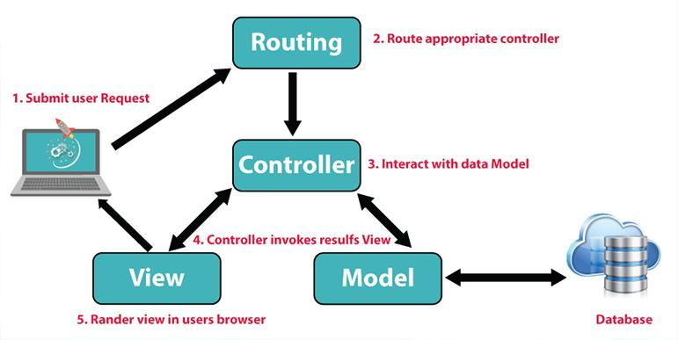

##### Figure 1: MVC model system overview diagram

The acronym **MVC** represents the terms Model, View, and Controller. Within that:

* Model: prepares data in accordance with controller commands and reliably structures data.
* View: Based on the user's actions, presents data to the user in an understandable manner.
* Controller: Takes input from the user, updates data in the Model with commands, and updates the View's user interface with commands sent to it.

Facebook created the open-source **ReactJS** library in 2013, which is a Javascript library used to create interactions between website components. ReactJS has several notable features, one of which is its ability to render data on both the server and client layers. Furthermore, ReactJS focuses on assisting developers in creating user interfaces, or UIs. Programmers writing front-end applications frequently have to focus primarily on two areas: user interface and handling user interaction. Any application's user interface (UI) is made up of various elements, such as buttons, search bars, menus, cards, and so forth. Let's say you are programming an e-commerce website. The next task you have is to add the chosen product to the cart once the user clicks the "Add to cart" button. When the user returns, go to the shopping cart and show that item once more => handle interaction.

#### Benefits of ReactJS

* Reactjs is incredibly productive: The components truly exist in the virtual DOM that Reactjs creates for itself. Performance will be significantly enhanced by this. Additionally, Reactjs determines which updates to the DOM are necessary and only commits those. This saves Reactjs money on expensive DOM operations.

#### The drawbacks of ReactJS

* Reactjs' primary drawbacks are:
  + Reactjs is useful only for the View layer. React is not an MVC framework like other frameworks; it is simply a view library. This is merely the Facebook library that aids in rendering the Varchar(255). As a result, React will need to integrate with other libraries rather than having a separate Model and Controller section. Moreover, React won't use Ajax or 2-way binding.
  + Certain configurations must be made in order to integrate Reactjs with conventional MVC frameworks.
  + React weighs a lot more than other frameworks. React and Angular are roughly the same size—about 35 KB versus 39 KB for Angular. Angular, meanwhile, is a comprehensive framework.
  + Accessible but challenging for novice Web users

### Platform client-side

#### HTML



##### Figure 2: HTML

* **HTML** is a contraction for HyperText Markup Language, which is a language used to create websites (translated as Hypertext Markup Language). Every page on a website, regardless of how many there are, is an HTML document. Tim Berners-Lee, the man who created the World Wide Web and is currently president of the World Wide Web Consortium (W3C, the body that establishes standards for the Internet environment), is considered the father of HTML.
* **HTML** is not a programming language, so "dynamic" functions cannot be created with it. HTML is used for web page layout and formatting, just like Microsoft Word.
* **HTML** When paired with JavaScript and CSS, it forms a strong basis for the internet. Tags, which are written in curly braces, are used to separate HTML elements.

##### Figure 3: CSS

#### CSS là gì? Công dụng chức năng và hướng dẫn sử dụng chi tiếtCSS

* + **CSS** is a language for locating and reformatting elements produced by markup languages (HTML). It is an acronym for Cascading Style Sheets. To put it briefly, it's a language that designs a website's style. It is easy to understand that CSS will assist us in adding styles to the elements if HTML is responsible for formatting the website's elements, such as text paragraphs, titles, tables, etc. That HTML is equivalent to altering the page's color, layout, text color, font, and structure.
  + **CSS** was created in 1996 by the World Wide Web Consortium (W3C) as a result of HTML's inability to incorporate tags for formatting web pages. CSS operates by conducting a search based on pre-selected areas. The name of an HTML tag, an ID, a class, or many other types can be the selected area. The necessary properties will then be applied to that selection. There is a strong correlation between CSS and HTML. They are inseparable; HTML is the markup language (the site's structure) and CSS specifies the style (everything that goes into the user interface).

#### JavaScript

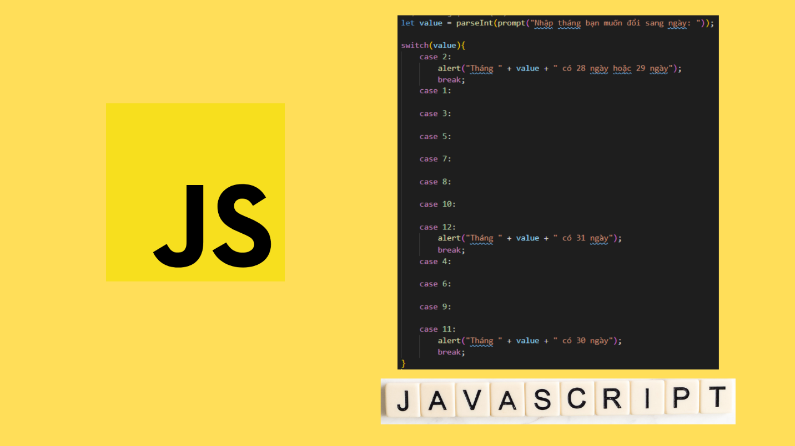

##### Figure 4: JavaScript

* **JavaScript** has been in widespread use for the past 20 years and is one of the three primary languages used for web programming. It was formerly known as Mocha (1995), before going by the names Mona, Livescript, and JavaScript in its current form. 92% of websites as of 2016 make use of JavaScript, so it's likely that you've visited a lot of websites that use this programming language.

##### Figure 5: BootstrapBootstrap là gì? Tất cả thông tin cần biết về BootsTrap

#### Bootstrap

* + - **Bootstrap** is a framework made of HTML, CSS, and JavaScript that makes it simple for users to design websites in accordance with standards, making them responsive to mobile, iPad, tablet, and other handheld devices.
    - **Bootstrap** comprises the most common ones, including buttons, tables, modals, typography, forms, navigation, and picture carousels, among many others. To help you create a responsive design that is simpler, faster, and more convenient, bootstrap includes a lot more components and Javascript.

#### **JQuery**What is jQuery? A Brief Look! - DevOpsSchool.com

##### Figure 6: Jquery

* **jQuery** is a multi-featured, small, quick JavaScript library that was developed in 2006 by John Resig. Its catchphrase, "Write less, do more," is extremely meaningful.
* **jQuery** streamlines Ajax interactions, animations, event handling, and HTML document browsing for quick web development. According to web analytics, jQuery is the JavaScript library that is most frequently used.
* **jQuery** is a JavaScript toolkit made to write less code to make a variety of tasks easier.

#### ReactJS



##### Figure 7: ReactJS

* **ReactJS** To put it simply, ReactJS is an open-source library that is heavily loaded with JavaScript. It was developed by the well-known Facebook tycoon, who was born in 2013. Web applications are the reason behind the creation of ReactJS. Quick, effective, and captivating with little coding work. ReactJS's primary objective is to make any website that uses it fluid, quick, scalable, and simple to use.

### Platform on the server side

#### MySQL



##### Figure 8: MySQL

* **MySQL** A robust, multithreaded, multiuser, and extremely fast SQL (Structured Query Language) database server is provided by the MySQL software. MySQL Server is designed for integration into widely distributed software and heavy-duty, mission-critical production systems. Oracle Corporation and/or its affiliates own the trademark registered under the name Oracle. Oracle Corporation and/or its affiliates own the trademark MySQL, which the customer may not use without express written permission from Oracle. Some names might be trademarks of the people who own them.
* **MySQL** is a relational database management system (RDBMS) that is free, open-source, and uses various proprietary licenses, including GNU General Public License (GPL). As an RDBMS, MySQL uses SQL to manage data inside a database. It organizes correlated data into one or more data tables, and this correlation helps structure the data.

#### NodeJS



##### Figure 9: NodeJS

* **NodeJS** is a platform developed using the C++ and Javascript-written "V8 Javascript engine." Ryan Lienhart Dahl created this platform back in 2009.
* Early JavaScript developers expanded it beyond just running in the browser to allow you to run it as a standalone application on your computer, which gave rise to Node.js.
* NodeJS make JavaScript can now be used for backend tasks instead of just website interaction.

### Data architecture and solutions

#### Use case illustration for clients without an account

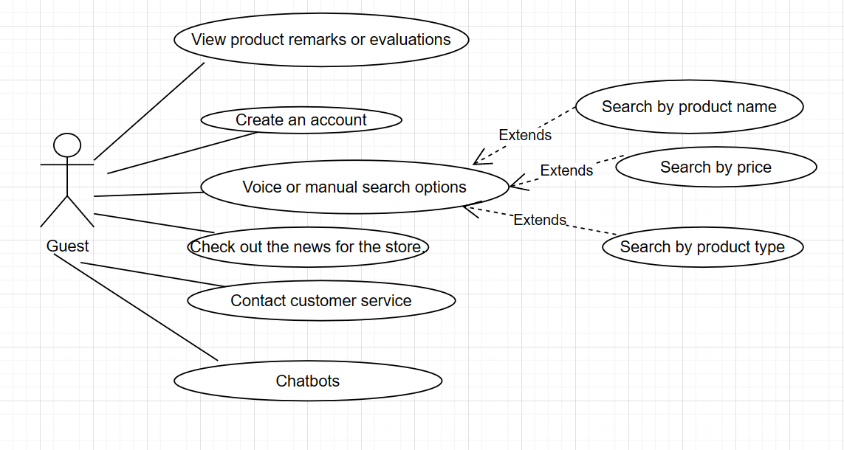

##### Figure 10: Visitor use case diagram

Use case diagram intended for clients without an account. Customers can use it to register for an account, view comprehensive product information, search by brand, price, or name, view news, and get in touch with customer service. Customers can only view product reviews and comments, in addition.

#### A customer's use case diagram displayed when they are logged into the website

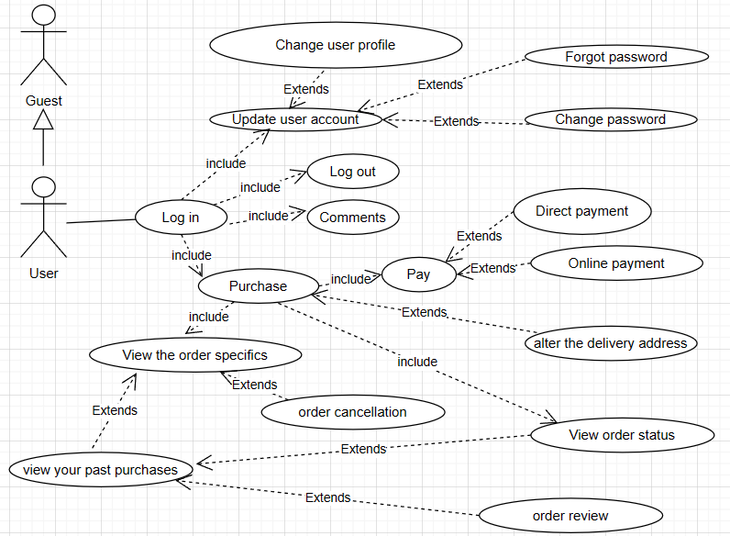

##### Figure 11: Member customers' use case diagram

Customer members' use case diagram in the system. Customers who are members, in particular, have access to additional features beyond those available to guests, such as the ability to update personal information (full name, phone number, profile picture), log in and out of their accounts, and log in. information about the account (password reset, forgotten password, contact, address, etc.) and account details. In addition, members can place orders, rate items after they've been purchased, add items to their carts, check their purchase histories, and cancel orders.

#### Employee UseCase diagram for store

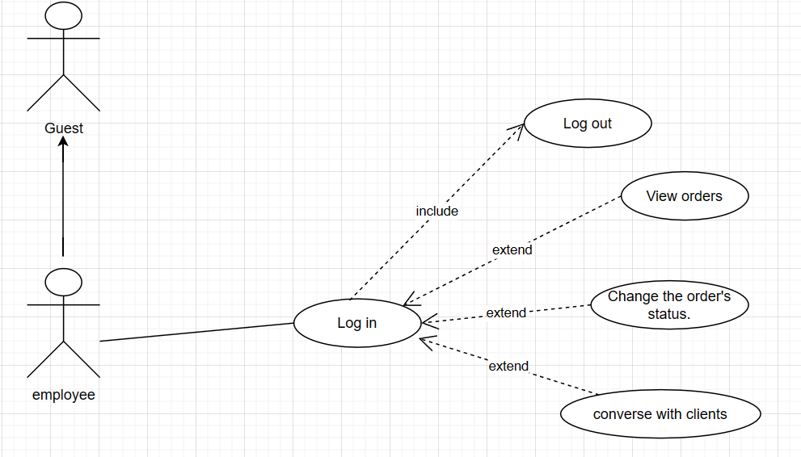

##### Figure 12: Store employees' use case diagram

Employee use case diagram in the system. Specifically, employees can do the following in addition to visitor functions: log in, log out of accounts, and request a password reset (forgot password, reset password). In addition, over half of the staff members are able to choose which orders to contact in order to sign contracts, converse with clients, respond to inquiries from clients regarding products, and monitor updates and delivered orders. Update the status of the customer's order.

#### The admin's UseCase diagram represents the manager of the store.

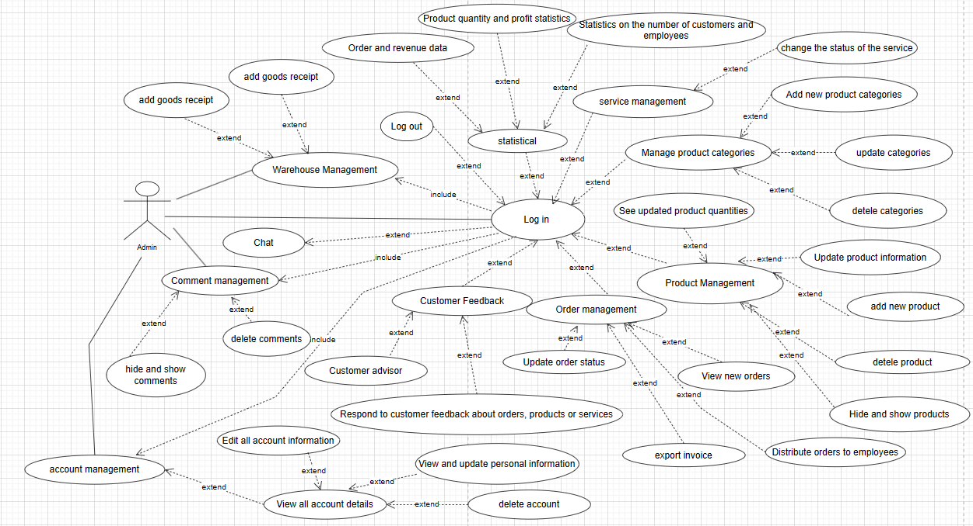

##### Figure 13: Use case diagram for a system administrator

Use case diagram for a system administrator. Admin in particular is able to access the administration system and log in and out. Manage the different kinds of products, reviews, orders, warehousing, employee and customer accounts, chat, and permissions for the employees. Administrators can also see data on revenue and profit for the day, week, month, year, and quarter, as well as information on the most viewed, best-selling, and number of new orders. Administrators can also monitor order completion rates, popularity percentage statistics of browsers used, visitation statistics, and user activity tracking. employee via the history of the system. Other unique features include controlling the appointment booking feature and viewing the profits from goods sold during the month.

### Conceptual data model (CDM)

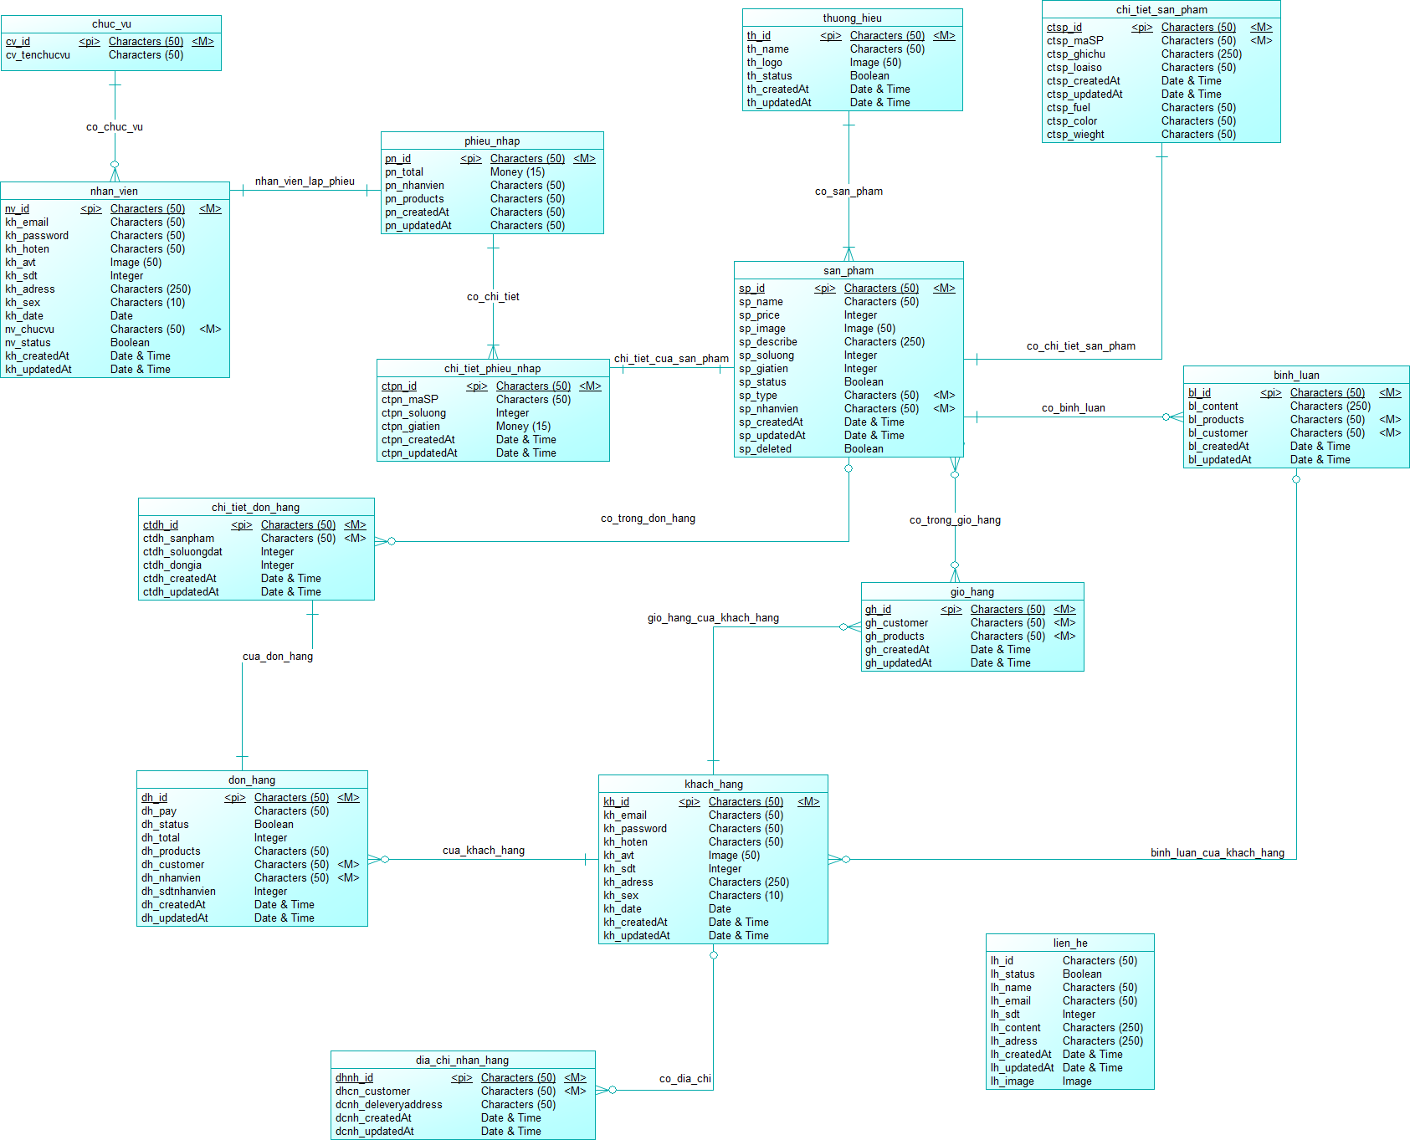

##### Figure 14: Conceptual data model (CDM)

### Logical data model (PDM)

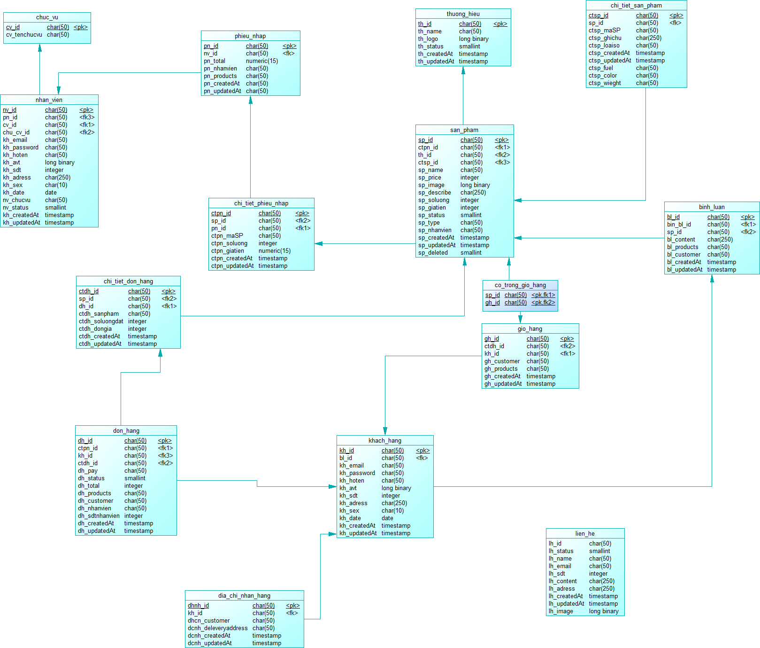

##### Figure 15: Logical data model (PDM)

### Table of data

| **Placement table** | | | | |
| --- | --- | --- | --- | --- |
| **Description of a data table** | | | | |
| **No** | **Attribute name** | **Datatypes** | **Constraint** | **Describe** |
| 1 | cv_id | Varchar(255) | Primary Key | Position code |
| 2 | cv_name | Varchar (255) | Not Null | Rank and place of employment |
| 3 | cv_luong | Int | Not Null | Employee salary |

###### Table 1: Position data description

| **Table of Employee Accounts** | | | | |
| --- | --- | --- | --- | --- |
| **Description of a data table** | | | | |
| **No** | **Attribute name** | **Datatypes** | **Constraint** | **Describe** |
| 1 | nv_id | Varchar (255) | Primary Key | Staff code |
| 2 | nv_email | Varchar (255) | Not Null | Staff email |
| 3 | nv_password | Varchar (255) | Not Null | Staff password |
| 4 | nv_hoten | Varchar (255) | Not Null | Staff name |
| 5 | nv_avt | Varchar(255) | Not Null | Staff image |
| 6 | nv_phone | Varchar(255) | Not Null | Staff phone |
| 7 | nv_adress | Varchar (255) | Not Null | Staff address |
| 8 | nv_date | Datetime | Not Null | Staff’s date born |
| 9 | cv_id | Int | Not Null | The chucvu collection's "cv_id" is referenced in the employee's position. |
| 10 | nv_status | Tinyint(1) | Not Null | Status employee account |
| 11 | nv_create | Datetime | Not Null | Date create account |
| 12 | nv_updated | Datetime | Not Null | Date update account |

###### Table 2: Define data from the employee account table.

| **Table of goods receipts** | | | | |
| --- | --- | --- | --- | --- |
| **Description of a data table** | | | | |
| **No** | **Attribute name** | **Datatypes** | **Constraint** | **Describe** |
| 1 | pn_id | Int | Primary Key | Receipts Id |
| 2 | pn_total | Double | Not Null | Receipts total |
| 3 | nv_id | Int | Not Null | The employee imports the reference "nv_id" from the nhan_vien collection |
| 4 | sp_code | Varchar(50) | Not Null | Products imported from collection products into the reference warehouse "sp_code" |
| 5 | pn_create | Datetime | Not Null | Date create receipts |
| 6 | pn_update | Datetime | Not Null | Date update receipts |

###### Table 3: Data from the goods receipt table description

| **Table of products** | | | | |
| --- | --- | --- | --- | --- |
| **Description of a data table** | | | | |
| **No** | **Attribute name** | **Datatypes** | **Constraint** | **Describe** |
| 1 | sp_id | Int | Primary Key | Product id |
| 2 | sp_code | Varchar(50) | Unique | Product code |
| 3 | sp_name | Varchar (255) | Not Null | Product name |
| 4 | sp_price | Double | Not Null | Product price |
| 5 | sp_image | Varchar(255) | Not Null | Product image |
| 6 | sp_describe | Varchar(255) | Not Null | Product describe |
| 7 | sp_sl | Int | Not Null | Product quantity |
| 8 | sp_xuatxu | Varchar(255) | Not Null | Product origin |
| 9 | cate_id | Int | Foreign Key | Product type |
| 10 | sp_gianhap | Double | Not Null | Product import price |
| 11 | sp_status | Int(3) | Not Null | Product status |
| 12 | nv_id | Int | Foreign Key | Product import by employee |
| 13 | sp_create | Datetime | Not Null | Date create product |
| 14 | sp_update | Datetime | Not Null | Date update product |
| 15 | sp_note | Varchar(255) | Not Null | Note about product |
| 16 | s_status | Tinyint(1) | Not Null | Product status |

###### Table 4: Product Table Data Description

| **Table of domesticated animals** | | | | |
| --- | --- | --- | --- | --- |
| **Description of a data table** | | | | |
| **No** | **Attribute name** | **Datatypes** | **Constraint** | **Describe** |
| 1 | cate_id | Varchar (255) | Primary Key | Species id |
| 2 | cate_name | Varchar (255) | Not Null | Species name |
| 3 | cate_img | Varchar(255) | Not Null | Species image |
| 4 | c_status | Tinyint(1) | Not Null | Species on off |
| 5 | cate_create | Datetime | Not Null | Date add species |
| 6 | cate_update | Datetime | Not Null | Date update species |
| 7 | cate_status | int(3) | Not Null | Species status |

###### Table 5: Product Brand Data Description

| **Cart table** | | | | |
| --- | --- | --- | --- | --- |
| **Description of a data table** | | | | |
| **No** | **Attribute name** | **Datatypes** | **Constraint** | **Describe** |
| 1 | gh_id | Int | Primary Key | Cart id |
| 2 | kh_id | Int | Foreign Key | "kh_id" is referred to by the customer ID in the users collection. |
| 3 | sp_code | Varchar (50) | Foreign Key | The items in the shopping cart make use of the collection products' "sp_code." |
| 4 | gh_create | Datetime | Not Null | Date create cart |
| 5 | gh_update | Datetime | Not Null | Date update cart |
| 6 | status | int(3) | Not Null | Cart status |

###### Table 6: Data Description for Cart Table

| **Order table** | | | | |
| --- | --- | --- | --- | --- |
| **Description of a data table** | | | | |
| **No** | **Attribute name** | **Datatypes** | **Constraint** | **Describe** |
| 1 | dh_id | Int | Primary Key | Order id |
| 2 | dh_pay | Varchar (255) | Not Null | Payments |
| 3 | dh_status | Int(3) | Not Null | Order status |
| 4 | dh_total | Double | Not Null | Order total |
| 5 | sp_code | Varchar (50) | Foreign Key | The items in the shopping cart make use of the collection products' "sp_code." |
| 6 | kh_id | Int | Foreign Key | "kh_id" is referred to by the customer ID in the users collection. |
| 7 | nv_id | Int | Foreign Key | Refer to the "nv_id" employee code from the "nhan_vien" collection. |
| 8 | dh_sl | Int | Not Null | Order quantity |
| 9 | dh_create | Datetime | Not Null | Date create order |
| 10 | dh_update | Datetime | Not Null | Date update order |
| 11 | dh_address | Varchar(255) | Not Null | Order address |

###### Table 7: Orders table data description

| **Table of customer accounts** | | | | |
| --- | --- | --- | --- | --- |
| **Description of a data table** | | | | |
| **No** | **Attribute name** | **Datatypes** | **Constraint** | **Describe** |
| 1 | user_id | Int | Primary Key | User Id |
| 2 | user_name | Varchar (255) | Not Null | User name |
| 3 | user_email | Varchar (255) | Unique | User email |
| 4 | user_password | Varchar (255) | Not Null | User password |
| 5 | user_avt | Varchar(255) | Not Null | User avatar |
| 6 | user_phone | Varchar(255) | Not Null | User phone |
| 7 | user_address | Varchar (255) | Not Null | User address |
| 8 | user_gt | Varchar(10) | Not Null | User gender |
| 11 | user_create | Datetime | Not Null | Date create user |
| 12 | user_update | Datetime | Not Null | Date update user |
| 13 | user_status | int(3) | Not Null | User status |

###### Table 8: Explanatory table of customer data

| **Table of services** | | | | |
| --- | --- | --- | --- | --- |
| **Description of a data table** | | | | |
| **No** | **Attribute name** | **Datatypes** | **Constraint** | **Describe** |
| 1 | service_id | Int | Primary Key | Service id |
| 2 | service_name | Varchar (255) | Not Null | Service name |
| 3 | service_price | Int | Not Null | Service price |
| 4 | service_des | Varchar(255) | Not Null | Service detail |

###### Table 9: Service Data Table Description

| **Table of comment** | | | | |
| --- | --- | --- | --- | --- |
| **Description of a data table** | | | | |
| **No** | **Attribute name** | **Datatypes** | **Constraint** | **Describe** |
| 1 | bl_id | Int | Primary Key | Coment Id |
| 2 | bl_content | Varchar (255) | Not Null | Content of comments |
| 3 | sp_id | Int | Foreign Key | "sp_id" from the products collection is referred to in the product code. |
| 4 | kh_id | Int | Foreign Key | "kh_id" is referred to by the customer ID in the users collection. |
| 5 | bl_create | Datetime | Not Null | Date create comment |
| 6 | bl_update | Datetime | Not Null | Date update comment |
| 7 | b_status | Tinyint(1) | Not Null | Comment status |

###### Table 10: Data from the comment table described

| **Table of contact details** | | | | |
| --- | --- | --- | --- | --- |
| **Description of a data table** | | | | |
| **No** | **Attribute name** | **Datatypes** | **Constraint** | **Describe** |
| 1 | lh_id | Int | Primary Key | Contact id |
| 2 | lh_status | Int(3) | Not Null | Contact status |
| 3 | lh_name | Varchar (255) | Not Null | Contact name |
| 4 | lh_email | Varchar (255) | Not Null | Contact email |
| 5 | lh_sdt | Varchar(255) | Not Null | Contact Phone |
| 6 | lh_content | Varchar (255) | Not Null | Support is required for content. |
| 7 | lh_address | Varchar(255) | Not Null | Contact address |
| 8 | lh_create | Datetime | Not Null | Date create contact |
| 9 | lh_update | Datetime | Not Null | Date update contact |
| 10 | lh_img | Varchar(255) | Not Null | Contact image |
| 11 | lh_ph | Varchar(255) | Not Null | Reach out for comments |

###### Table 11: Table Data Description for Contact Information

| **Table of Order Details** | | | | |
| --- | --- | --- | --- | --- |
| **Description of a data table** | | | | |
| **No** | **Attribute name** | **Datatypes** | **Constraint** | **Describe** |
| 1 | ctdh_id | Int | Primary Key | Order details id |
| 2 | sp_code | Varchar(50) | Foreign Key | "sp_code" from the products collection is referred to in the product code. |
| 3 | ctdh_sl | Int | Not Null | Order details quantity |
| 4 | ctdh_create | Datetime | Not Null | Order details date create |
| 5 | ctdh_update | Datetime | Not Null | Order details date update |
| 6 | dh_id | Int | Foreign Key | "dh_id" from the order collection is referred to in the order details. |
| 7 | ctdh_price | Int | Not Null | Order details price |

###### Table 12: Data description of the order detail table

| **Detailed goods receipt table** | | | | |
| --- | --- | --- | --- | --- |
| **Description of a data table** | | | | |
| **No** | **Attribute name** | **Datatypes** | **Constraint** | **Describe** |
| 1 | ctpn_id | Int | Primary Key | Details goods receipt id |
| 2 | pn_id | Int | Foreign Key | The Good receipt makes reference to "pn_id" from the Good receipt collection. |
| 3 | sp_code | Varchar (50) | Foreign Key | "sp_code" from the products collection is referred to in the product code. |
| 4 | ctpn_sl | Int | Not Null | Products quatity |
| 5 | ctpn_create | Datetime | Not Null | Date create detail goods receipt |
| 6 | ctpn_update | Datetime | Not Null | Date update detail goods receipt |
| 7 | ctpn_gianhap | Double | Not Null | Products price import |

###### Table 13: Input ticket detail table data description

| **Table of pet** | | | | |
| --- | --- | --- | --- | --- |
| **Description of a data table** | | | | |
| **No** | **Attribute name** | **Datatypes** | **Constraint** | **Describe** |
| 1 | p_id | Int | Primary Key | Pet id |
| 2 | cate_id | Int | Foreign Key | Pet species |
| 3 | p_img | Varchar (255) | Not Null | Pet image |
| 4 | kh_id | Int | Foreign Key | "kh_id" is referred to by the customer ID in the users collection. |
| 5 | p_create | Datetime | Not Null | Date create book pet |
| 6 | p_status | Int(3) | Not Null | Pet status |
| 7 | p_update | Datetime | Not Null | Date update book pet |
| 8 | p_name | Varchar(255) | Not Null | Pet name |
| 9 | service_id | Int | Foreign Key | "Service_id" from the service collection is referred to by the service ID. |

###### Table 14: Description of Pet Table Data

* **Finish:**

The primary specifications established by the website that sells pet care goods and services have been made clearer with the articulation of the system's functional and database requirements. In terms of functions, use use case diagrams to analyze the system's primary functions and provide a detailed description of each function, system component, and use case relationship. assisting users in getting a general understanding of the system. Determine the database for the system based on the functions that were analyzed, and then make sense of the entities, relationships, and constraints that exist within the system.

### Flow diagram showing some of the system's primary features

#### Login function

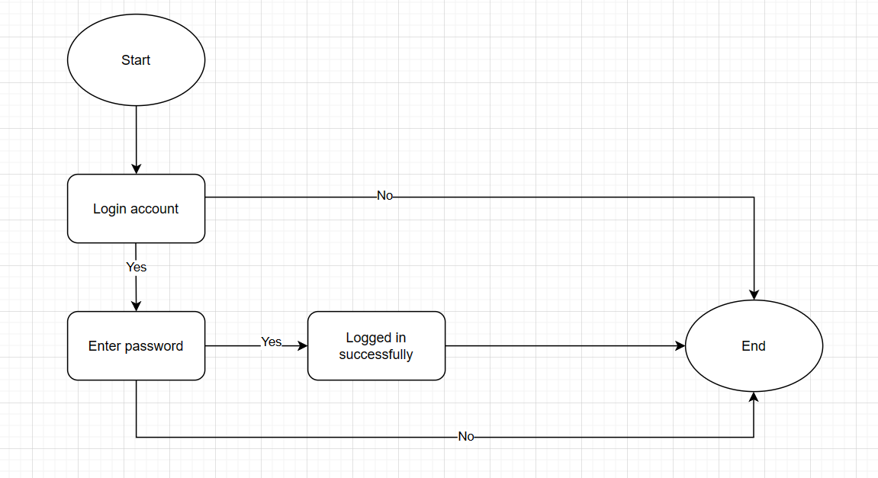

##### Figure 16: A flow chart that illustrates how to log in.

#### The function of purchasing and order payment

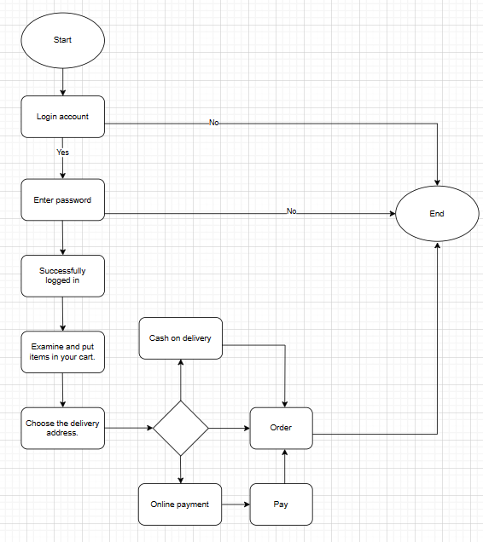

##### Figure 17: Order function flow chart

#### Update function for order status

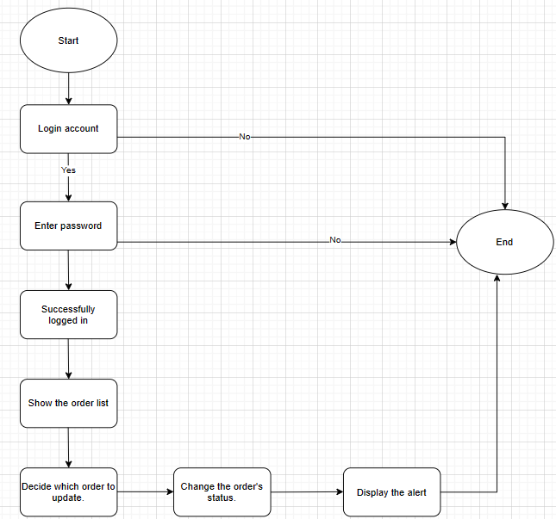

##### Figure 18: Flow chart for updating order status

#### Product details search feature

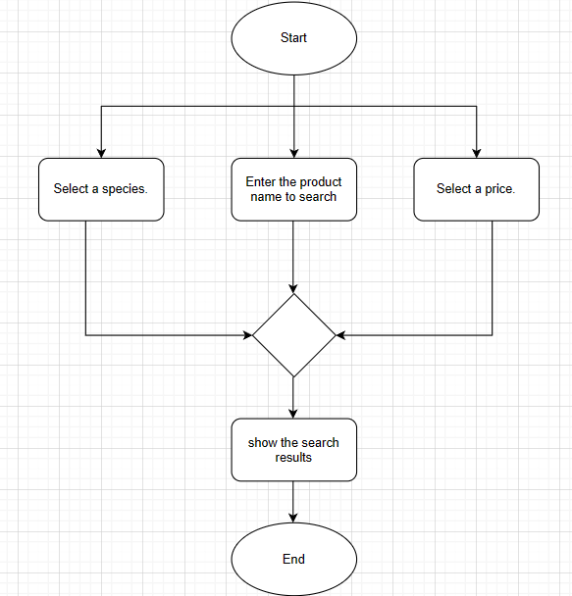

##### Figure 19: Flow chart for product search

#### Function for registering an account

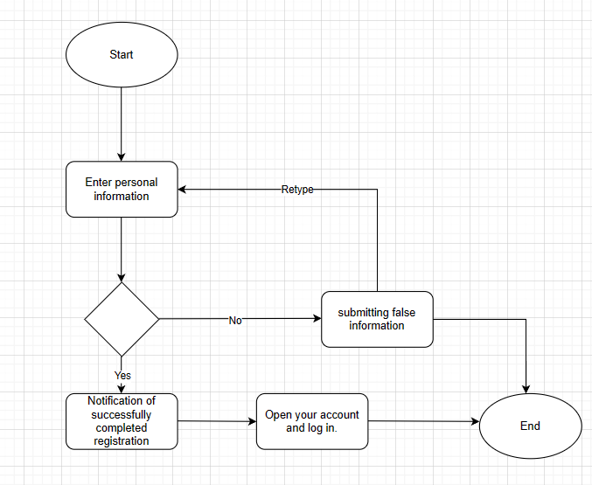

##### Figure 20: Account registration function flow chart

### System architecture based on function

#### Function for registering members

* **Name of function:** Create an account
* **Describe:** Free users can register an account to log in to the website by using the "register account" button.
* **Object:** Customers
* **Required conditions:** Customer
* **Handling:**
* **Step 1:** Customers can choose to "Register account" from the system's login interface. All the necessary information for the user to register will be displayed on the functional interface.
* **Step 2:** The user registers by providing all necessary information.
* **Step 3:** User clicks "Register"
* **Step 4:** The data entered by the user is verified by the system:
* The system will display an invalid and requires re-registration message if the registration information is found to be incorrect.
* If the user provides accurate and complete information, the system will create a new member account for them, send them a notification, and take them back to the home screen.
* **Result:** Customer registration succeeds or fails

#### Login function

* **Function name:** log in
* **Describe**: gives users access to the system for managing products, ordering, and making purchases.
* **Object:** customer, admin
* **Prerequisites:** Needs to have an account to log in.
* **Processing:**
* **Step 1:** Visit the main page of the system.
* **Step 2:** The user fills out the login form with their account and password.
* **Step 3:** Select "Login" from the menu.
* **Step 4:** The user's account and password will be verified by the system:
  + Users will be able to access the system if their account and password match those on file.
  + The system will ask the user to re enter and display an error message if it is incorrect.
* **Outcome**: successful or unsuccessful login

#### Product search function

* **Function name:** Search product
* **Describe:** Search for products on the system
* **Object:** Customer
* **Prerequisites:** Customer
* **Processing:**
* **Step 1:** Consumers input the information they wish to find about the product.
* **Step 2:** The system verifies the data the customer entered about the product.
* **Step 3:** Give the product's quantity and the necessary details.
* **Outcome:** Shows the products that were requested.

#### The function of account logout

* **Function name:** Sign out of your account
* **Describe:** Exit the system by logging out.
* **Đối tượng:** Customer, admin
* **Prerequisites:** must successfully log in to the system
* **Processing:**
* **Step 1:** From the user's primary interface, the user chooses the "Log out" feature.
* **Step 2:** The system performs an audit, disconnects the account, and then reroutes to the login screen.
* **Result:** customer successfully logged out of the system

#### Function of customer information management

* **Function name:** Management of customer information
* **Describe:** Customers or the admin can examine each other's personal information.
* **Object:** admin,khách hàng
* **Prerequisites:** needs to access the system with success.
* **Processing:**
* **Step 1:** From the home page interface, choose "Profile"
* **Result:** Customer information will be displayed

#### Order function

* **Function name:** order
* **Describe:** With the "Order" function, customers can manage the products they buy such as: price and quantity,...
* **Object:** Customer
* **Prerequisite:** must successfully log in to the system
* **Processing:**
* **Step 1:** After choosing the item you wish to purchase, the system will take you to the shopping cart where clients may view prices and quantity photographs..
* **Step 2:** The user completes the form request with all necessary details.
* **Step 3: Order:**
* The customer can proceed to make an order once the quantity of the product has been agreed upon. The system will record the order information and the amount to be paid.
* **Result:** order success or failure

#### Product management function

* **Function name:** product management
* **Describe:** Admins can add, update, delete, hide, show, and more products with the "Product Management" tool.
* **Object:** admin
* **Prerequisite:** must successfully use an admin account to log into the system
* **Processing:**
* **Step 1:** choose one of the add, edit, and delete functions on the home page interface
* **Step 2:** Complete the matching function's form details.
* **Result:** admin successfully added, edited, deleted, information of a product

#### Function of managing product catalogs

* **Function name:** product catalog management
* **Describe:** With the "Manage product categories" function, admins can add, edit, delete, hide and show product categories.
* **Object:** admin
* **Prerequisite:** must successfully log in to the system with an admin account
* **Processing:**
* **Step 1:** Select an option from the add, edit, delete, or conceal features available on the main screen.
* **Step 2:** Complete the matching function's form details.

**Result:** admin successfully added, edited, deleted, hidden, and showed information of a product

#### Function for managing product comments

* **Function name:** comment management
* **Describe:** With the "Comment Management" function, admins can add, edit, delete, hide and show comments about products
* **Object:** admin
* **Prerequisite:** must successfully log in to the system with an admin account
* **Quá trình xử lí:**
* **Step 1:** Select a function from the list of add, modify, delete, hide, and show on the main interface functions.
* **Step 2:** Complete the matching function's form details.

**Result:** admin successfully adds, edits, deletes, hides, shows information of 1 product comment

#### Customer care function

* **Function name:** customer care
* **Describe:** Admins can reply to queries and grievances regarding the product from customers by using the "customer care" feature.
* **Object:** admin
* **Prerequisites:** Need to successfully use an admin account to log into the system
* **Processing:**
* **Step 1:** choose one of the functions add, edit, delete, hide, show on the home page interface
* **Step 2:** Complete the corresponding function's form information.

**Kết quả:** phản hồi thông tin đến khách hàng Success

#### Goods receipt management function

* **Function name:** Manage goods receipt
* **Describe:** Admin can create and update goods receipts using the "Manage goods receipt" function.
* **Object:** admin
* **Prerequisites:** Need to successfully use an admin account to log into the system
* **Processing:**
* **Step 1:** Decide which item needs to be stored.
* **Step 2:** Complete the corresponding function's form information.

**Result:** creating a new goods receipt successfully

#### Employee, customer, and individual account management functions

* **Function name:** quản lý tài khoản
* **Describe:** Administrators have the ability to add, edit, delete, hide, and show account information through the "Account Management" function.
* **Object:** admin
* **Prerequisites:** Need to successfully use an admin account to log into the system
* **Processing:**
* **Step 1:** Select the account to update or create a new account.
* **Step 2:** Complete the corresponding function's form information.

**Result:** Successfully updated or created new account information.

#### Statistics function

* **Function name:** Statistics.
* **Describe:** The administrator can view sales revenue and profits at any desired time and period using the "Statistics" function. In particular, the admin can view sales quantity and profits for each type of product.
* **Object:** admin.
* **Prerequisites:** must be able to access the system and log in with an admin account.
* **Processing:**
* **Step 1:** Decide which product or time period requires statistics**.**
* **Step 2:** Complete the relevant function's form with all the necessary data.

**Result:** successful display of profit information for the time or product.

#### Function of scheduling

* **Function name:** Set up veterinary care and checkups.
* **Describe:** Customers can make an appointment for their pet to come in for an examination by using the "book care and medical examination for pets" function. Administrators have the ability to update an appointment, regardless of its completion status..
* **Object:** admin, customer.
* **Prerequisites:** must be able to access the system and log in with an admin account and a user account.
* **Processing:**
* **Step 1:** Select "book pet" from the customer's menu.
* **Step 2:** Complete the relevant function's form with all the necessary data.
* **Step 3:** When a customer brings their pet into the pet shop, the administrator will adjust the appointment schedule.

**Result:** the appointment was successfully booked and the admin will be able to manage the scheduled appointment.

* **Wrap up:**

Create the system in accordance with the functions that are described, the user objects that are related, and the activities that correspond to each function of the system have been analyzed in the specification. Each function is demonstrated through text and diagrams.

## CHAPTER 3: OBTAINED OUTCOMES

### Customer interface

#### The homepage both before and after logging in

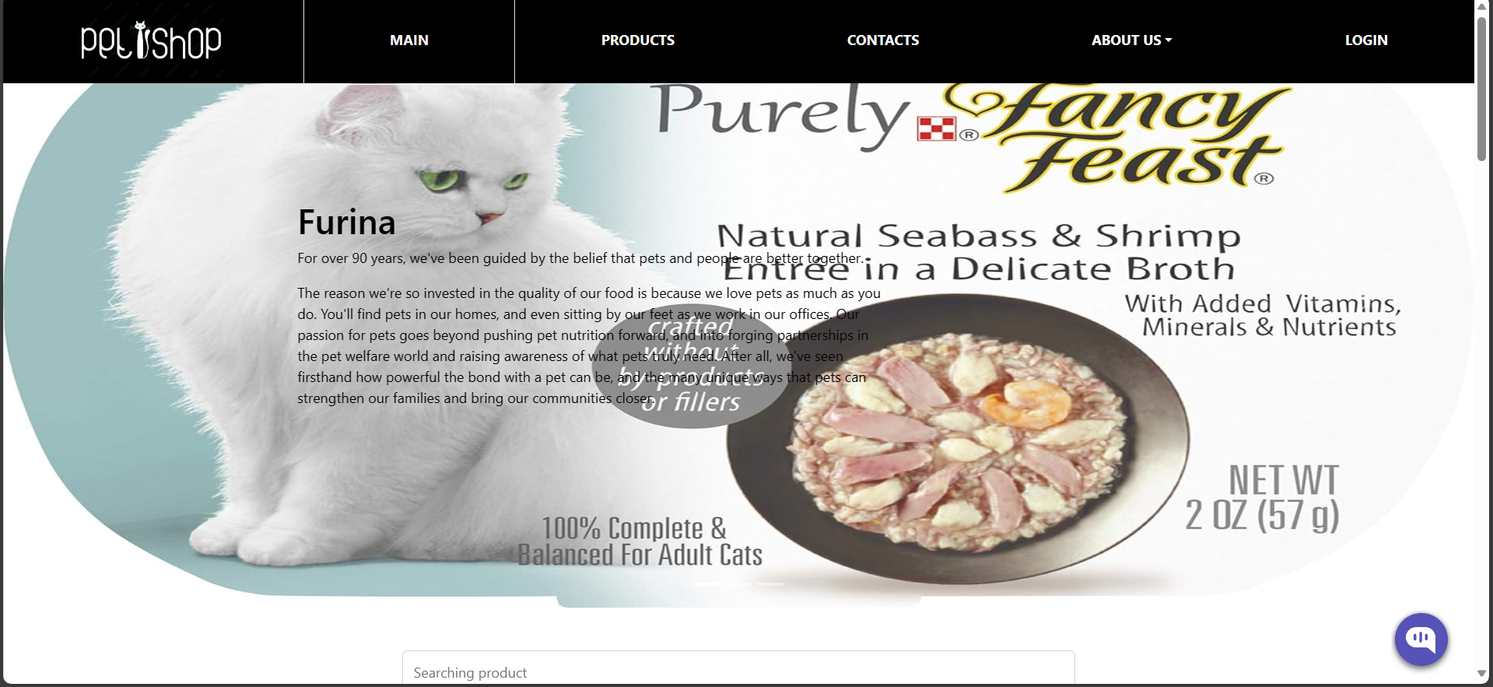

##### Figure 21: Home page interface without login

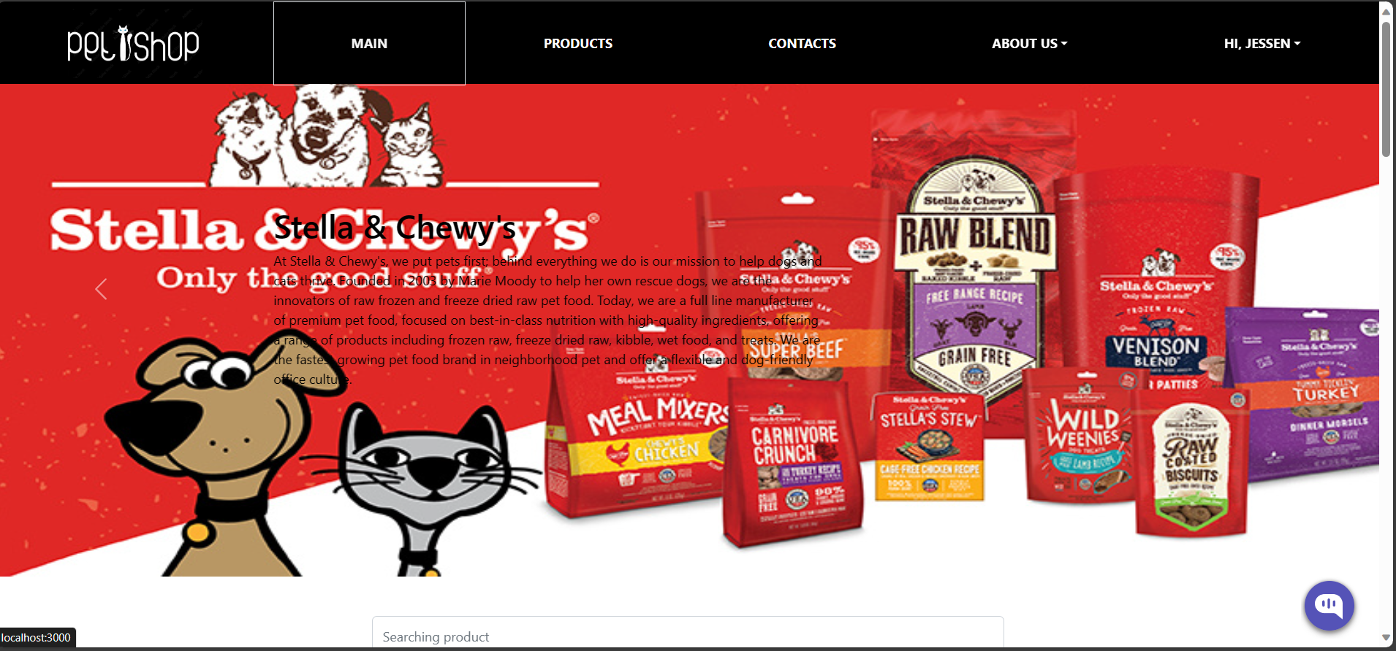

##### Figure 22: Home page interface after logging in

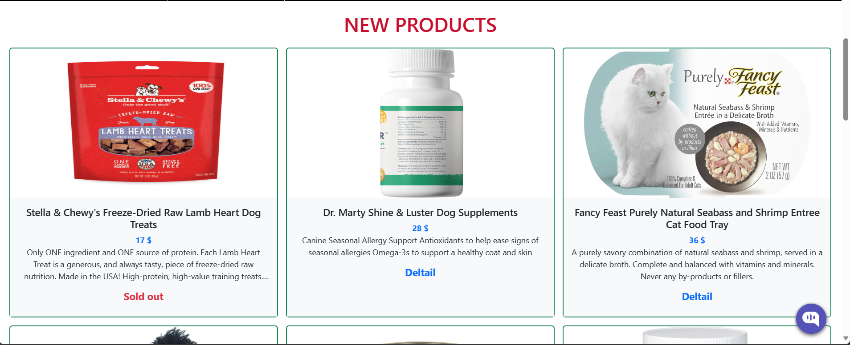

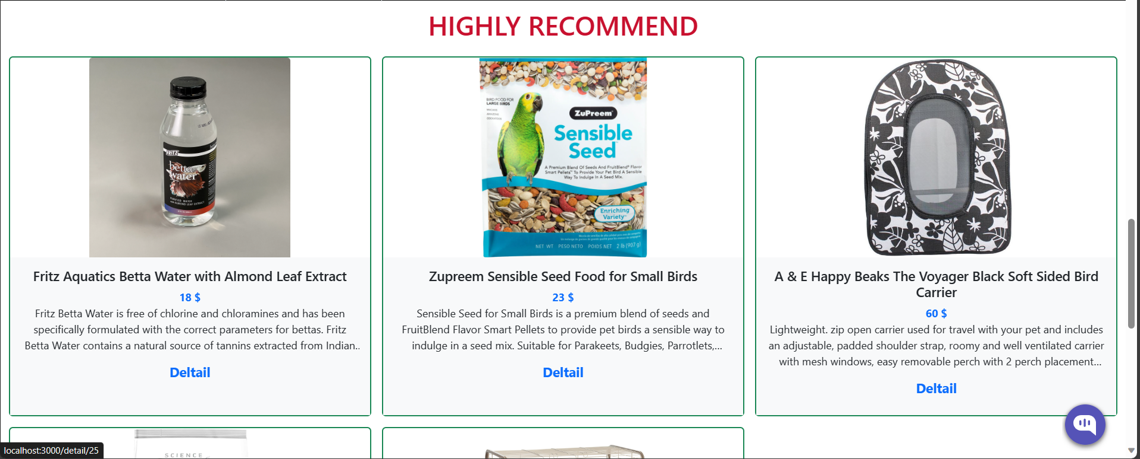

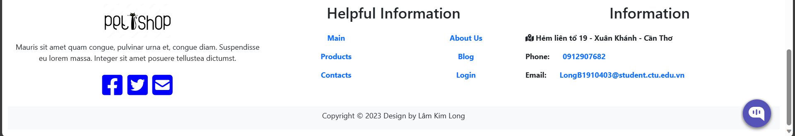

##### Figure 23: Home page interface

Customers always find that the home page interface is crucial because it gives them a better understanding of the system. Customers can use the system to register, log in to their accounts, search for products they want, view their shopping carts quickly, and discover hot items, best-selling products, most viewed products, hot news from the system, and some featured products by category.

#### Login page interface

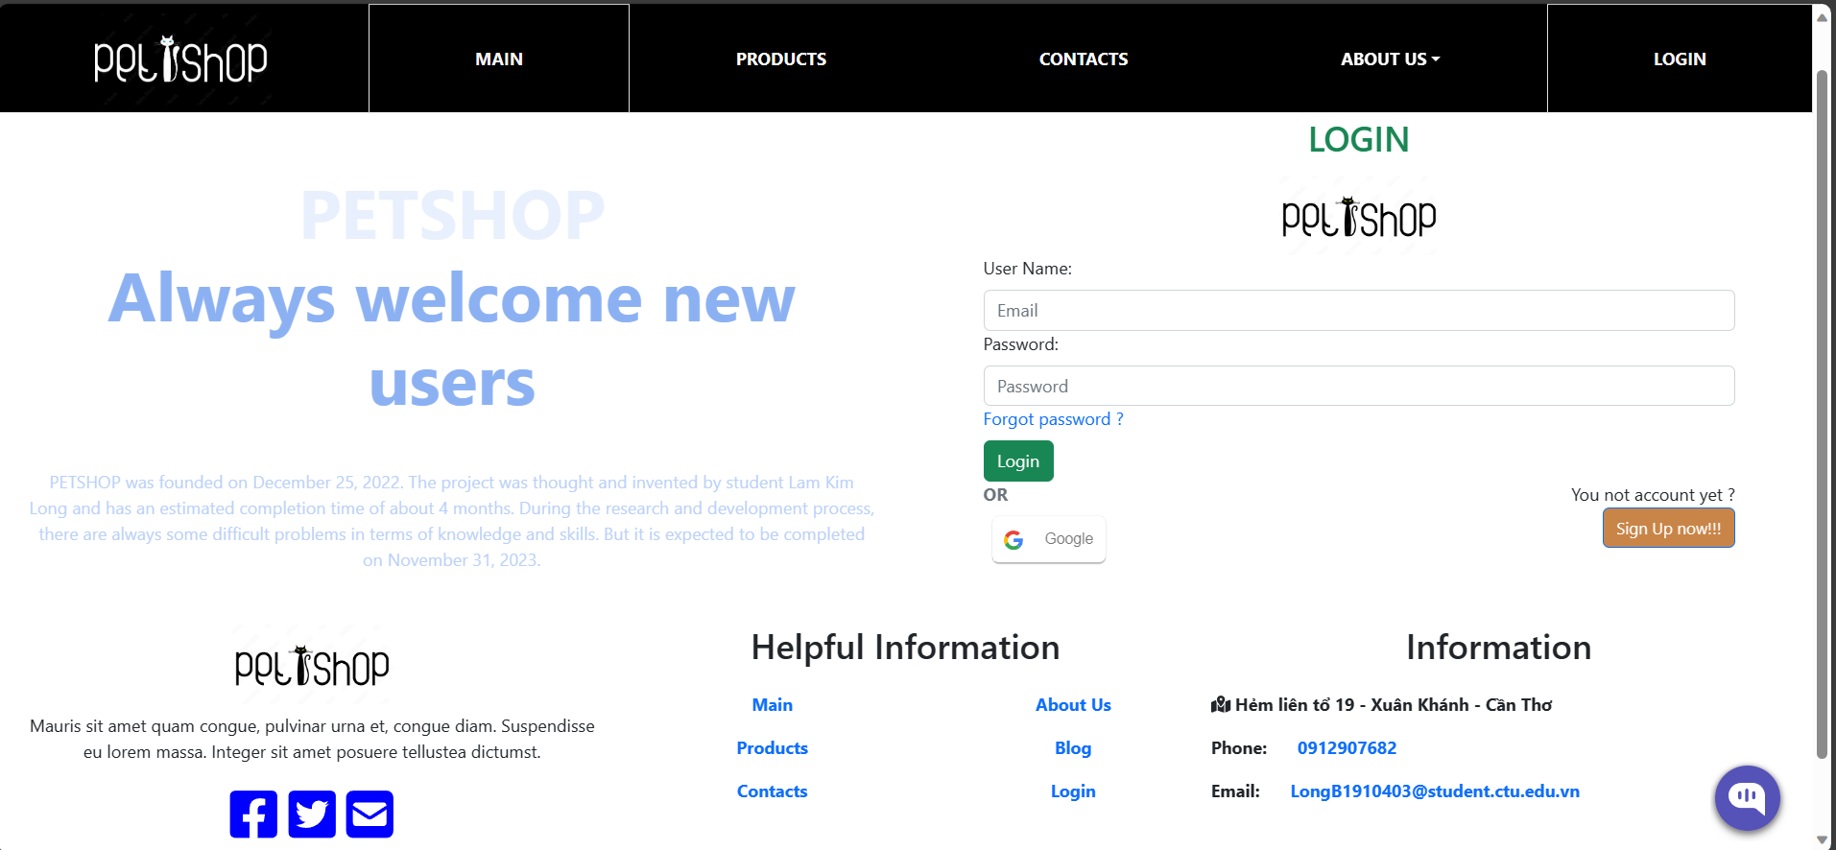

##### Figure 24: Login page interface

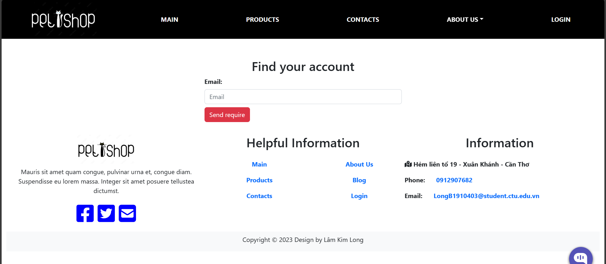

##### Figure 25: Password reset page interface

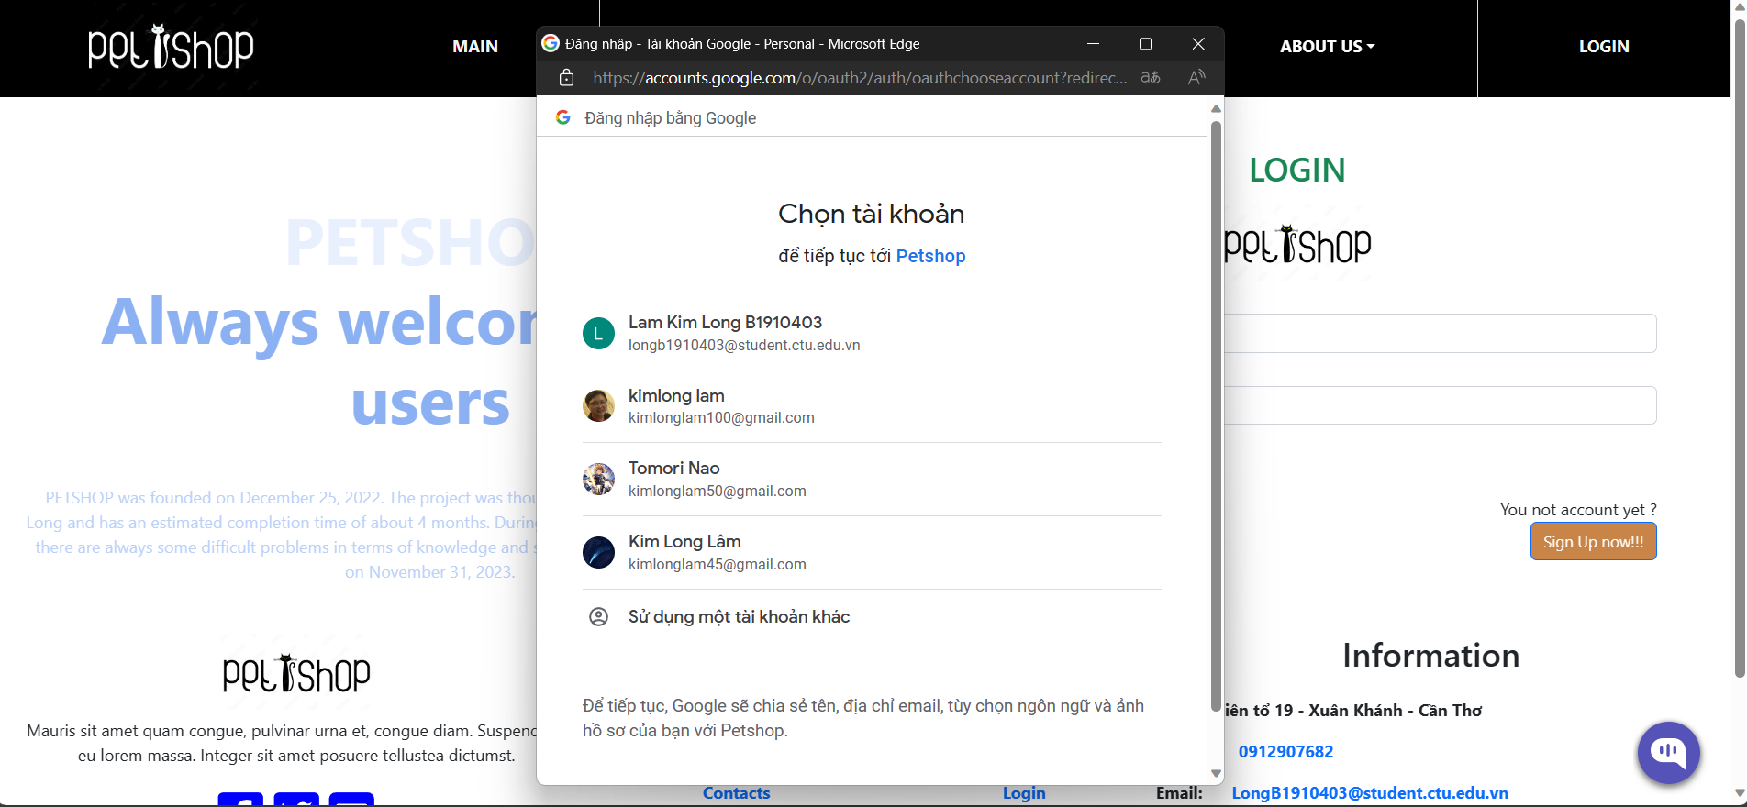

##### Figure 26: Google login interface

The login page interface includes 3 parts:

* Log in with your registered account and password
* Sign in with your google account
* Reset password

There are two steps involved in the login process. The home page will load automatically and you will get a "successful login" message if you enter the correct account and password. If it is incorrect, on the other hand, it will print the message "wrong account or password" and force you to log in once more.

#### Account registration page interface

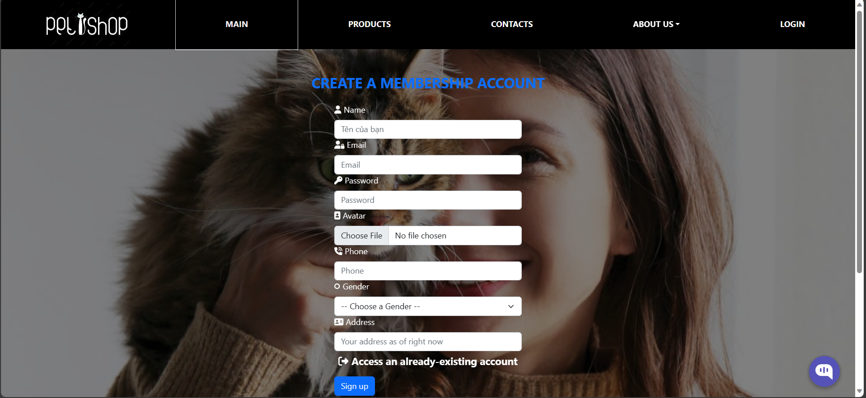

##### Figure 27: Interface of member account registration page

The member registration page interface requires entering all necessary information to register an account. After registering, you will be redirected to the login page

#### Product page interface

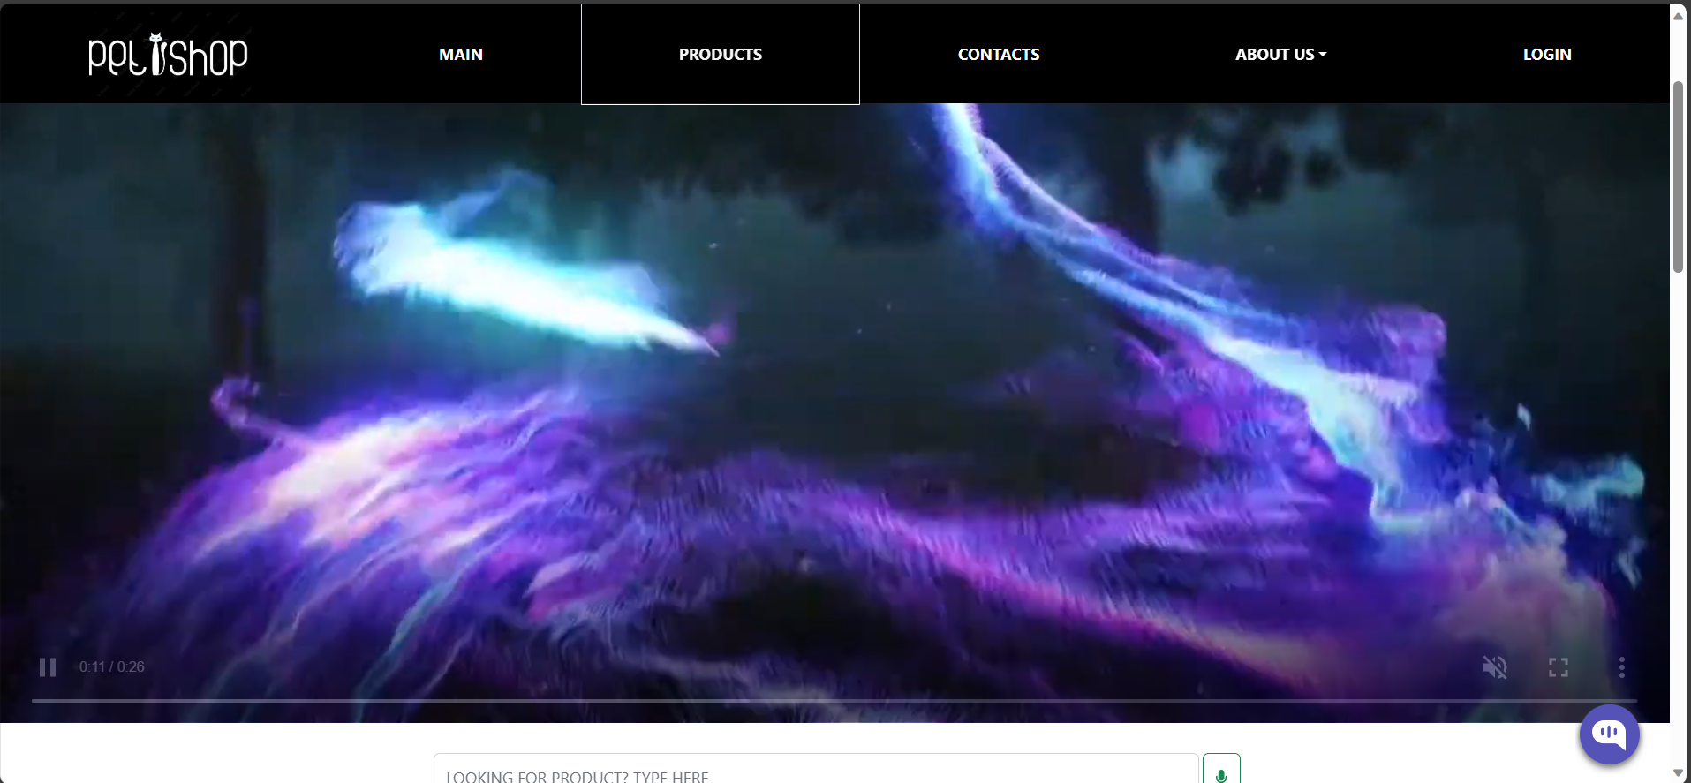

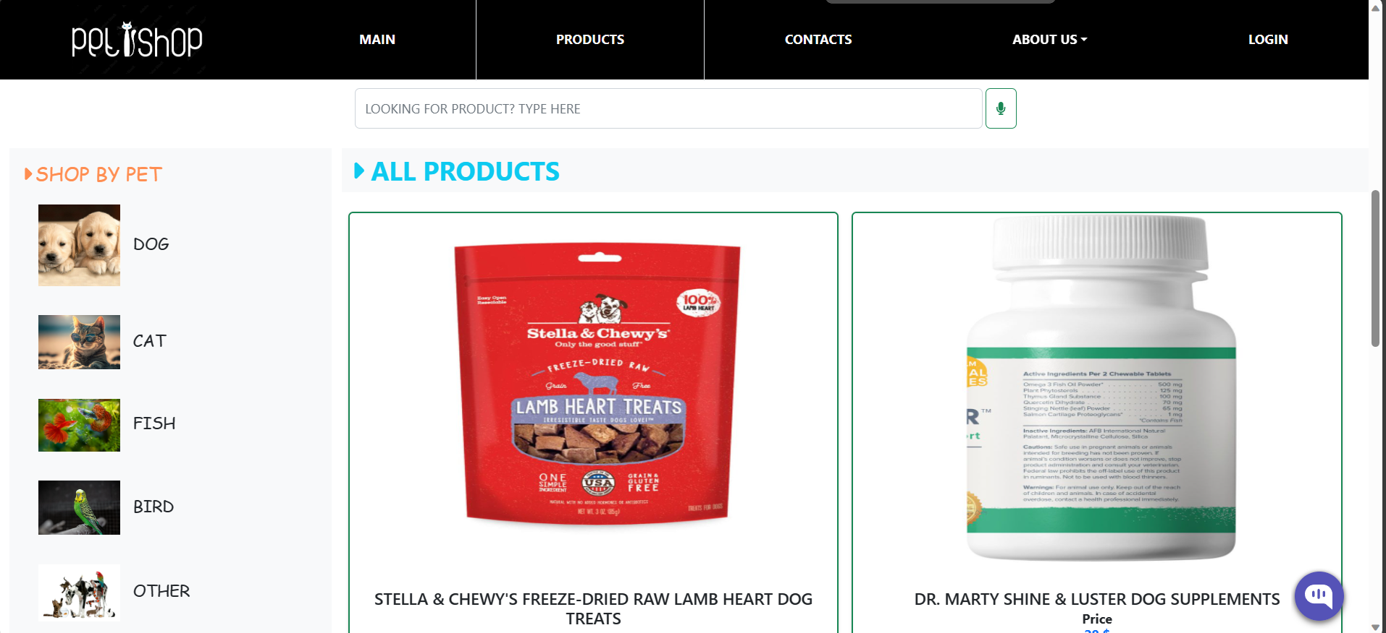

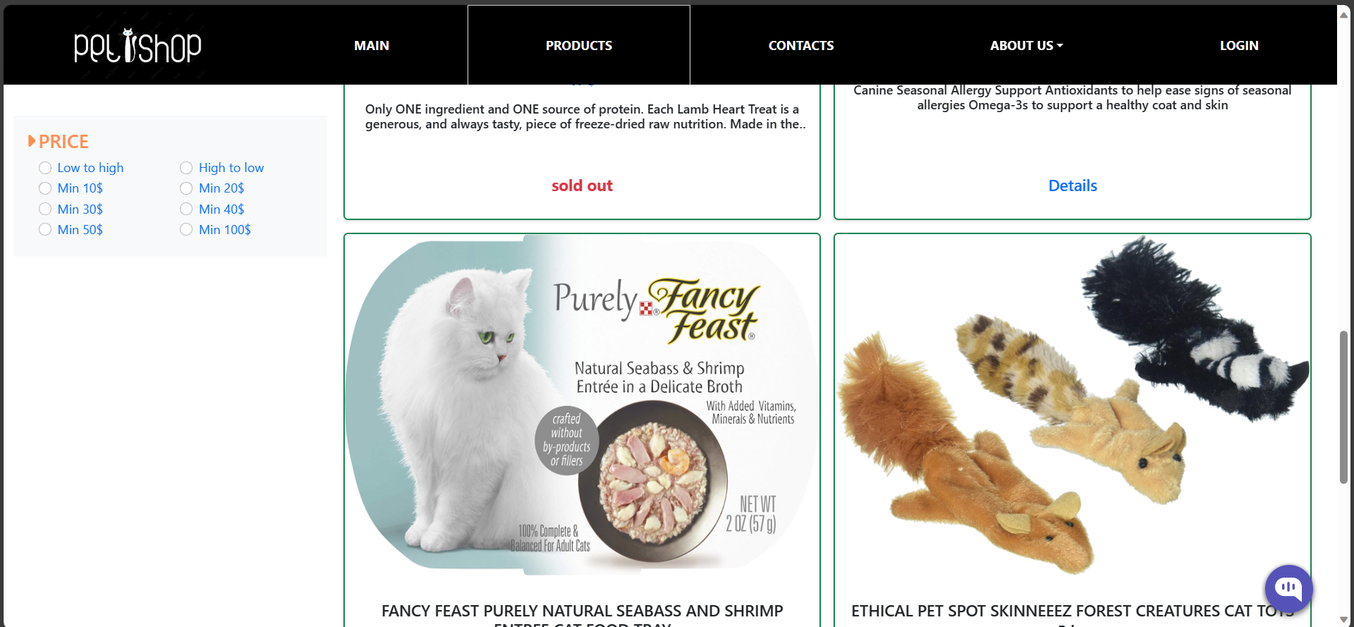

##### Figure 28: Product page interface

Show all products available in the store

#### Search page interface

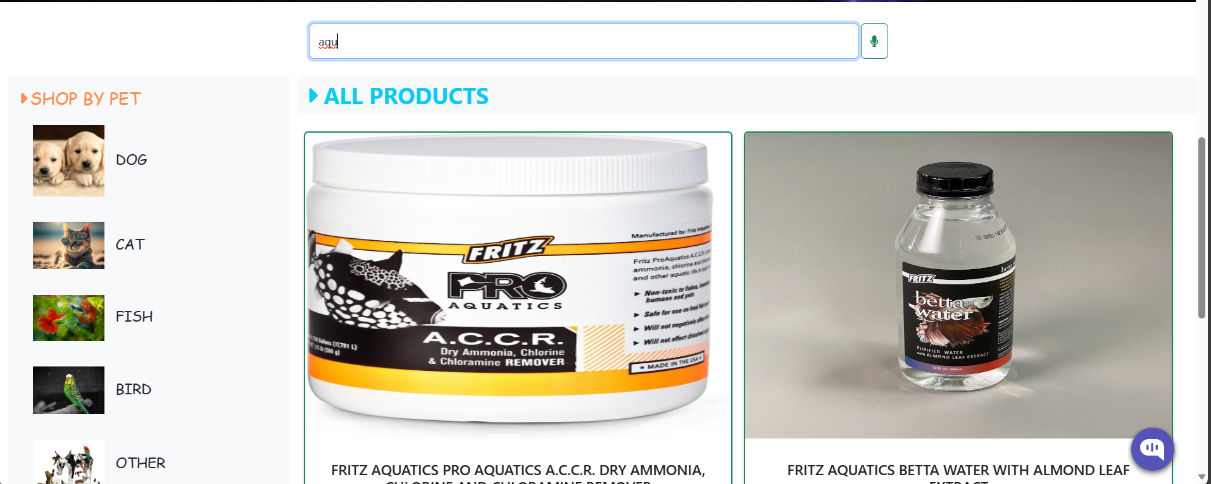

##### Figure 29: Product interface after searching

Display products according to search request

#### Product price filter page interface

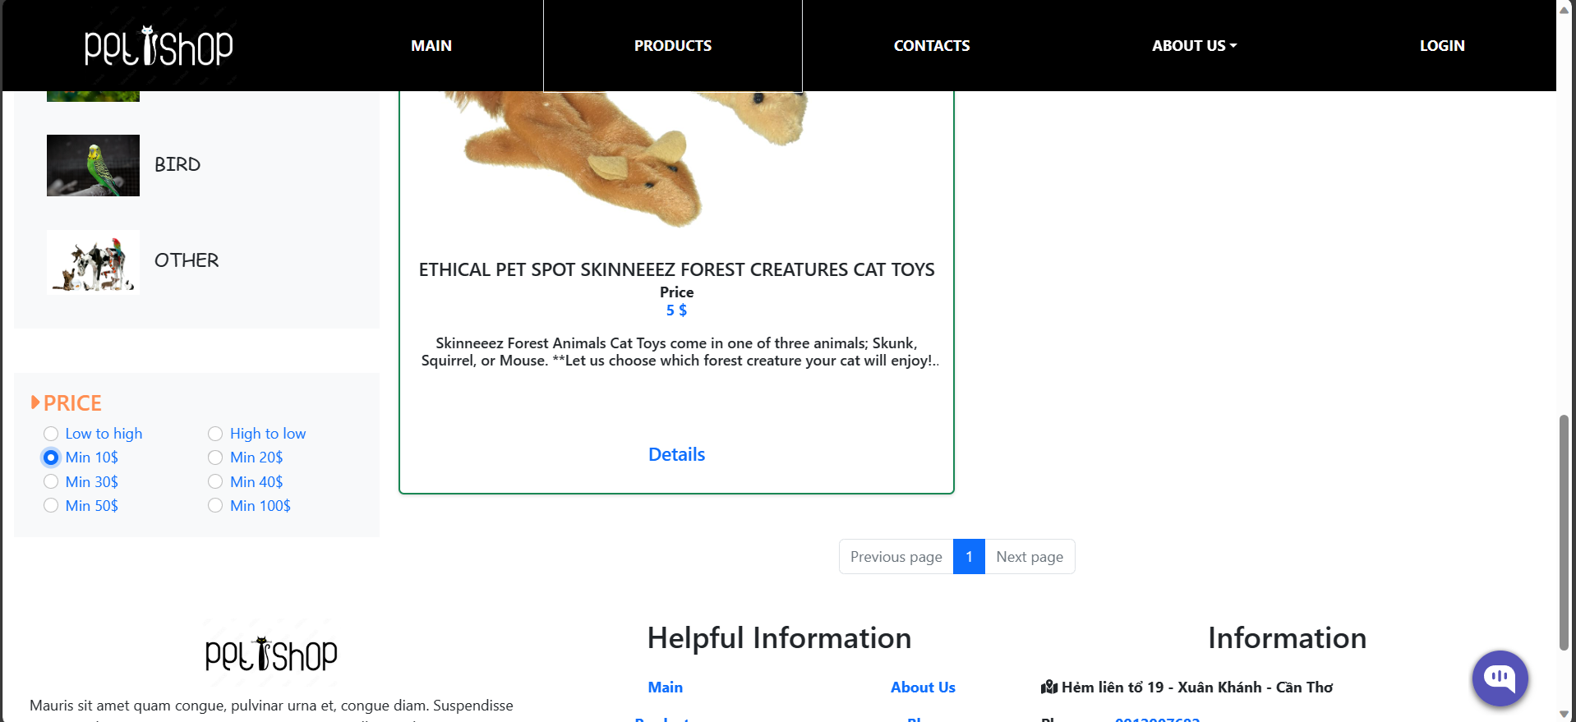

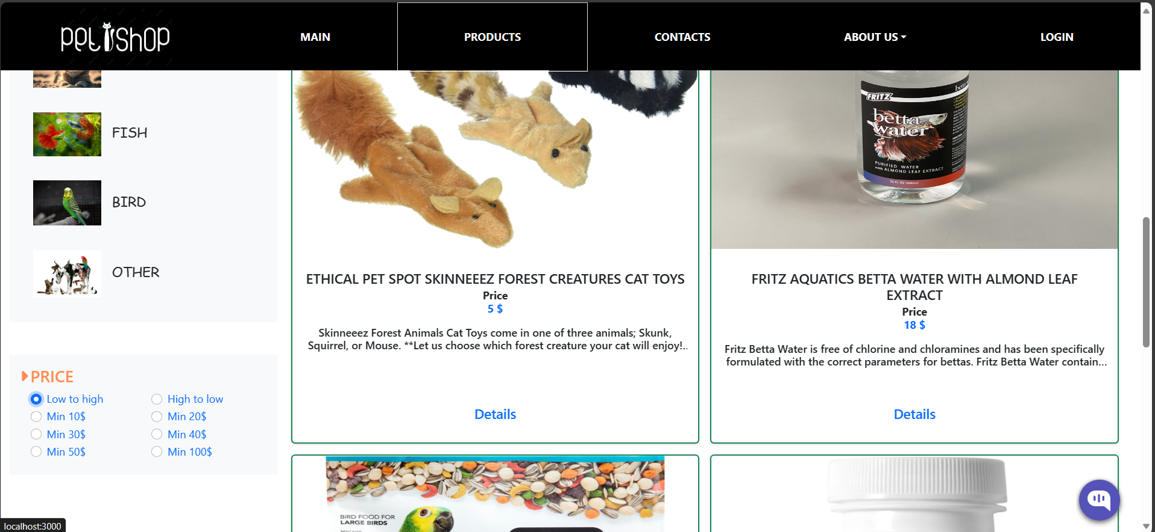

##### Figure 30: Product page interface after filtering by price

Display products according to the price selected by the customer

#### Product detail page interface

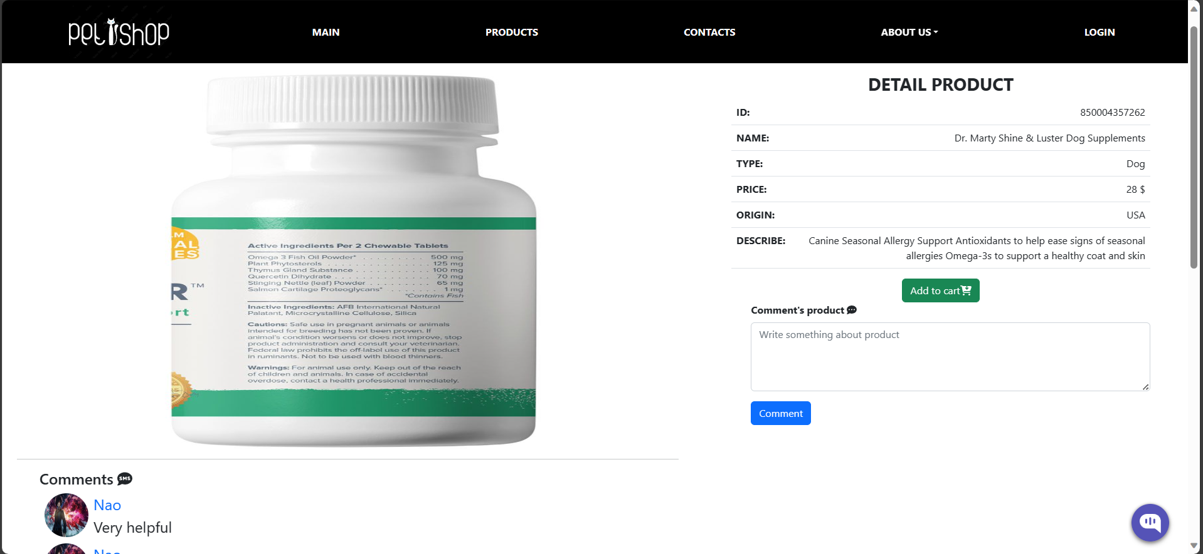

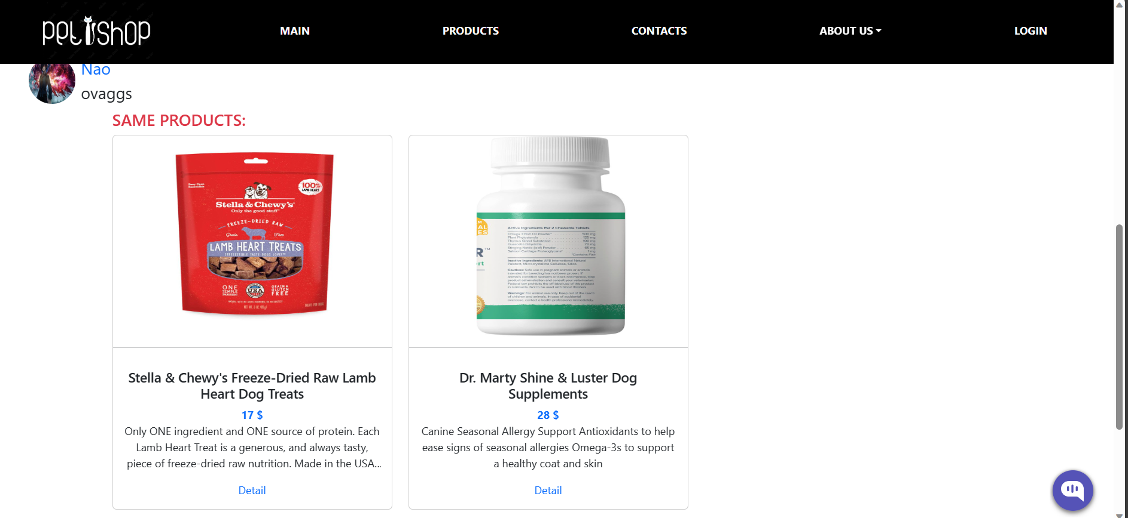

##### Figure 31: Product detail page interface

Display detailed product information, display products of the same type, display product comments

#### Cart page interface

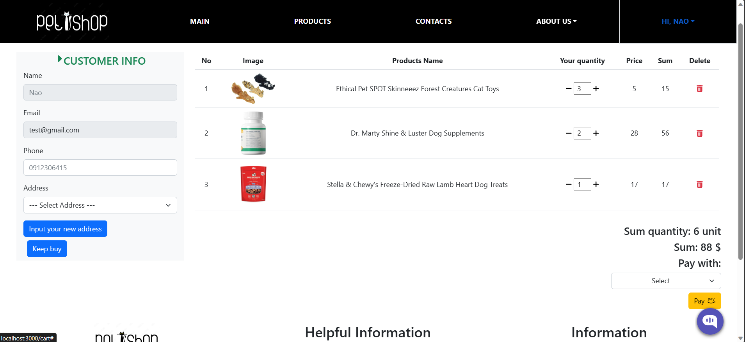

##### Figure 32: Cart page interface

Display product information that customers ordered

#### Paypal payment interface

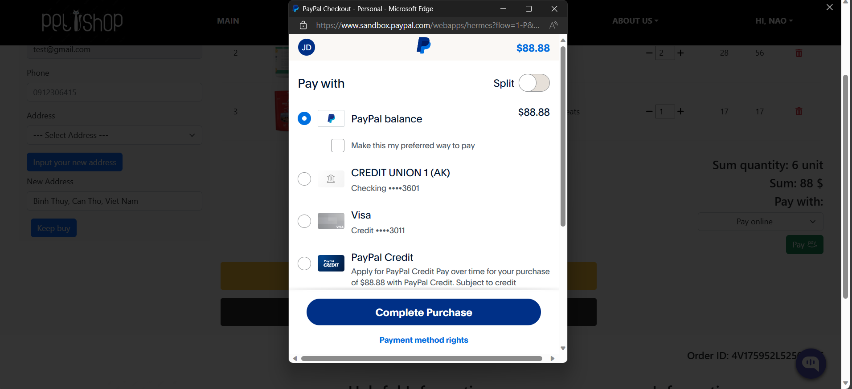

##### Figure 33: Paypal payment interface

Display paypal account information

#### Order page interface

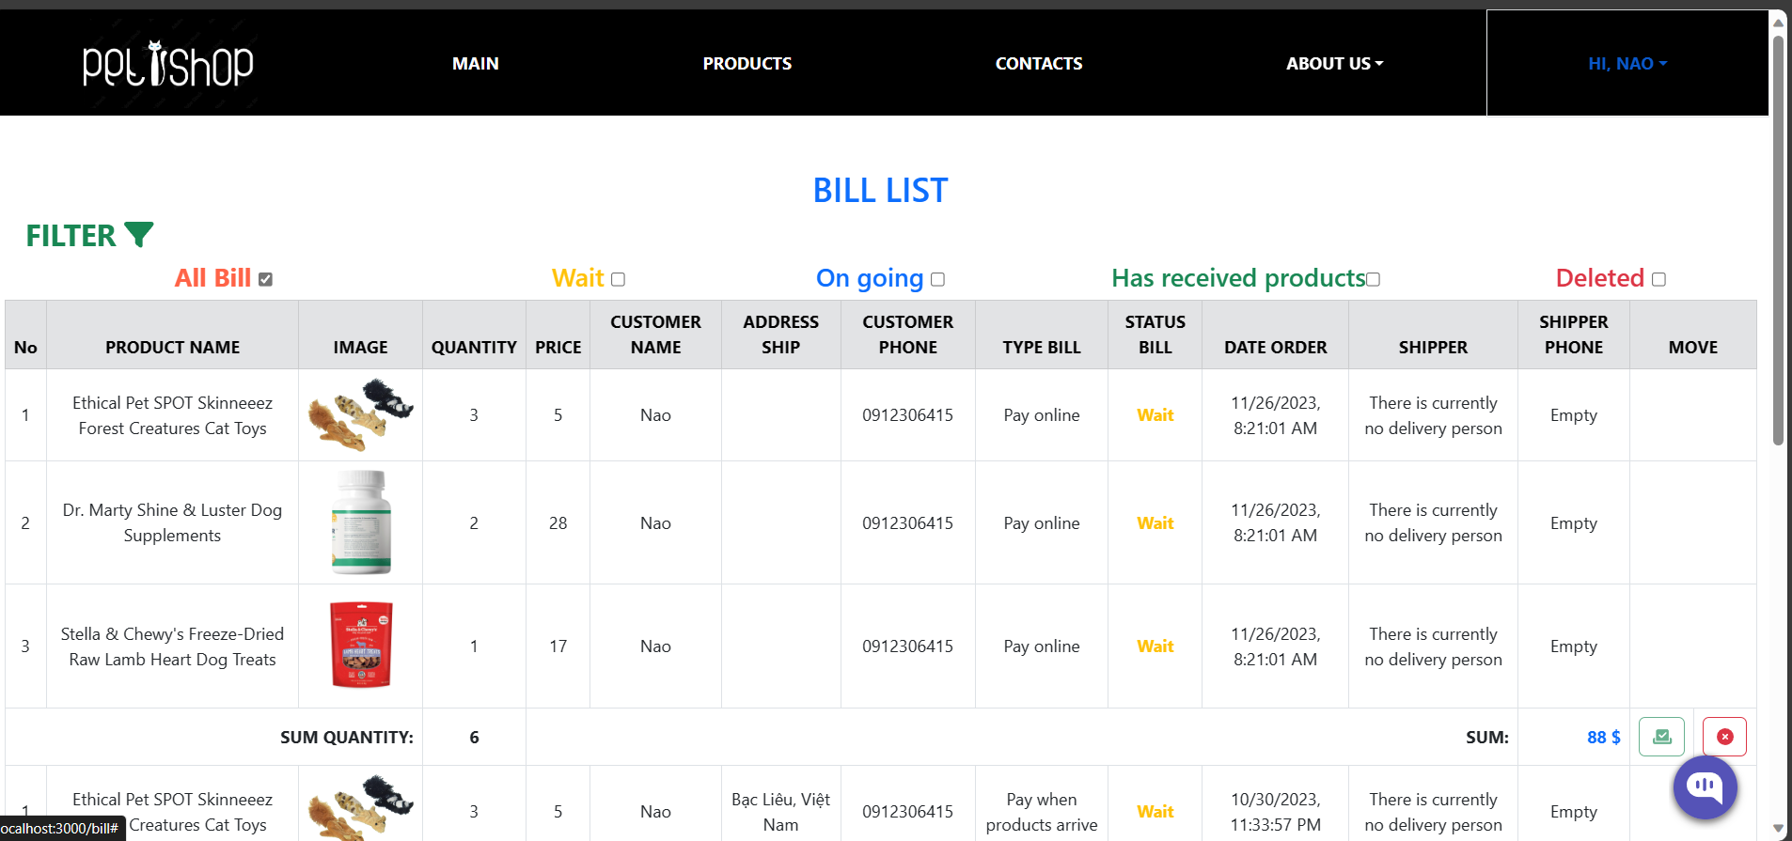

##### Figure 34: Order page interface

Display order list

#### Order page interface after filtering

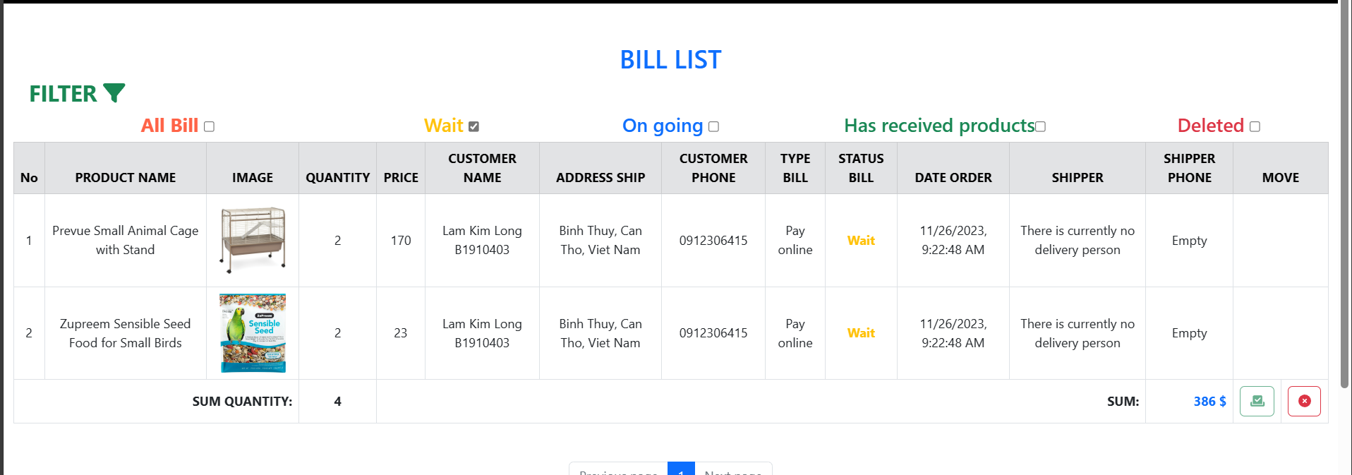

##### Figure 35: Order page interface after filtering "Wait" status

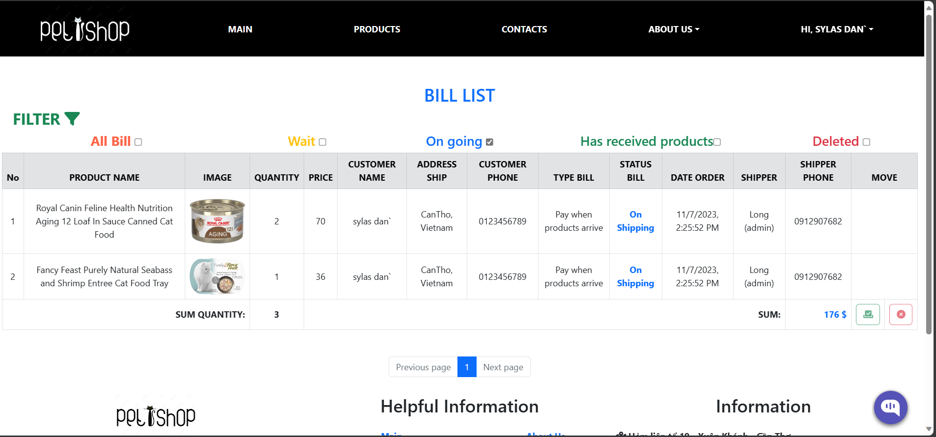

##### Figure 36: Order page interface after filtering "On Shipping" status

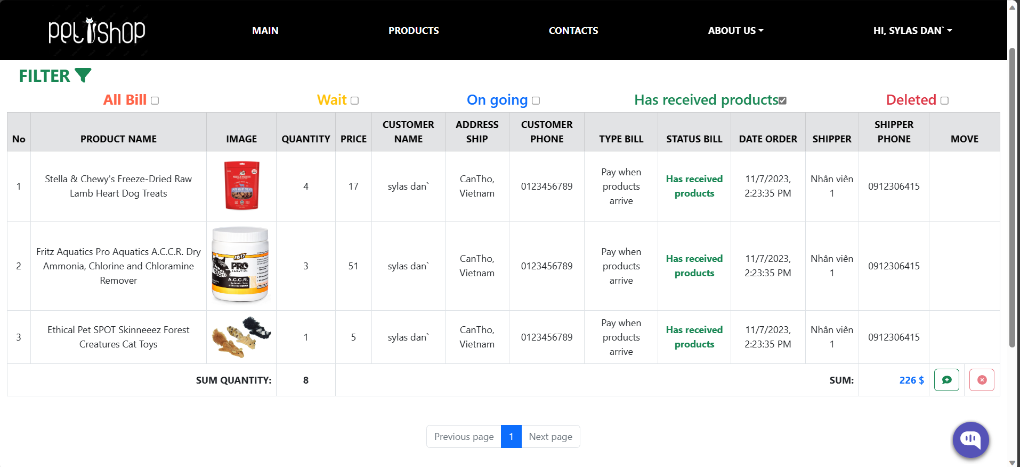

##### Figure 37: Order page interface after filtering the status "Goods received"

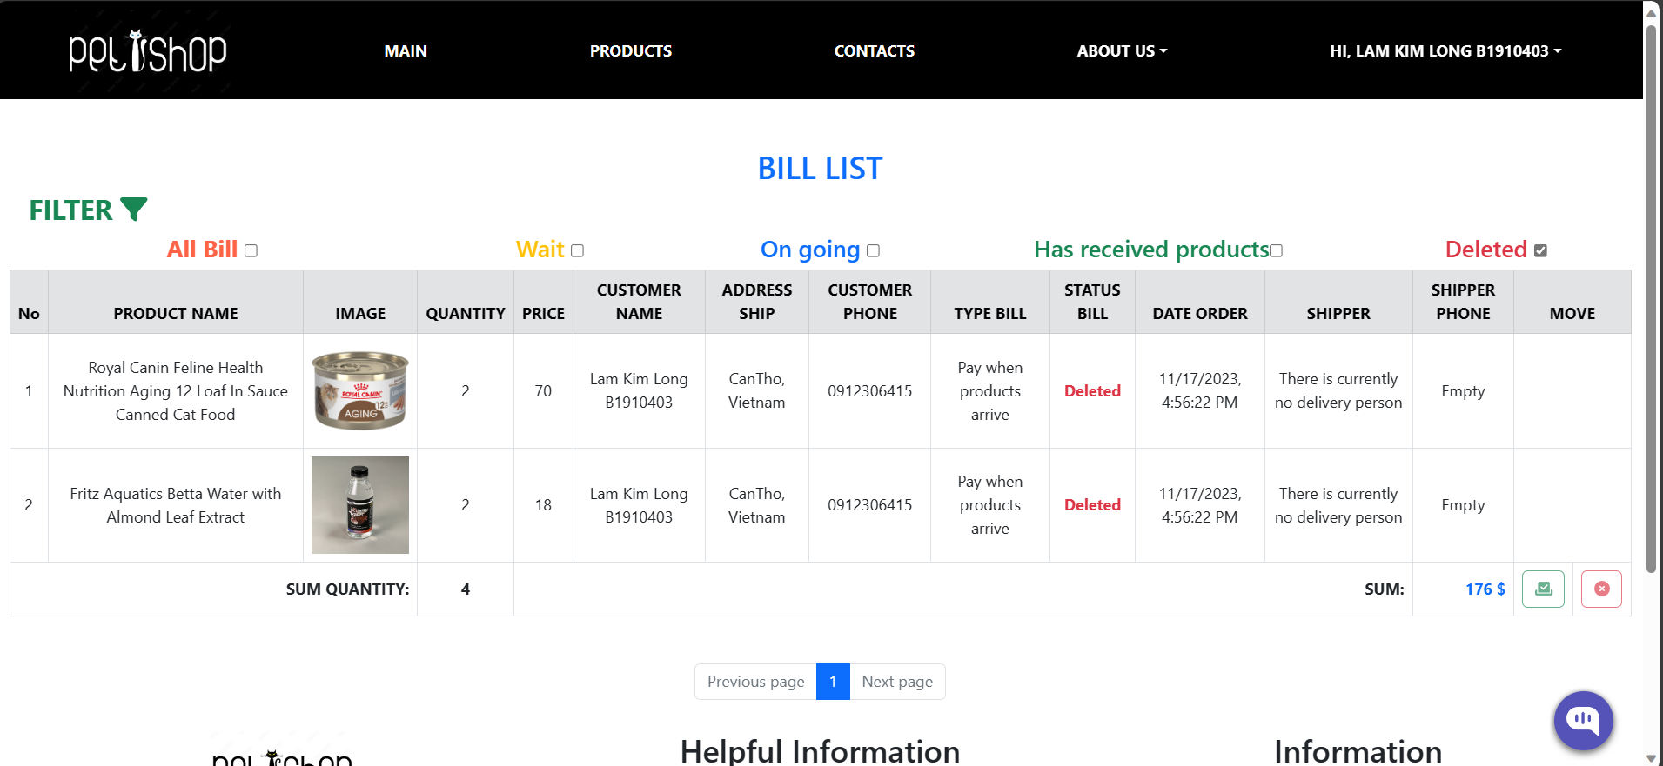

##### Figure 38: Order page interface after filtering "Cancelled" status

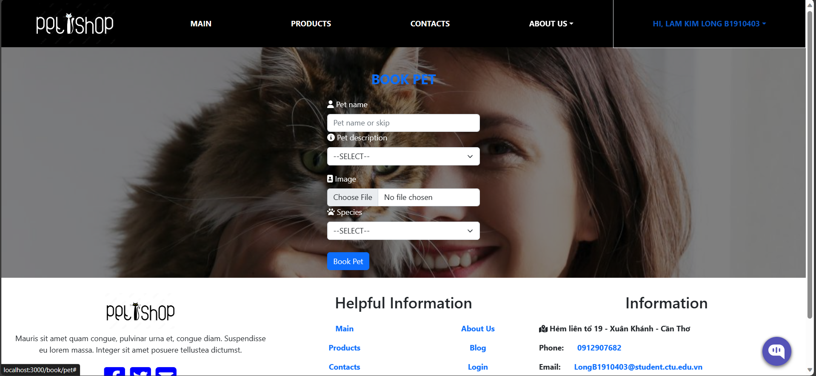

##### Figure 39: Pet appointment booking page interface

#### News page interface

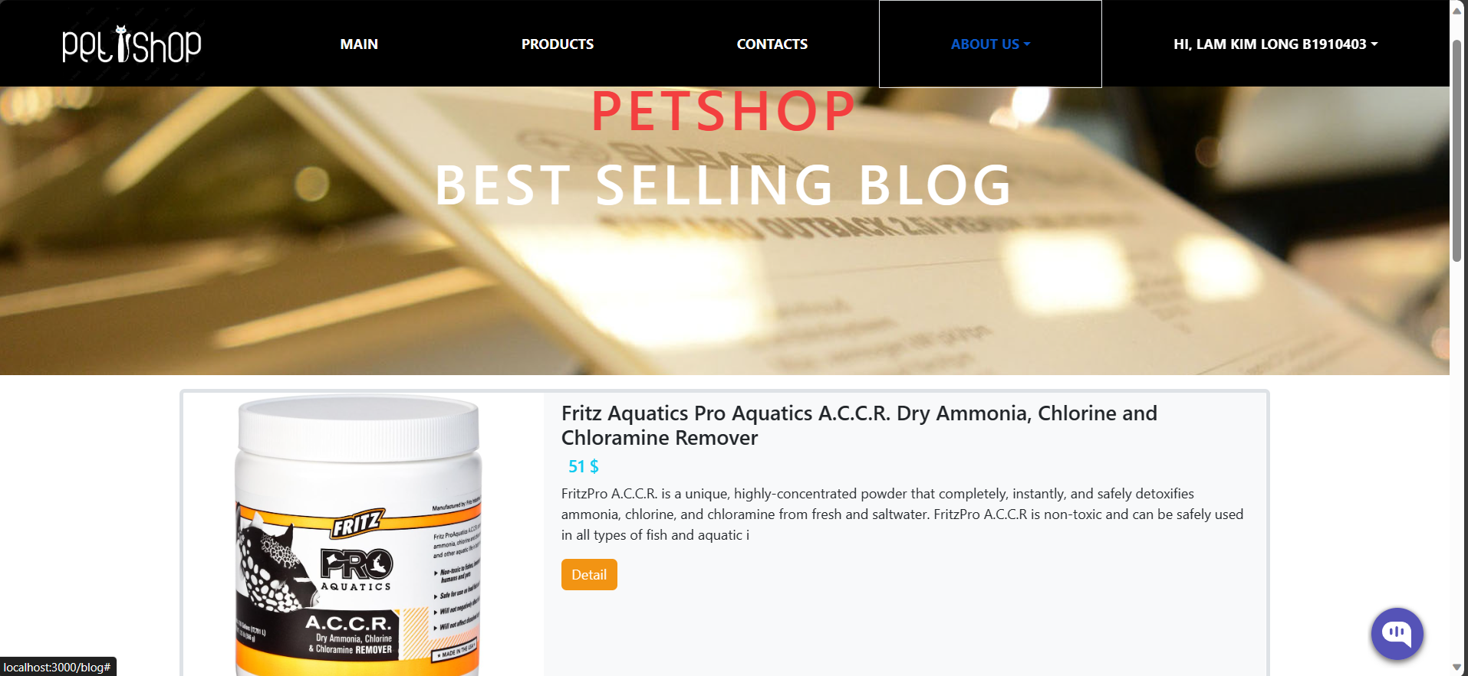

##### Figure 40: News page interface

Displays news about the store.

#### About us page interface

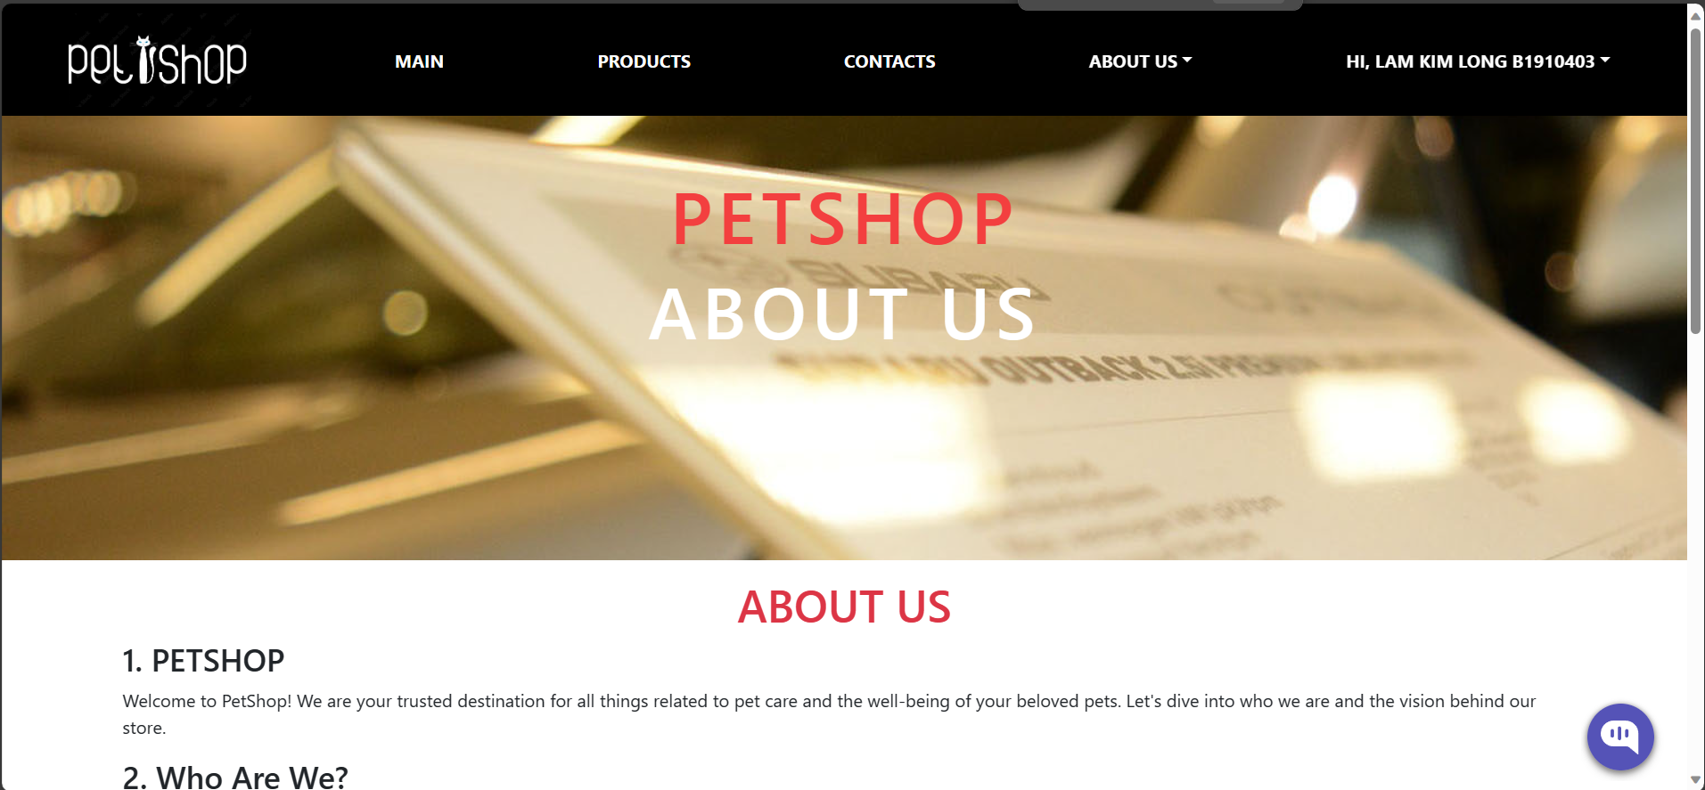

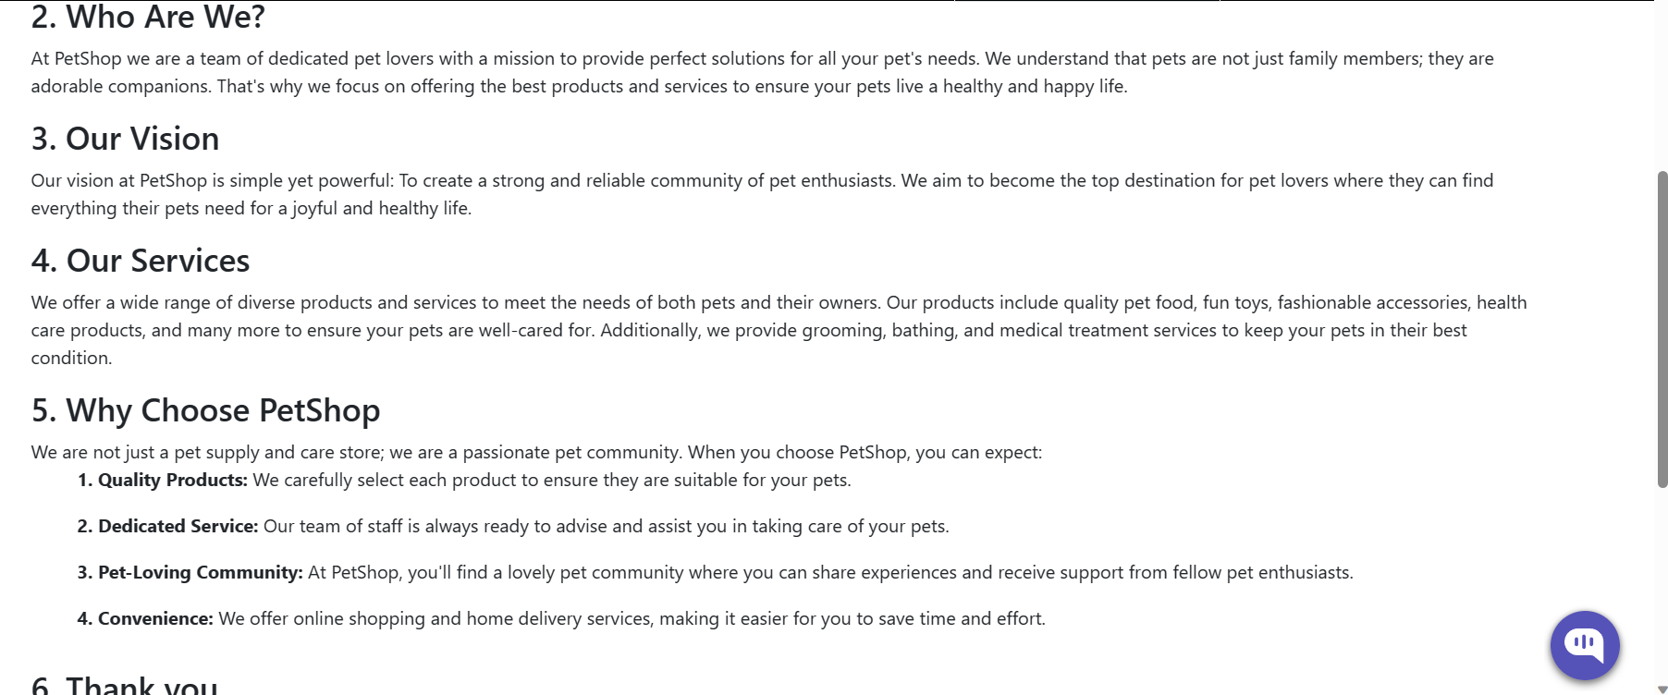

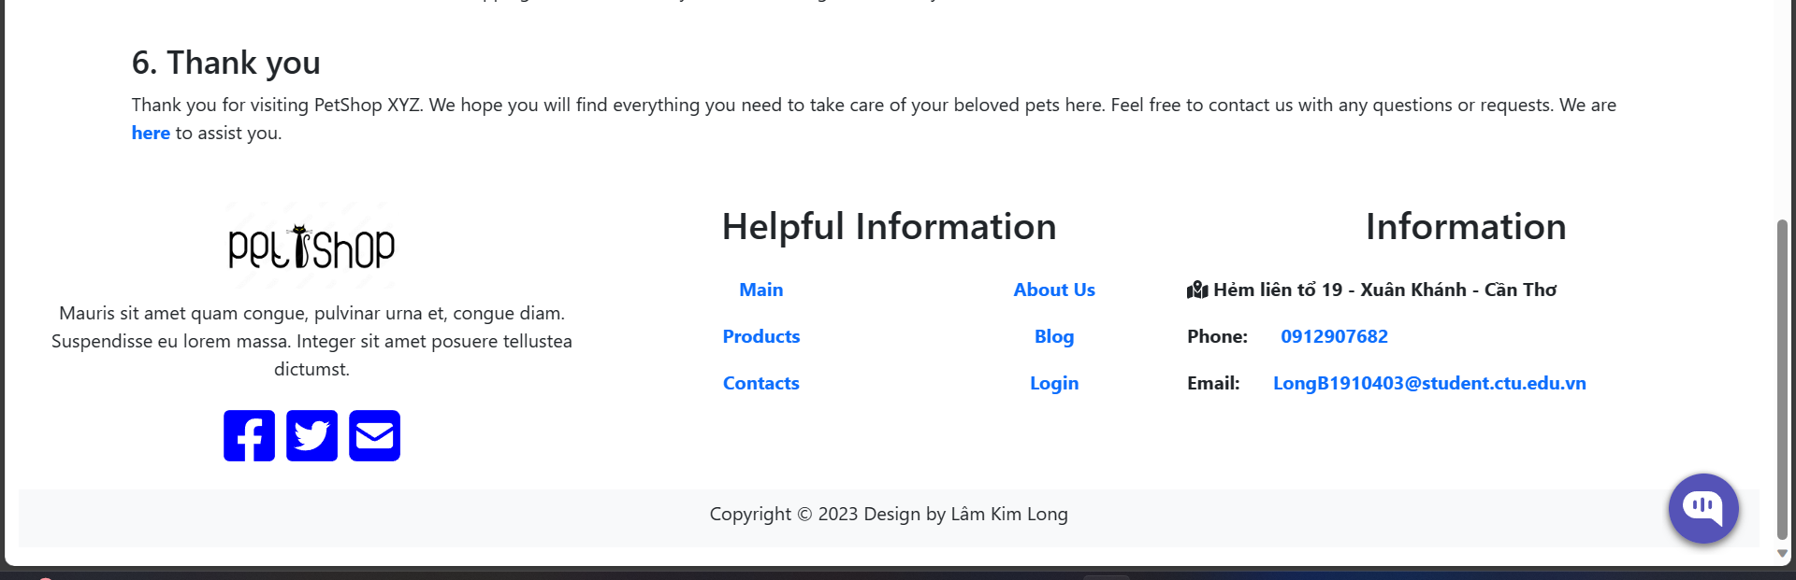

##### Figure 41: About us page interface

Introducing information about the store

### Staff interface

#### Employee login page interface

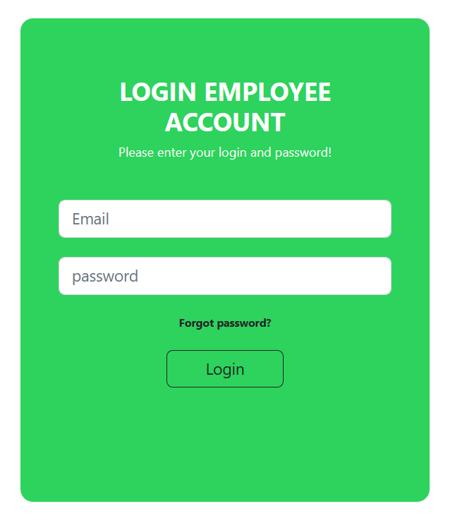

##### Figure 42: Employee login page interface

Employees enter their account and password to log in

#### Interface of employee order list page

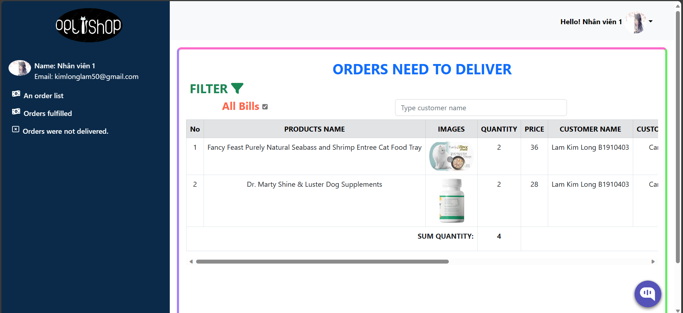

##### Figure 43: Interface of all employee order list page

All orders that an administrator has given an employee permission to complete. Workers are free to accept or reject directives that the administrator has approved.

#### Interface of employee's delivered orders page

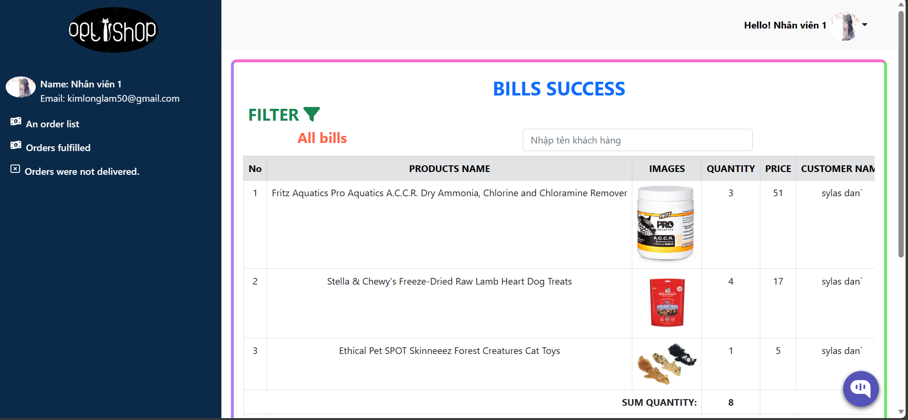

##### Figure 44: Interface of the employee's successfully delivered orders page

Displays all orders that that employee successfully delivered to customers.

#### Interface of the employee's failed delivery order page

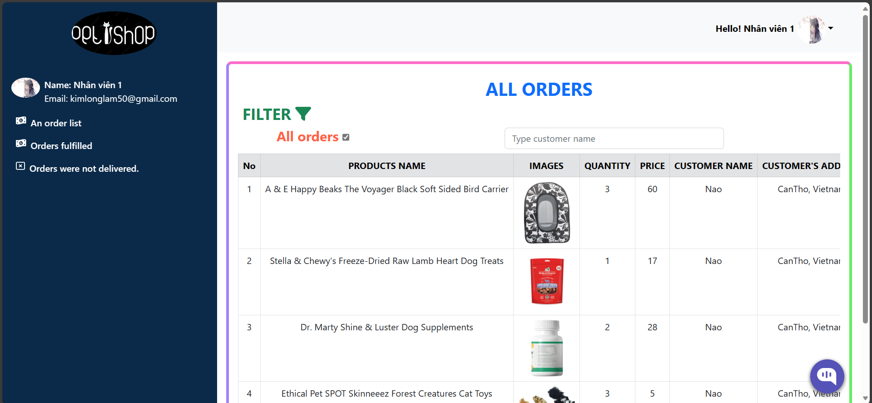

##### Figure 45: Interface of the employee's failed delivery order page

Displays all orders that the employee failed to deliver.

### Administrator interface

#### Administrator login page interface

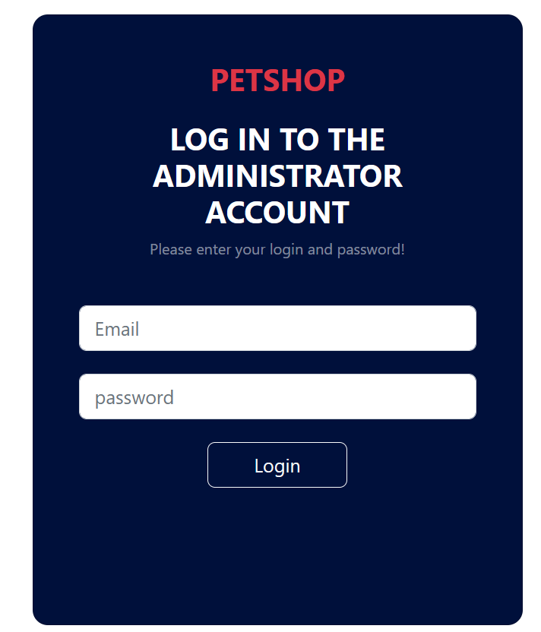

##### Figure 46: Admin login page interface

Admin enters account and password to log in to the store management system

#### Store dashboard interface

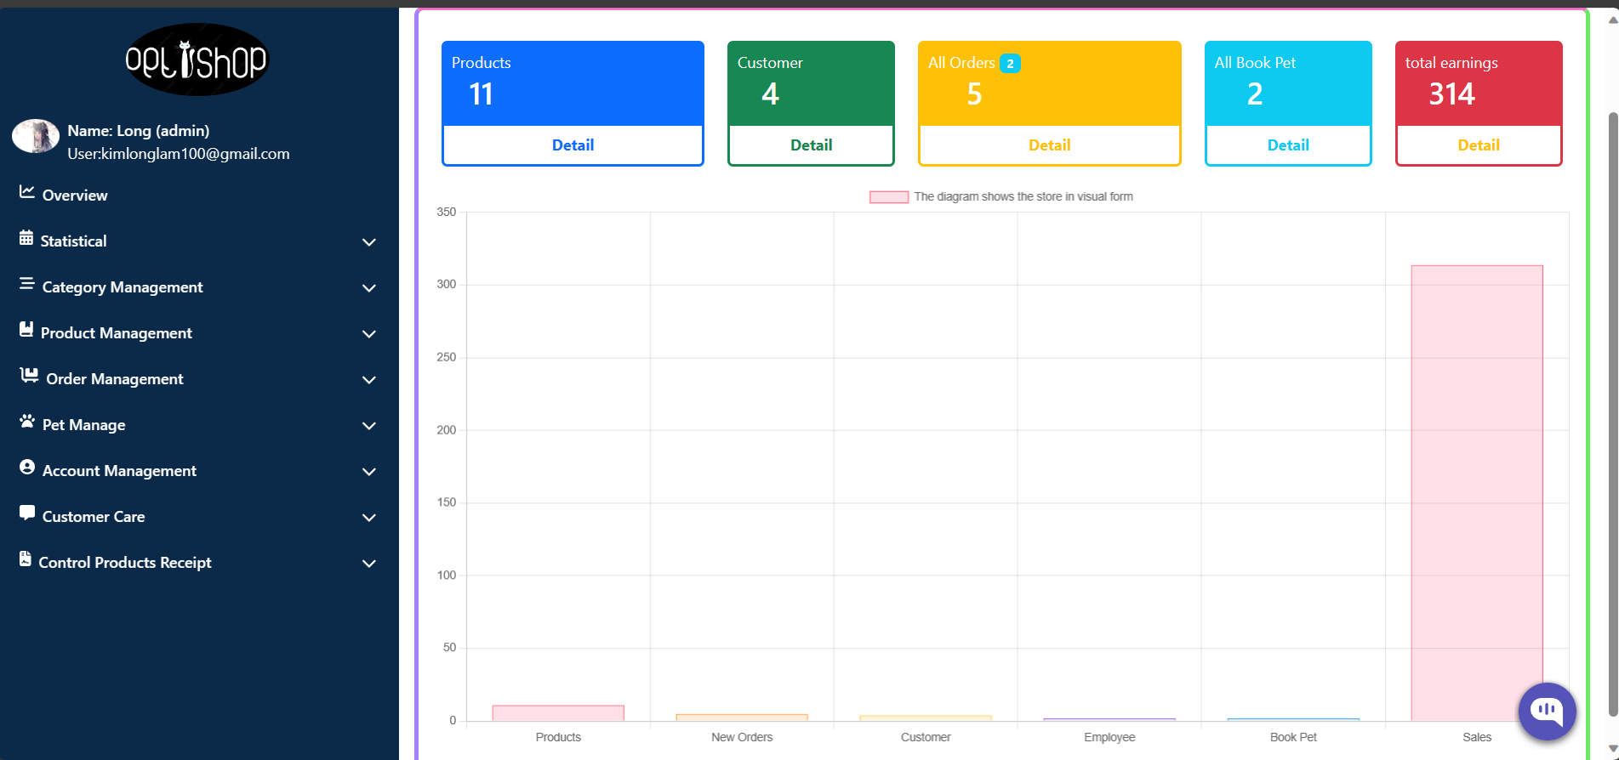

##### Figure 47: Store dashboard interface

Present data about the store in a visual manner, such as the total number of items, the number of patrons, the number of staff members, the number of orders, the number of new orders, and the total sales income.

#### Interface of profit statistics page for all products over time

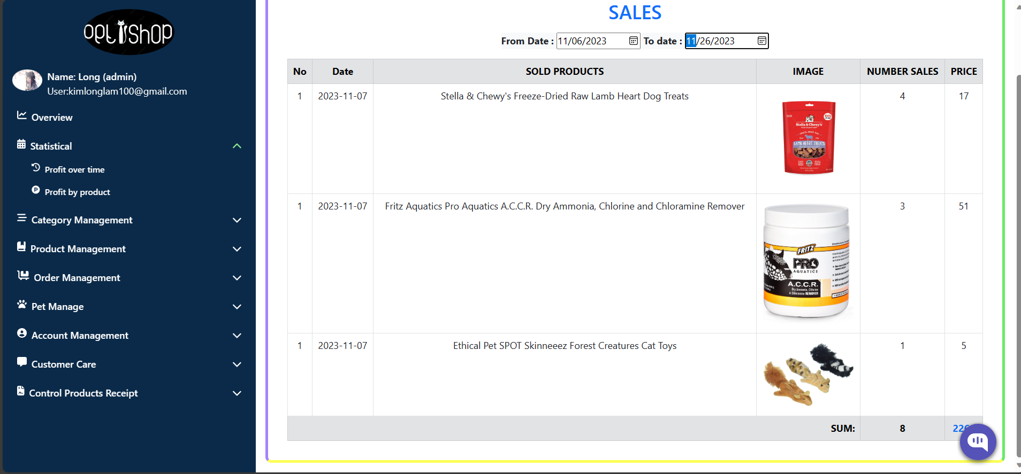

##### Figure 48: Interface of profit statistics page over time

Display information about sold products and profits within the required time period.

(eg: June 11, 2023 – November 26, 2023)

#### Interface of profit statistics page for each product

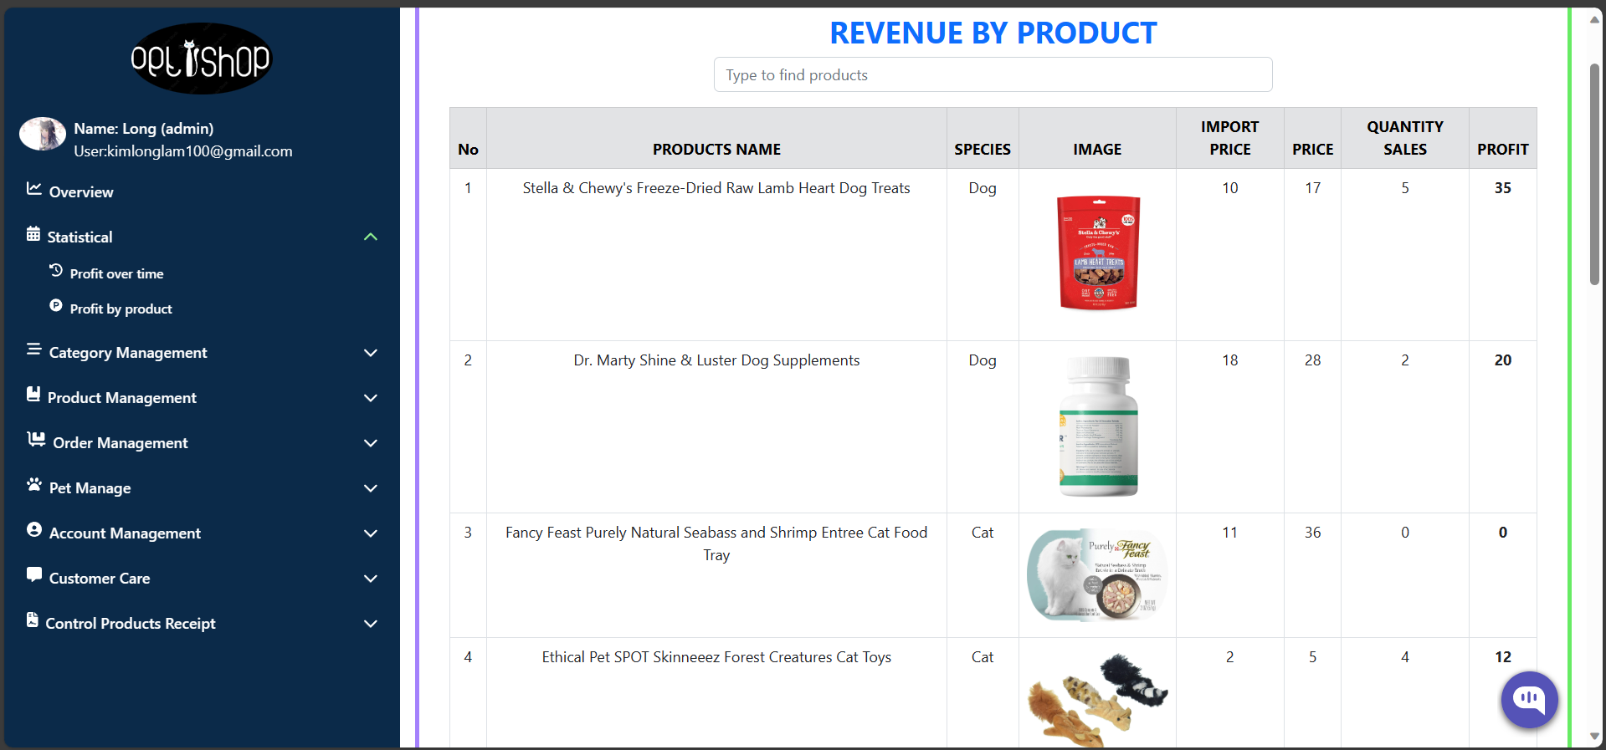

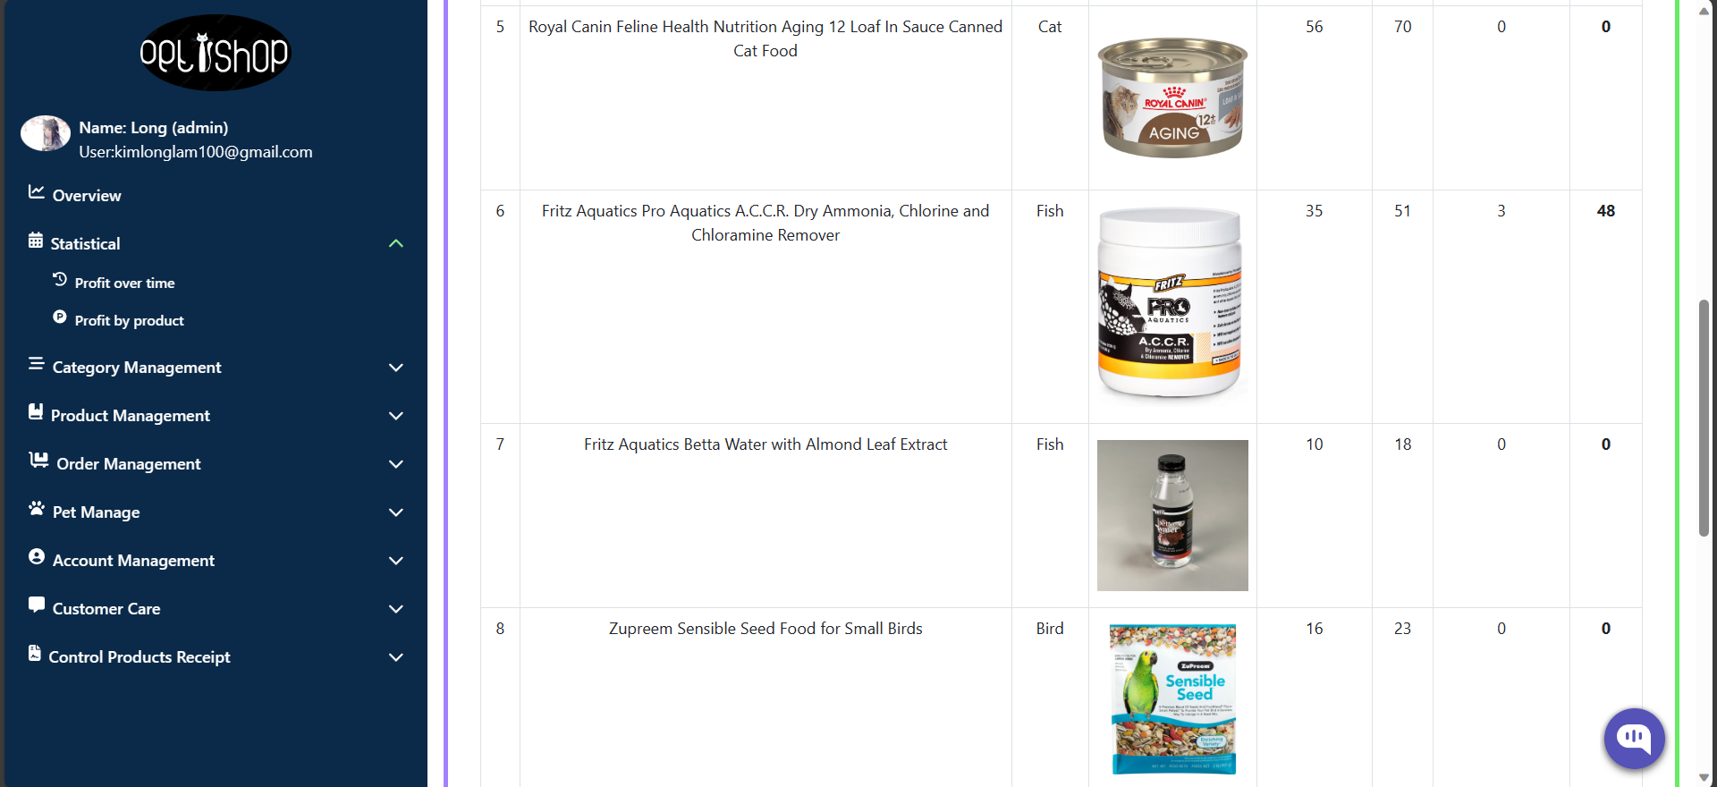

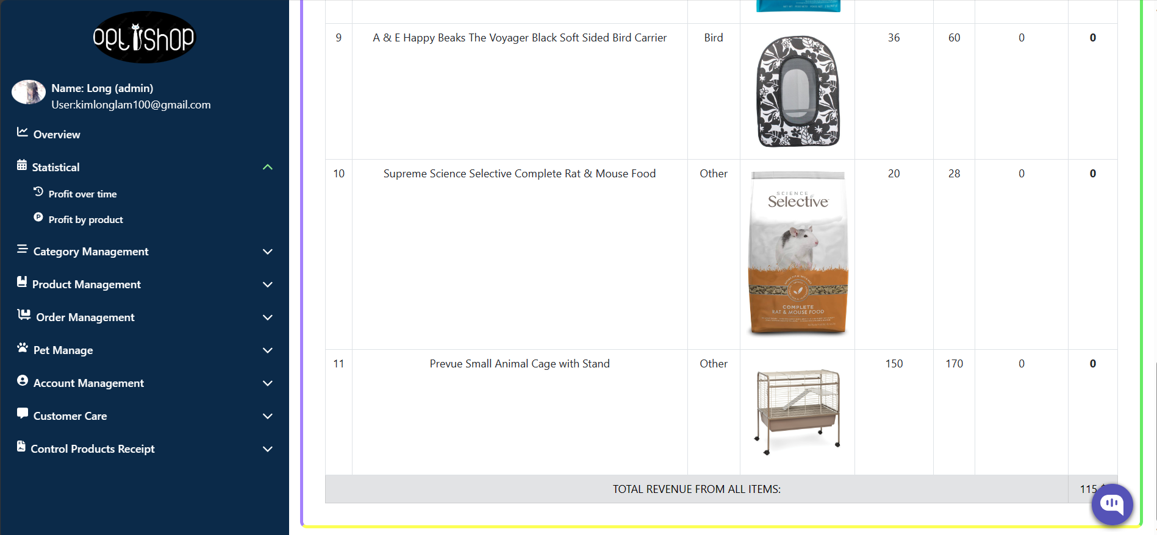

##### Figure 49: Total profit of all products

shows product profits as well as the amount sold, the selling price, and the profit margin for each individual product. Lastly, show the overall profit from all of the store's sales.

#### Product catalog management page interface

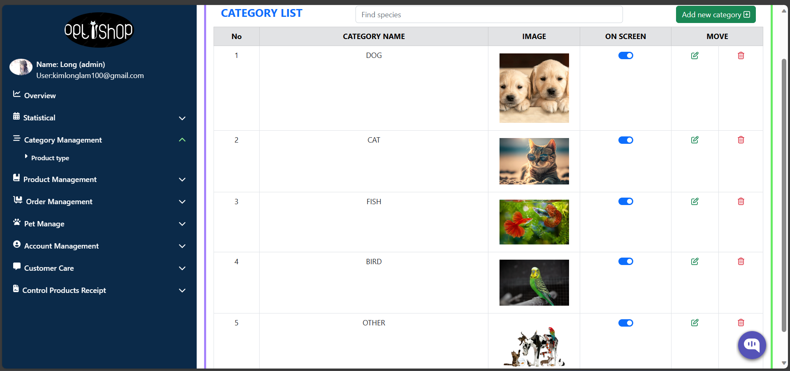

##### Figure 50: Product category management page interface

Shows every category of products that the store sells.

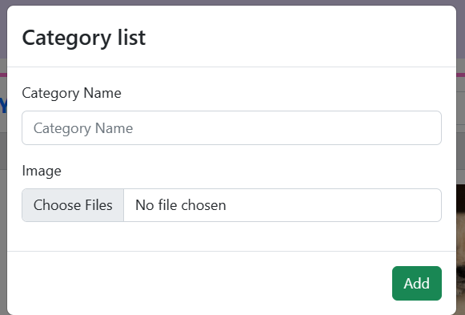

##### Figure 51: Adding a new category

Admin enters information and presses the add button to add a new category

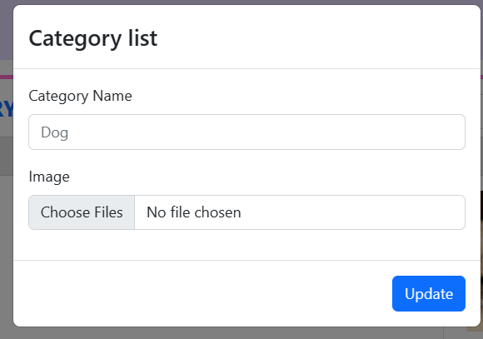

##### Figure 52: Editing category information

Admin presses the update button to update the category information

#### Product management page interface

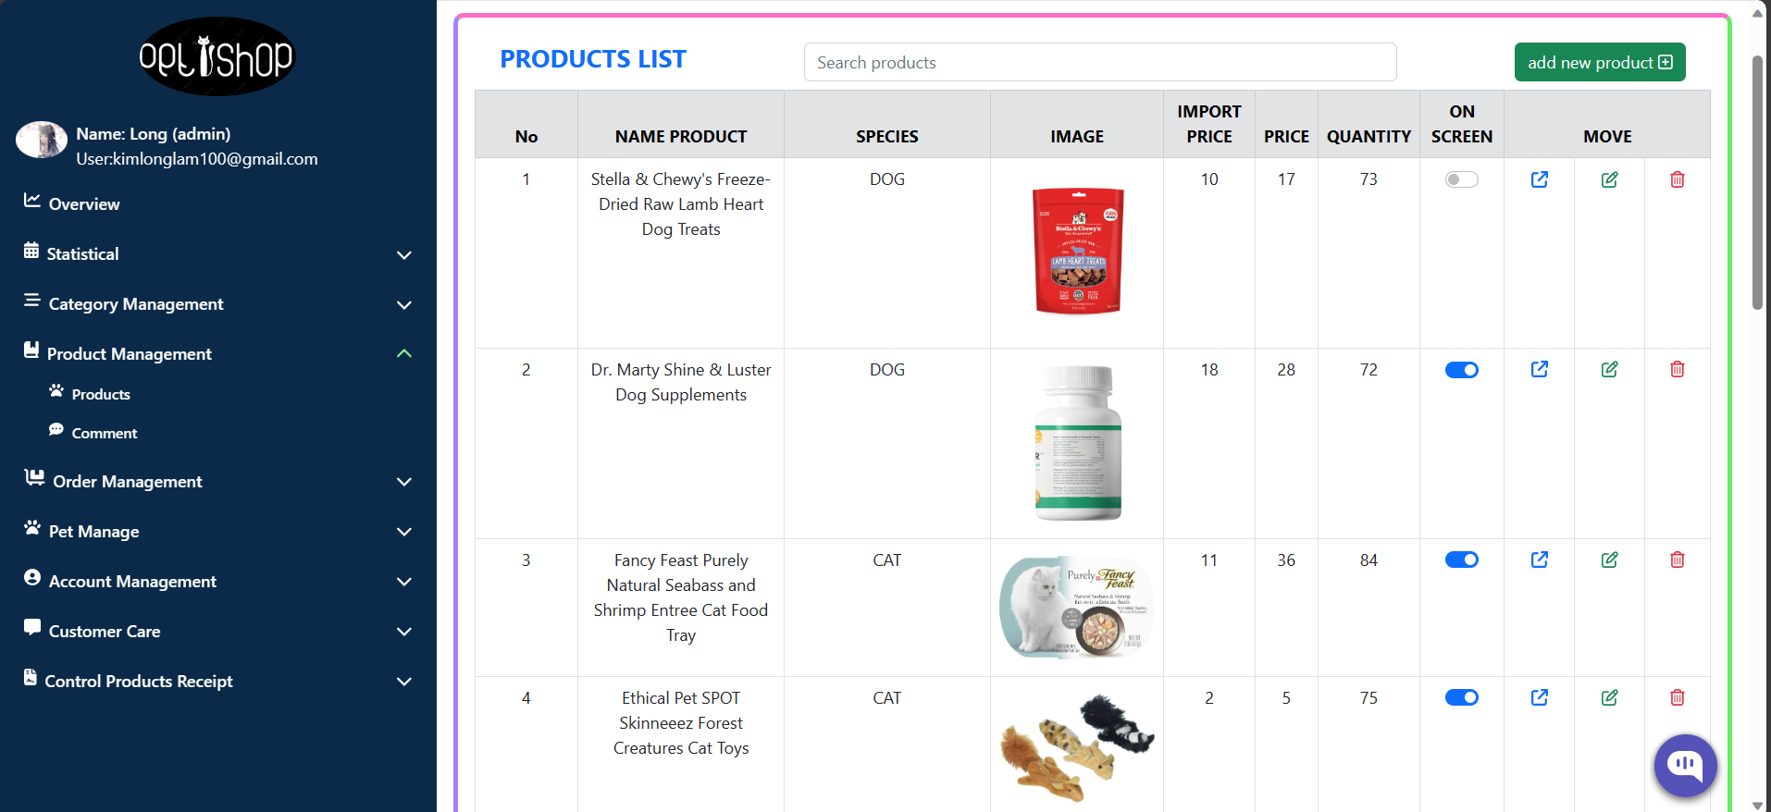

##### Figure 53: Product management page interface

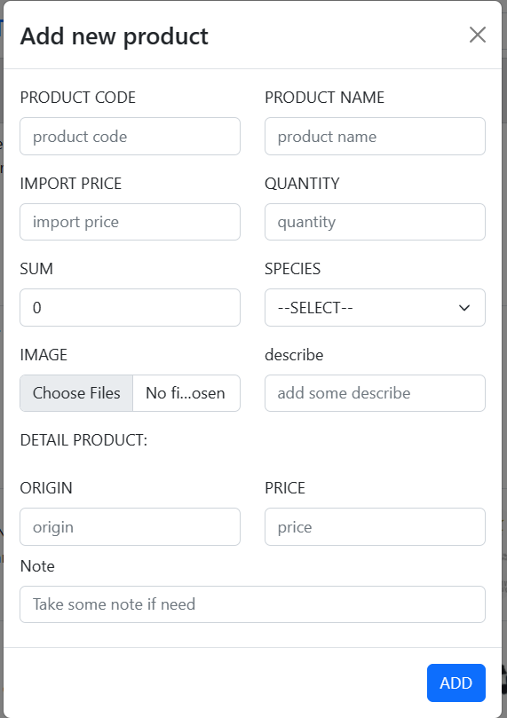

##### Figure 54: Product adding page interface

Admin enters all information and presses the add button to add the product

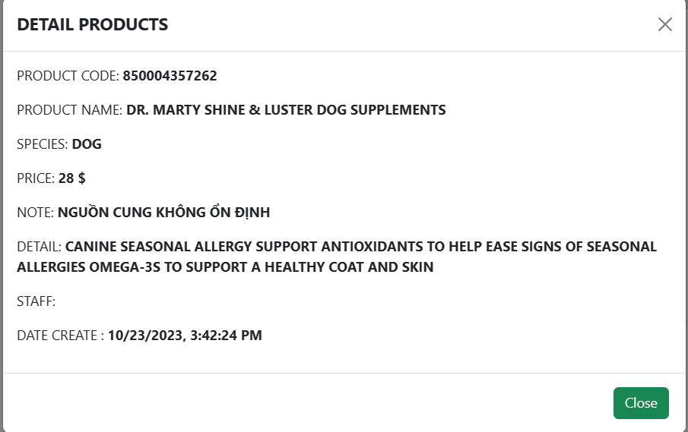

##### Figure 55: Image interface to view product details

Show product details

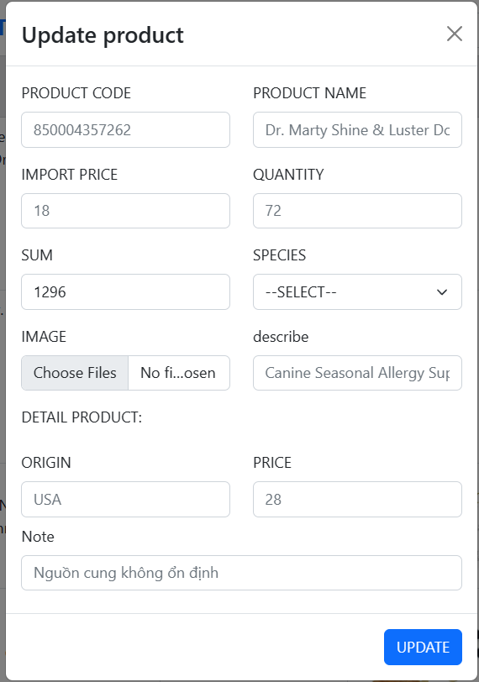

##### Figure 56: Product information update interface

Admin enters the information that needs to be updated then presses the update button to update the product information

#### Product comment management page interface

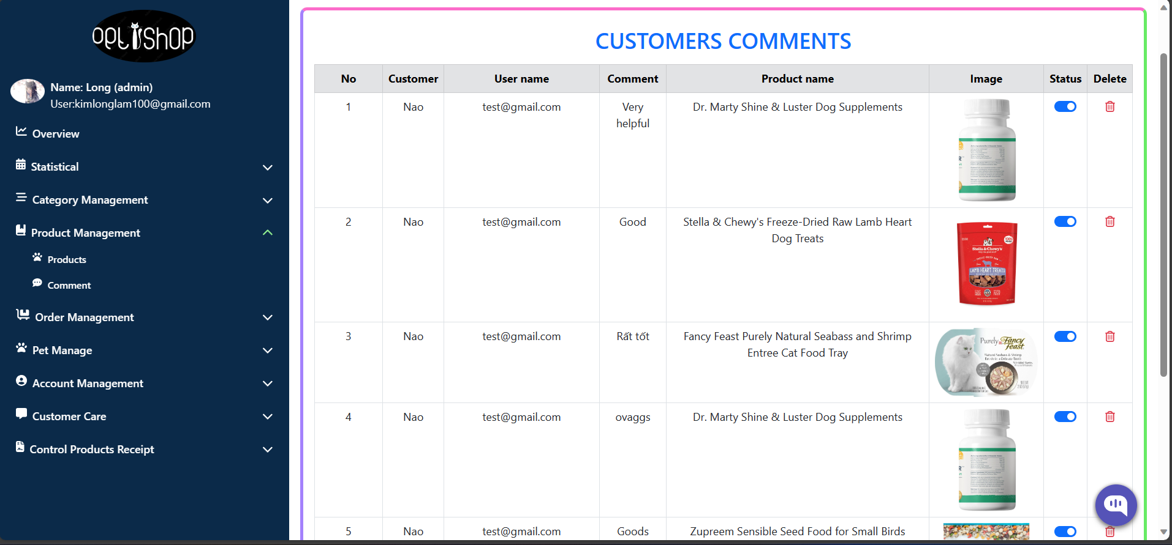

##### Figure 57: Product comment management page interface

#### Customer care page interface

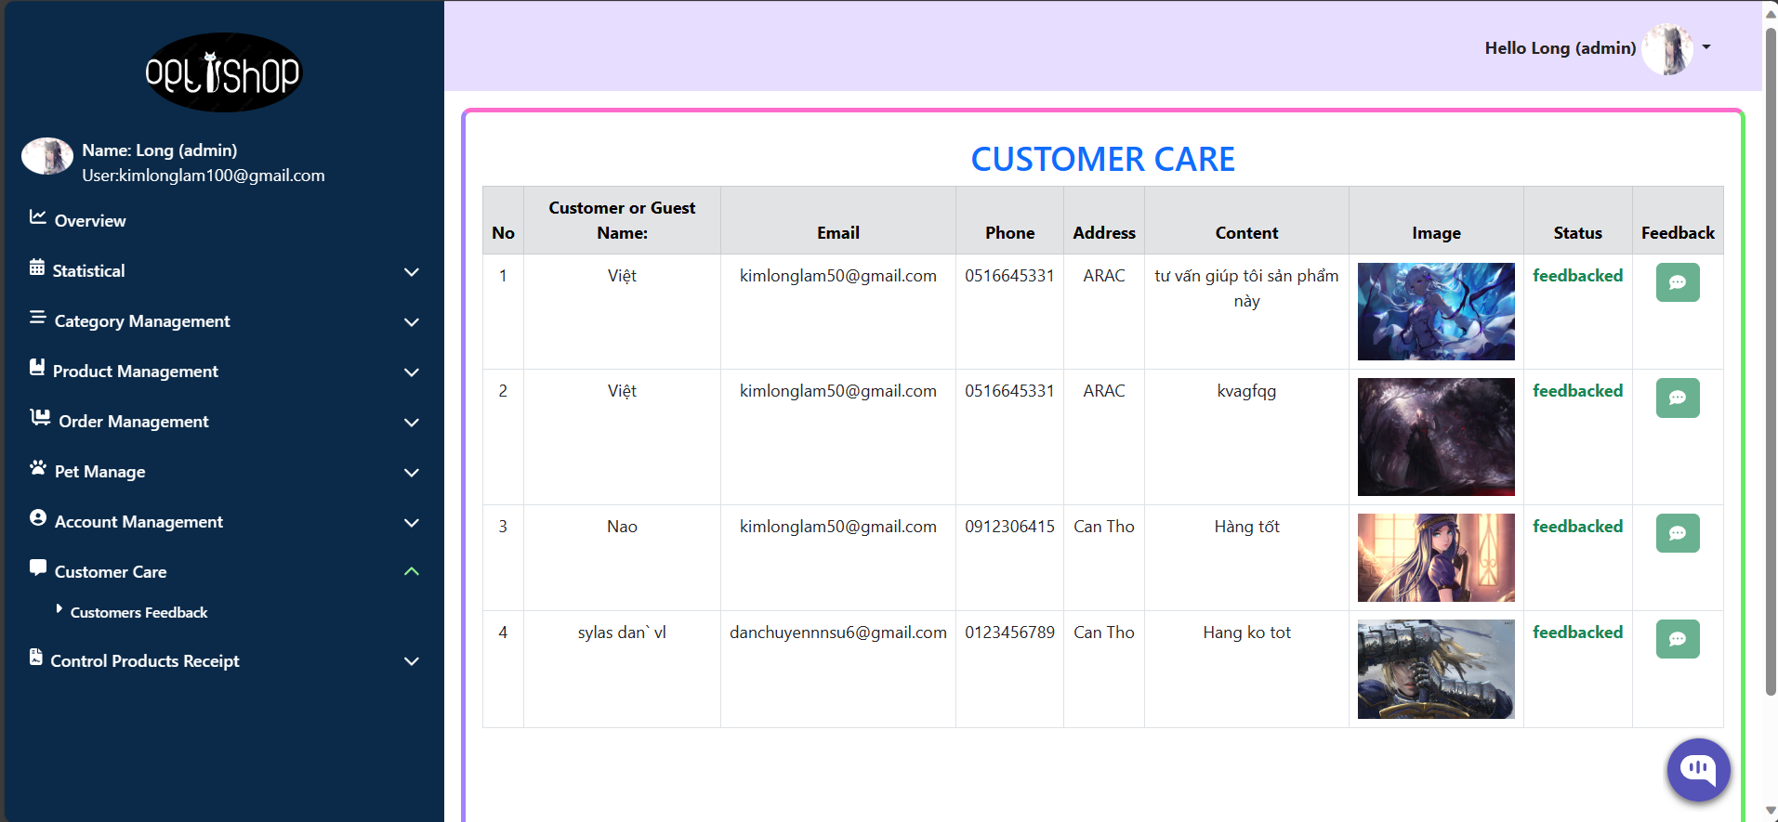

##### Figure 58: Customer care page interface

Admin responds to customers' questions, requests for information, and customer reviews about service or product quality.

#### Order management page interface

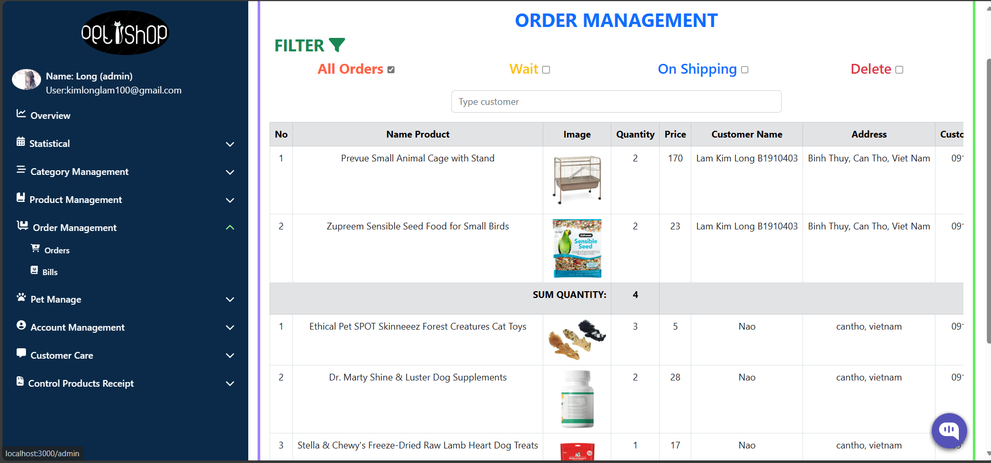

##### Figure 59: Order management page interface

Display all newly arrived orders, awaiting confirmation, in progress, and canceled orders for admin to divide work

#### PDF invoice export interface

**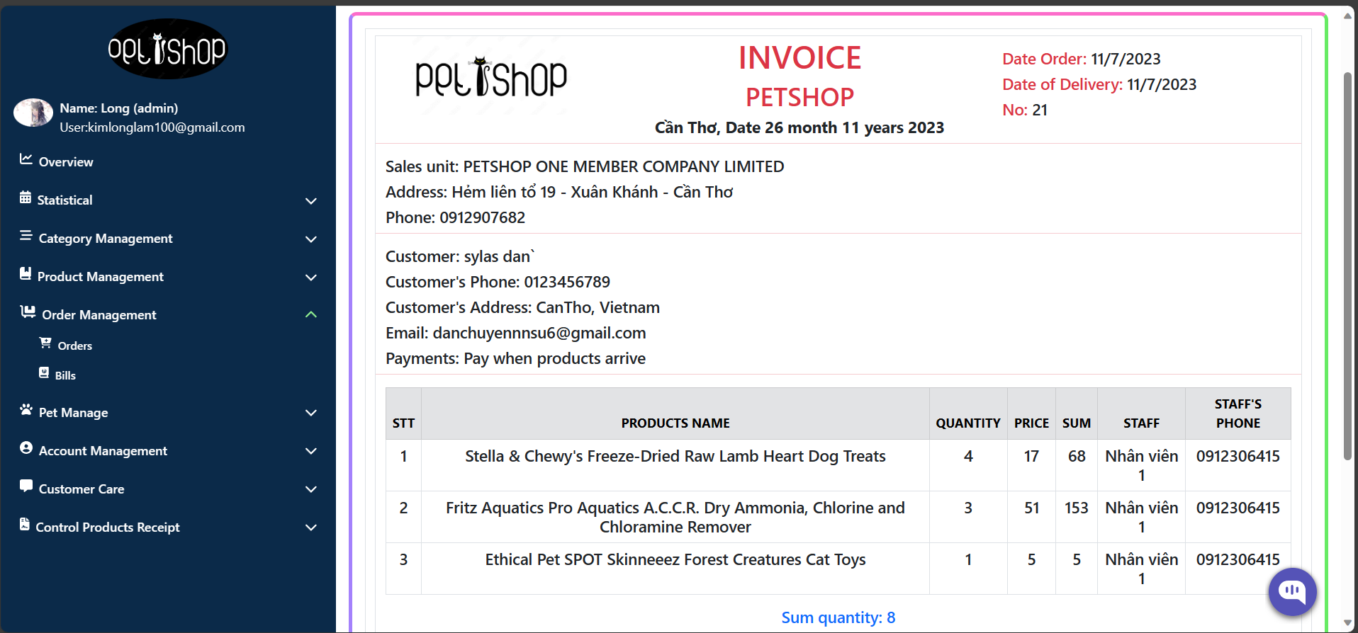  
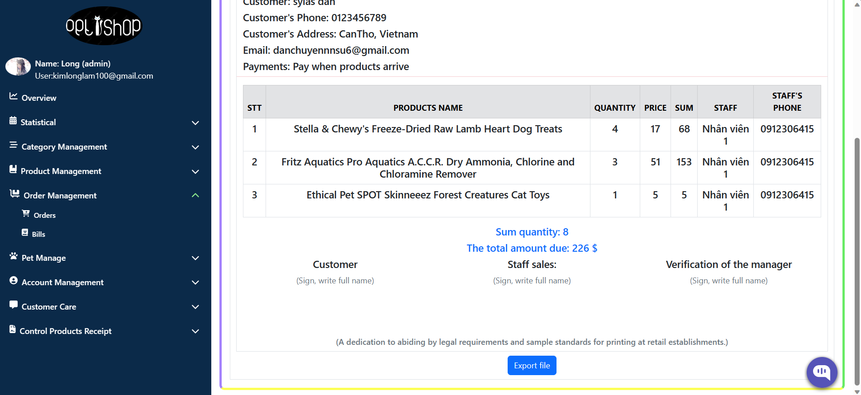  
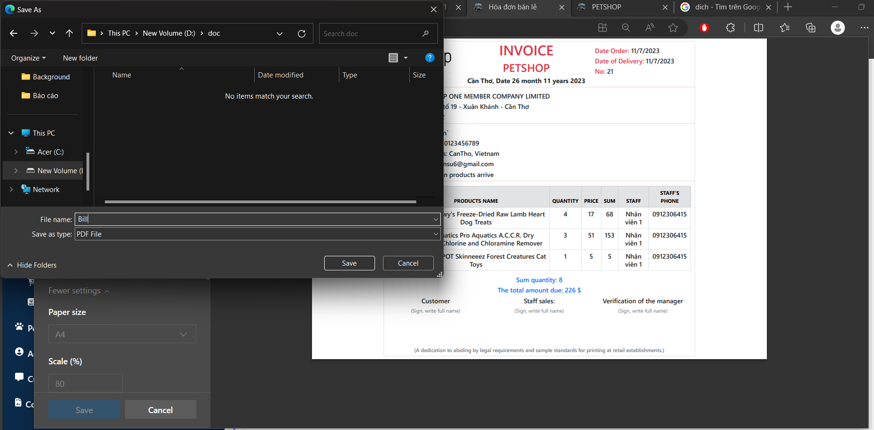  
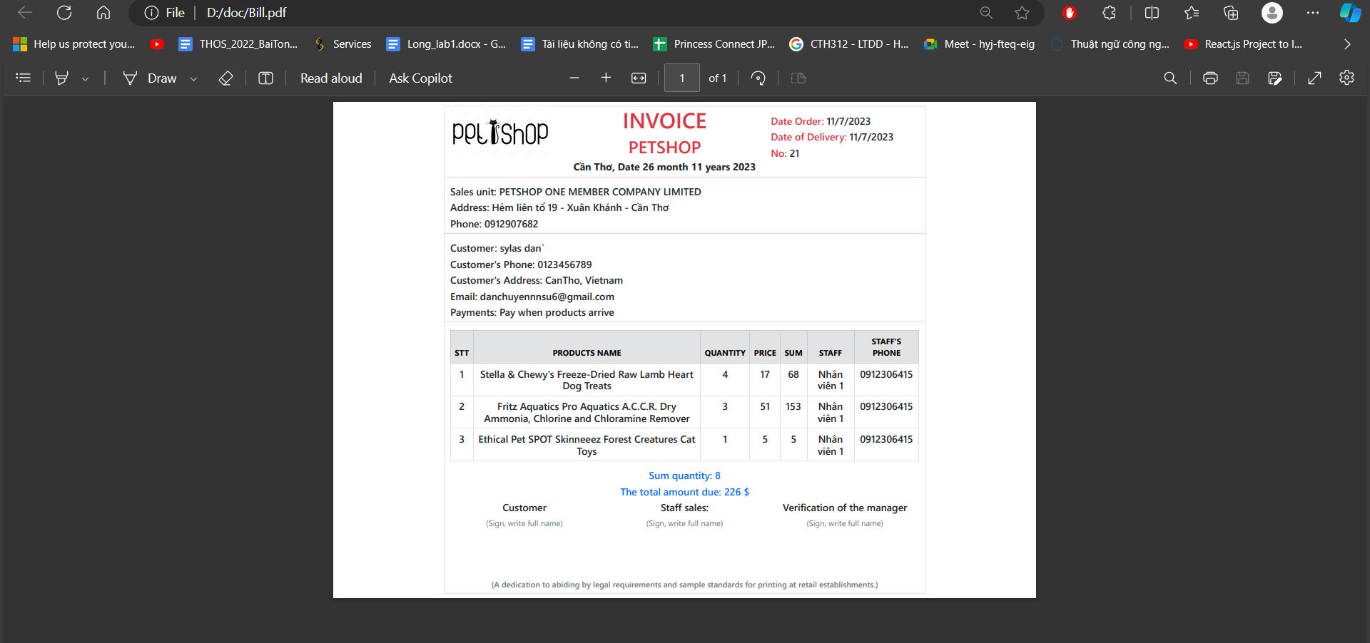**

##### Figure 60: PDF invoice export interface for requesting customers

#### Interface of adding warehouse receipt page

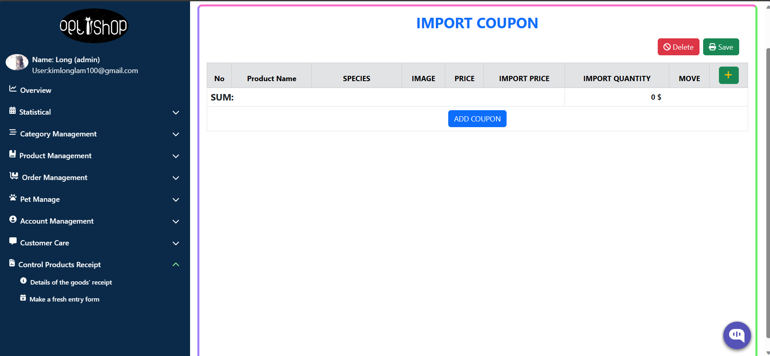

##### Figure 61: Interface of adding warehouse receipt page

Admin, click the + button, choose the item you wish to stock, enter the required details, and then click the add ticket button.

#### All warehouse receipts are listed on the page interface

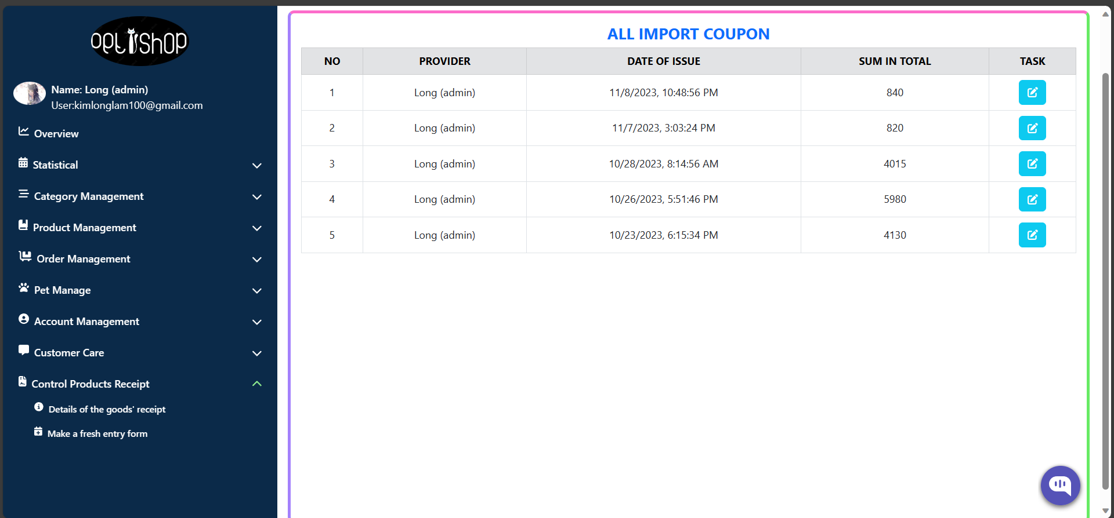

##### Figure 62: Interface of goods receipt information page

Displays a list of all store receipts.

#### The goods receipt details page's interface

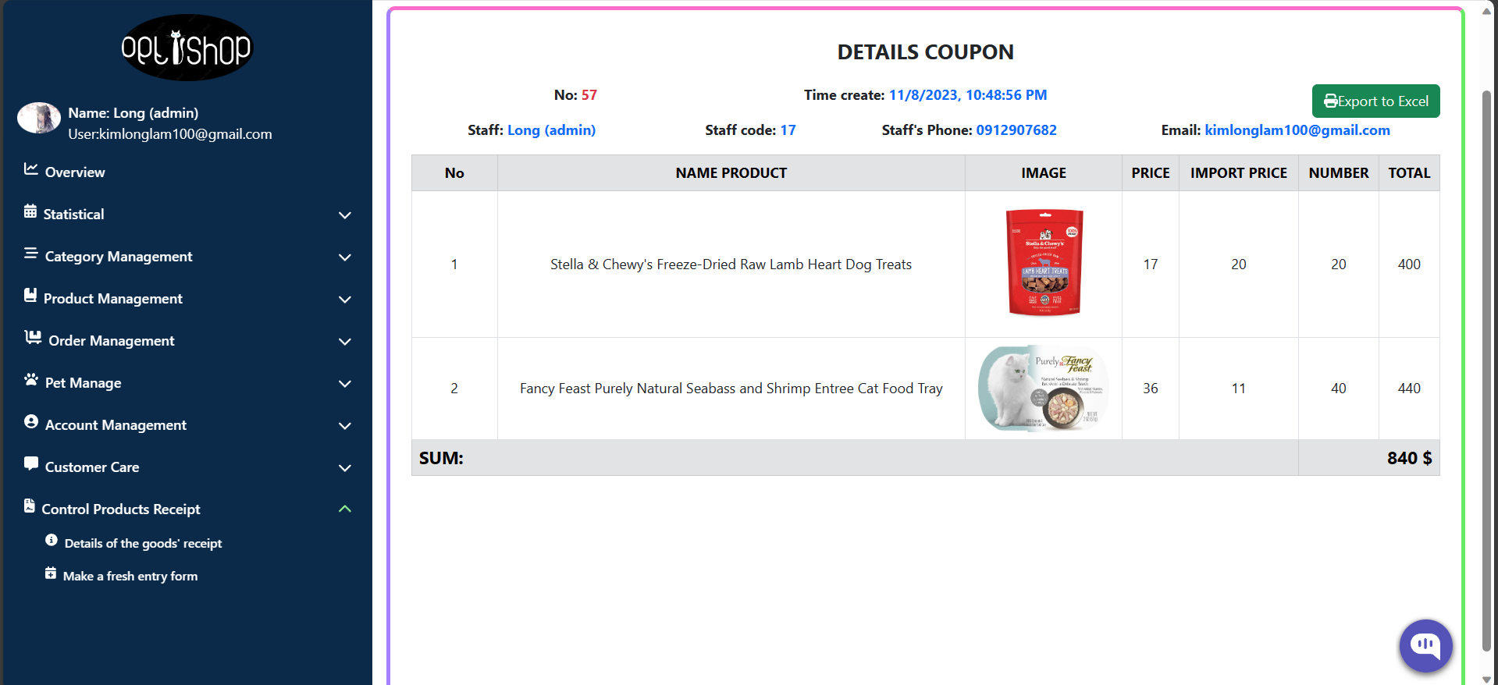

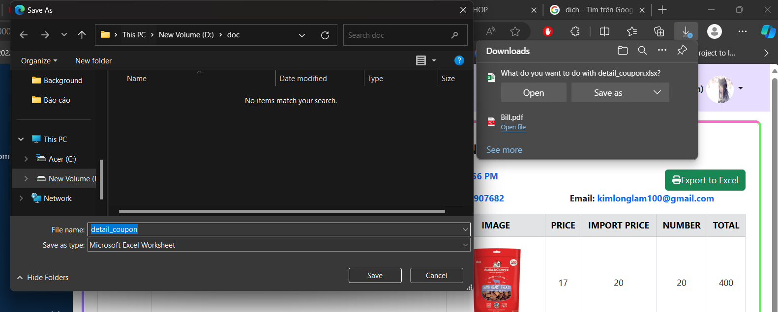  
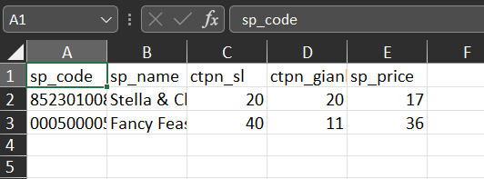

##### Figure 63: Interface of goods receipt details page

Show the goods receipt in full and export the data to an Excel file.

#### Employee account management page interface

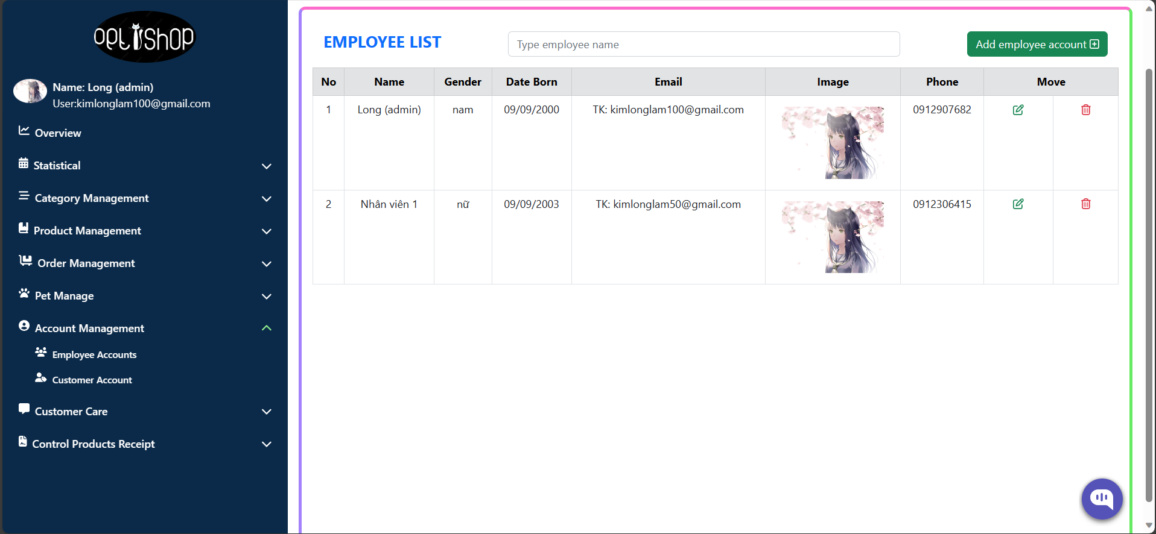

##### Figure 64: Employee account management page interface

Displays a list of employees available in the store

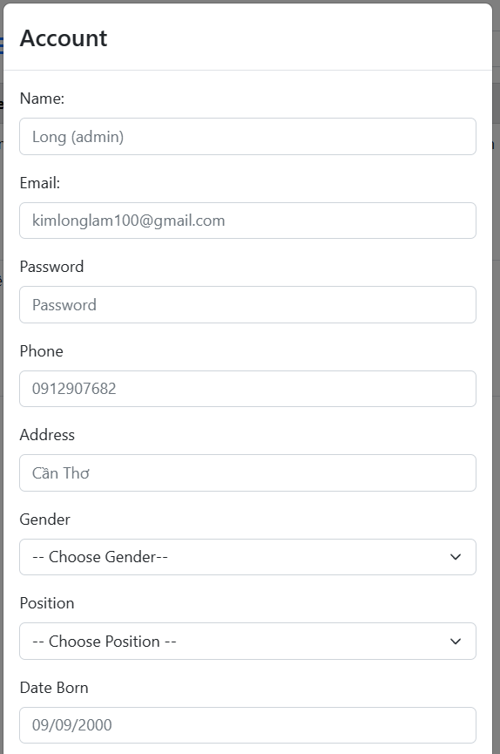  
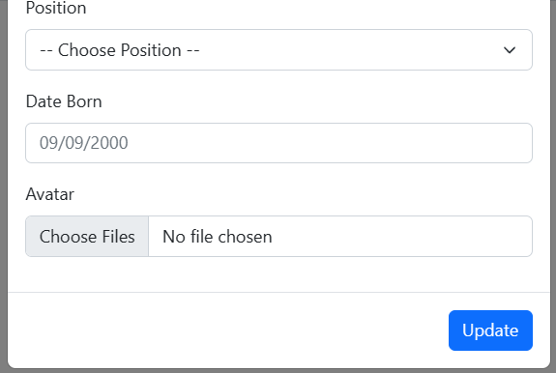

##### Figure 65: Interface for editing account information

Admin has the right to update and edit account information of employees and customers.

**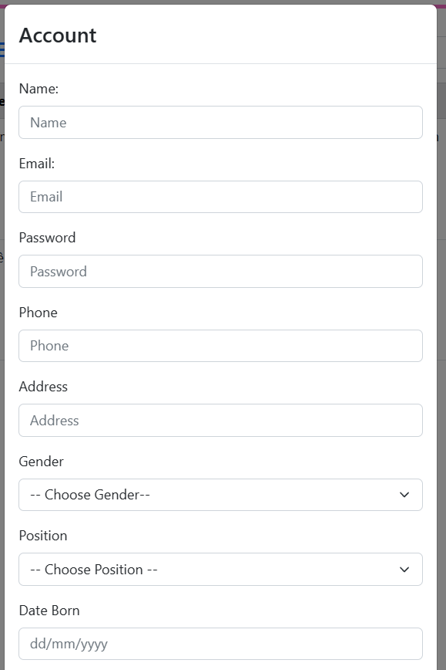  
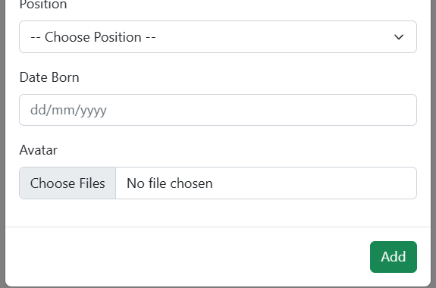**

##### Figure 66: New account addition interface.

Admin can create a new employee or customer account

#### Customer account management page interface

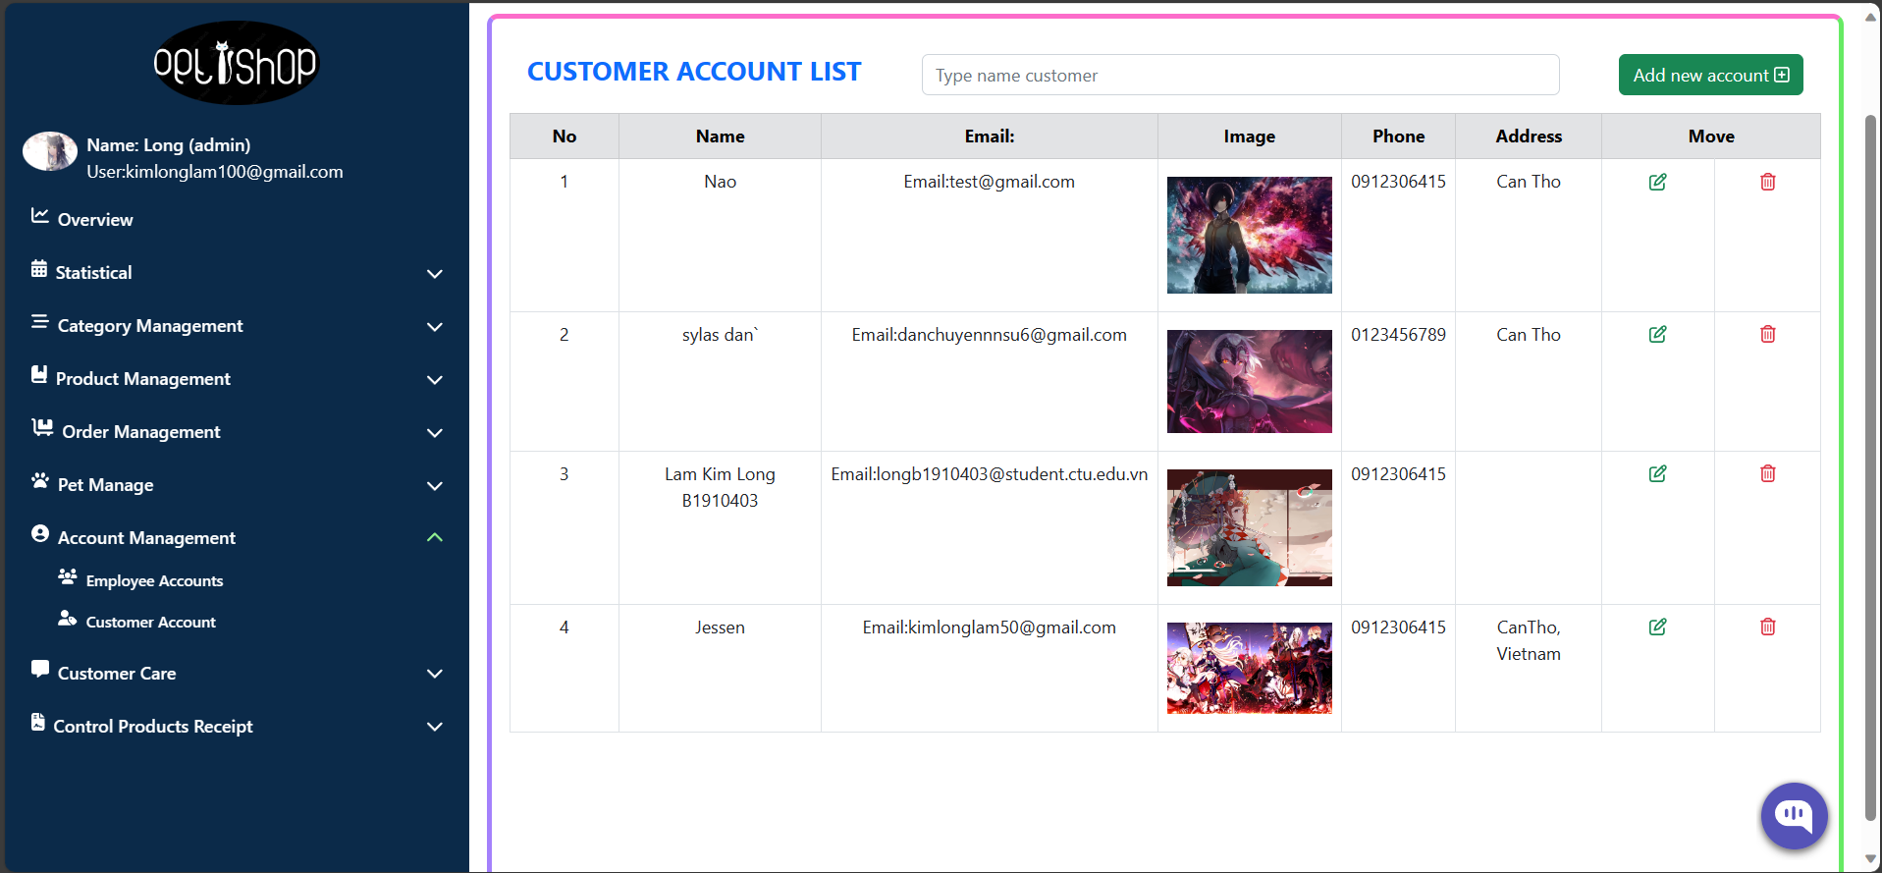

##### Figure 67: List of store customer accounts

Show all customers of the store.

#### Interface of a chatbot

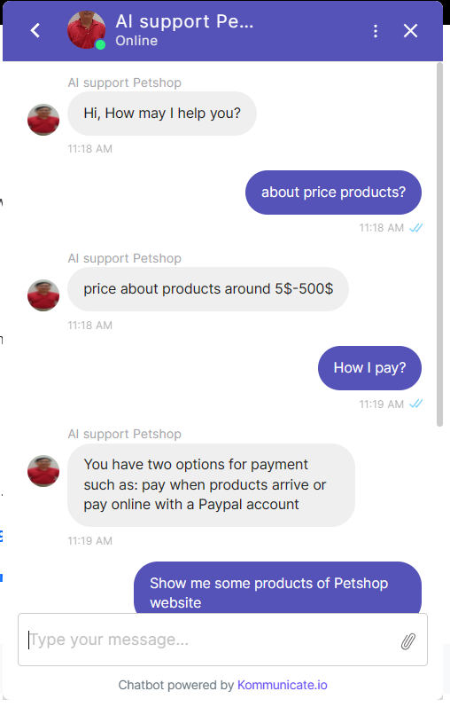

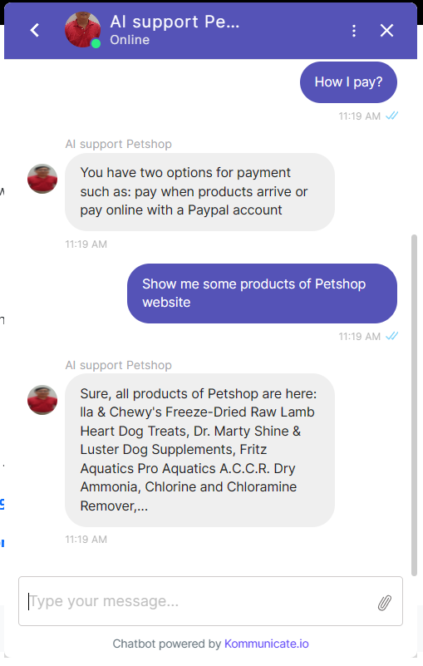

##### Figure 68: Chat bot

Chatbot automatically responds and guides customers

#### Pet care interface

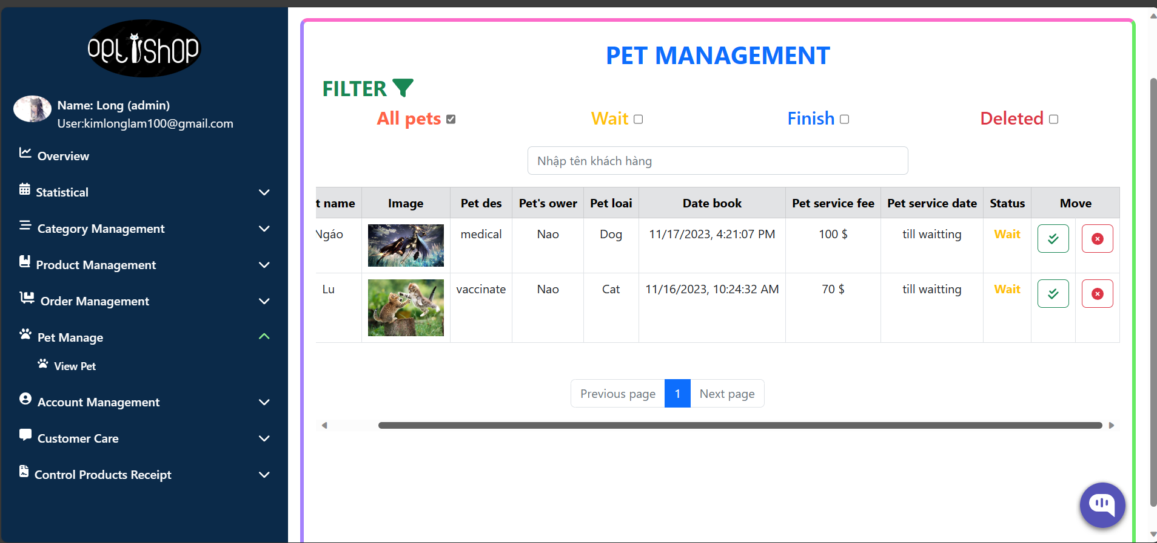

##### Figure 69: Schedule of appointments for pet care

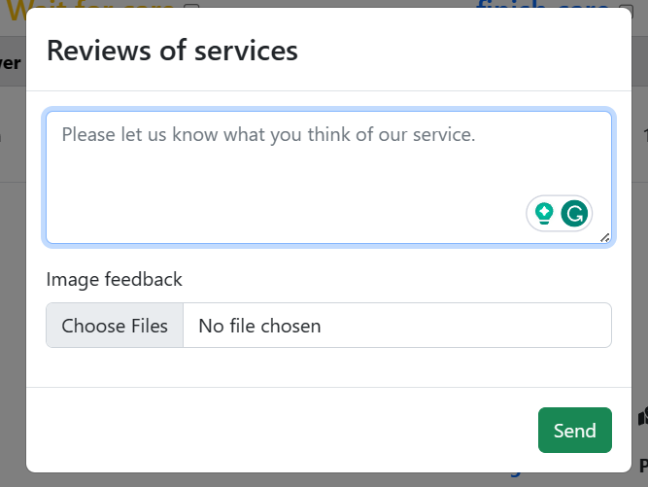

##### Figure 70: User comments following service completion

## CHAPTER 4: TESTING AND EVALUATION

### I. INTRODUCTION

#### 1.1. Goals

To locate potential system faults. Verify whether the system satisfies the predetermined requirements. Before delivering the product to the customer, make sure the system is complete. Functional testing, database testing, and usability testing are all part of the testing process.

* Possibility:

+ Is the purpose of usability testing to determine how user-friendly an application is? Whether or not users find the application easy to use.

+ There are no typographical or grammatical errors in the content.

+ Notification of confirmation for update operations.

* Function:

+ The purpose of functional testing is to confirm if the application satisfies the functional and business requirements specified in the specification.

+ Verify the email function (enter the incorrect email if you registered using the same email address).

+ Verify if you can constrain data, force data entry, empty data, and display a message when incorrect data is entered.

+ When a field in an application reaches its limit, check the display.

* Database

+ Database testing involves determining whether the information in the application and the database match. if the application-manipulated data is accurately added to the database.

+ The information in the database and the information shown to the user are identical.

+ Entering invalid data will allow you to verify the data's validity.

#### 1.2.Test range

Test case specifications that match some of the functions this document describes.

### II. TEST MANAGEMENT

#### 1.Testing is done and work activities are scheduled.

The system testing process will be conducted according to the following steps:

**Step 1:** Make a test plan

**Step 2:** Report test results

#### 2. Environment

**‒ Hardware:**

+ Processor: Intel core I5 ​​8250U

+ RAM: 8GB + Hard drive: SSD 128GB

+ Network configuration: Internet connection

**‒ Software:**

+ Operating system: Windows 10

+ Browser: Google Chrome, Microsoft Edge

+ Database management system: MySQL

#### 3 Resources and resource allocation

‒ Testing resources: Laptop 3.

### III. TEST PLAN DETAILS

#### 1. Functions will be tested

‒ Function testing script

| **No** | **Describe** | **Date** |
| --- | --- | --- |
| 1 | Login function | 11/27/2023 |
| 2 | Order function | 11/27/2023 |
| 3 | Product search and filter function | 11/27/2023 |
| 4 | Order management function | 11/27/2023 |
| 5 | Product management function | 11/27/2023 |
| 6 | Warehouse management function | 11/27/2023 |
| 7 | Online chat function | 11/27/2023 |

###### Table 15: Functional testing scenarios

‒ Usability testing scenario

| **No** | **Describe** | **Date** |
| --- | --- | --- |
| 1 | Check the contents | 11/27/2023 |
| 2 | Links between activities | 11/27/2023 |
| 3 | Notifications when updates are performed | 11/27/2023 |

###### Table 16: usability testing scenarios

‒ DB testing scenario

| **No** | **Describe** | **Date** |
| --- | --- | --- |
| 1 | Data displayed | 11/27/2023 |
| 2 | Data size | 11/27/2023 |
| 3 | Validity of data | 11/27/2023 |

###### Table 17: DB testing scenario

#### 2. Functions will not be tested

Simple functions with straightforward processing, functions that are similar to functions that have already been tested, and incomplete functions are examples of functions that shouldn't be tested.

#### 3. Criteria for test success or failure

When functional performance meets expectations and the requirements specification is followed, testing is considered successful. Results that don't match expectations, show errors, or don't follow the requirements specification are considered test failure criteria.

#### 4. Test cases

**1. Login function**

| **No** | **Test cases** | **Testing steps** | **Expected results** | **Actual results** | **Success/**  **Failure** |
| --- | --- | --- | --- | --- | --- |
| **1** | The customer logs in with valid information | Step 1: Select login.  Step 2: Log in with email test@gmail.com and password 123456 | Logged in successfully | As expected | Success |
| **2** | Administrator logs in with valid credentials | Step 1: Go to the admin login page.  Step 2: Log in with email kimlonglam100@gmail.com and password 123456 | Logged in successfully | As expected | Success |
| **3** | The employee logs in with valid information | Step 1: Go to the employee login page.  Step 2: Log in with email kimlonglam50@gmail.com and password 123456 | Logged in successfully | As expected | Success |

###### Table 18: Description of testing the login function

**2. Ordering function**

| **No** | **Test case** | **Testing steps** | **Expected results** | **Actual results** | **Success/ Failure** |
| --- | --- | --- | --- | --- | --- |
| **1** | Order with complete and valid information | Step 1: Select login. and add products to cart  Step 2: Enter full information and select payment method  Step 3: send purchase request | Order Success | As expected | Success |
| **2** | Order with incomplete valid information | Step 1: Select login. and add products to cart  Step 2: Enter full information and select payment method  Step 3: send purchase request | Error | As expected | Not Success |
| **3** | Order paid with invalid card | Step 1: Select login. and add products to cart  Step 2: Select online payment.  Step 3: Enter a card number that does not exist | Error | As expected | Success |
| **4** | To enter a product purchase quantity that is greater than the amount in stock, place an order. | Step 1: Select login. and add products to cart  Step 2: Update the purchase quantity, which is substantial. | Error | As expected | Success |

###### Table 19: Description of testing the ordering function

**3. Product search and filtering function**

| **No** | **Test case** | **Testing steps** | **Expected results** | **Actual results** | **Success/ Failure** |
| --- | --- | --- | --- | --- | --- |
| **1** | Enter a product name that is not in the system | Step 1: Type in a product name that isn't already in the database. | No products found | No products found | Success |
| **2** | Enter a product name in the system | Step 1: Type in a product name that is already in the database. | Found product | Found product | Success |

###### Table 20: Description of testing the search function

**4. Order management function**

| **No** | **Test case** | **Testing steps** | **Expected results** | **Actual results** | **Success/ Failure** |
| --- | --- | --- | --- | --- | --- |
| **1** | Browse order status from "Waiting for confirmation" to "Delivering" | Step 1: Log in to the admin page. Click to select order management  Step 2: Find the order whose status needs to be updated and select update.  Step 3: Success update notification | Update  success | As expected | Success |
| **2** | If the order status is “Delivery failed” | Step 1: Log in to the admin page. Click to select order management  Step 2: Find the order whose status needs to be updated and select update.  Step 3: Success update notification | Update  success | As expected | Success |
| **3** | Order cancellation when not in the "Wait" state | Step 1: Log in to the customer page. Click select order  Step 2: Find the order that needs to update its status and choose to cancel the order.  Step 3: Success update notification | Update  success | As expected | Success |

###### Table 21: Description of testing the order management function

**5. Chatbot function**

| **No** | **Test case** | **Testing steps** | **Expected results** | **Actual results** | **Success/ Failure** |
| --- | --- | --- | --- | --- | --- |
| **1** | The customer does not have an internet connection | Step 1: Go to the website home page  Step 2: Choose “chatbot” | Send message Success | As expected | Success |
| **2** | Chat information is invalid | Step 1: Go to the website home page  Step 2: Choose “chatbot” | Send Success message and reply "I don't understand what you said" | No As expected | Failure |

###### Table 22: An explanation of the cahtbot function test

# SECTION THREE: CONCLUSION AND DEVELOPMENT DIRECTIONS

## Conclude

"Building a system for selling pet care products and services" was successfully designed and built, meeting the majority of the requirements and features. Customers without accounts, members (customers with registered accounts), employees, and administrators make up the four main user groups on the website.

- Clients who don't have an account: Look up products by price, category, or name... View product details, but your ability to rate and comment on it is restricted. In order to access the system, create an account. System consulting is supported by the Chatbox system.

- Members are clients who have set up an account: Additional advantages for members include the ability to schedule a pet care appointment, rate products, make payments, leave comments on news articles, and use the system's chat feature.

- Admin: Control orders, goods, articles, manufacturers, suppliers, warehouse receipts, shipping costs, and categories.

- The worker observes the delivery of the order, verifies the contact, and modifies the order's status.

## Limit

The system could not help but have certain limitations because of the project's time constraints and the learning curve associated with writing the program while studying web design and programming languages. There are other insignificant functions absent. The database isn't rich and diverse yet. The user interface is still far too hazy..

## Development

The system will have a more elegant design and function flawlessly on PC and mobile platforms in the future. Create fresh shopping features to satisfy the demands of your clientele. Upgrade the system to enable quick access. Increase the number of chatbox systems you create, as well as their security and overall performance.

**REFERENCES**

1. Trần Cao Đệ, Đỗ Thanh Nghị (2012). Giáo trình kiểm thử phần mềm, NXB Đại học Cần Thơ.
2. Đỗ Thanh Nghị (2015), Giáo trình lập trình web, NXB Đại học Cần Thơ.
3. Refer to ReactJS : <https://legacy.reactjs.org/docs/getting-started.html>
4. Refer to Bootstrap: <https://getbootstrap.com/>
5. Refer to ReactBootstrap: <https://react-bootstrap.github.io/getting-started/introduction>
6. Refer to DB MySQL: [MySQL Introduction (w3schools.com)](https://www.w3schools.com/mysql/mysql_intro.asp)
7. Refer to NodeJS: <https://nodejs.org/en>
8. Refer to NPM: <https://www.npmjs.com/>
9. Refer to axios: [Bắt đầu | Tài liệu Axios (axios-http.com)](https://axios-http.com/vi/docs/intro)
10. Refer to jsonwebtoken: [jsonwebtoken - npm (npmjs.com)](https://www.npmjs.com/package/jsonwebtoken)
11. Refer to kommunicate-chatbot: [AI Chatbot for Customer Service Automation | Kommunicate](https://www.kommunicate.io/)
12. Refer to W3Schools: <https://www.w3schools.com/>
13. Refer to stackOverflow: <https://stackoverflow.com/>
14. Refer to PayPal: [https://developer.paypal.com/ docs/api/overview/.](https://developer.paypal.com/%20docs/api/overview/.%20)